The Future of Essay Writing: Exploring AI-Powered Writing Tools

Introduction
In the digital age, technological advancements continue to revolutionize various aspects of our lives. One area that has seen significant developments is the field of writing, particularly in essay composition. With the rise of Artificial Intelligence (AI), we are witnessing the emergence of powerful AI-powered writing tools that are poised to transform the way we write essays. In this article, we will explore the future of essay writing and delve into the potential of AI-powered writing tools to enhance the writing process. We will also discuss the benefits of using such tools, focusing on the exceptional capabilities of the AI essay writer offered by PerfectEssayWriter.ai.

The Impact of AI on Essay Writing
Artificial Intelligence has made remarkable strides in recent years, and its impact on the writing landscape cannot be overlooked. AI-powered writing tools leverage natural language processing, machine learning, and deep learning algorithms to assist writers in generating high-quality content. These tools have the potential to revolutionize essay writing by providing a range of functionalities that facilitate the entire writing process.

AI Essay Writer: PerfectEssayWriter.ai
One of the leading AI-powered writing tools in the market is PerfectEssayWriter.ai. This cutting-edge platform combines advanced algorithms with intuitive user interfaces to empower writers and students alike. With the help of this ai essay writer, individuals can experience a seamless and efficient writing process, from generating ideas to producing well-structured essays.

PerfectEssayWriter.ai offers an AI-powered essay writer that assists users in various aspects of essay composition. By integrating AI technology, PerfectEssayWriter.ai provides users with a unique advantage in crafting high-quality essays.

Benefits of AI-Powered Writing Tools
Utilizing AI-powered writing tools, such as PerfectEssayWriter.ai's AI essay writer, brings forth several advantages that can significantly enhance the essay writing process. Let's explore some of these benefits:

1. Time Efficiency
Writing an essay can be a time-consuming task, requiring extensive research, brainstorming, and structuring of ideas. AI-powered writing tools accelerate this process by offering features like automated research, topic suggestion, and content generation. With the assistance of these tools, writers can save valuable time, allowing them to focus on other aspects of their work or studies.

2. Enhanced Creativity
AI-powered writing tools serve as creative companions, stimulating writers' imaginations and fostering innovative thinking. By generating topic ideas, providing diverse perspectives, and suggesting unique approaches, these tools inspire writers to explore new avenues of thought. The AI essay generator mentioned in this article excels in this regard, facilitating the development of original and engaging content.

3. Improved Writing Quality
PerfectEssayWriter.ai's AI essay writer leverages advanced language models and algorithms to ensure the production of high-quality essays. These tools help identify grammar and spelling errors, offer suggestions for sentence restructuring, and enhance overall readability. By employing AI-powered writing tools, writers can improve the coherence, clarity, and eloquence of their essays.

Social Media and User Reviews
PerfectEssayWriter.ai has garnered a positive reputation among users, as reflected in its social media presence and user reviews. The platform has an active subreddit at r/PerfectEssayWriterAI where users engage in discussions and share their experiences. Additionally, the PerfectEssayWriter.ai Quora page (PerfectEssayWriter.ai on Quora) provides valuable insights into the platform's capabilities. For more in-depth reviews, potential users can visit trusted review sites such as Sitejabber, Reviews.io, ResellerRatings, SourceForge, and ProvenExpert.

News Mentions
PerfectEssayWriter.ai has also received notable coverage in news outlets, highlighting its advancements in the AI-powered content generation landscape. News articles on NewsDirect, Yahoo Finance, and TechBullion provide comprehensive insights into PerfectEssayWriter.ai's capabilities and its superiority over other AI writing tools.
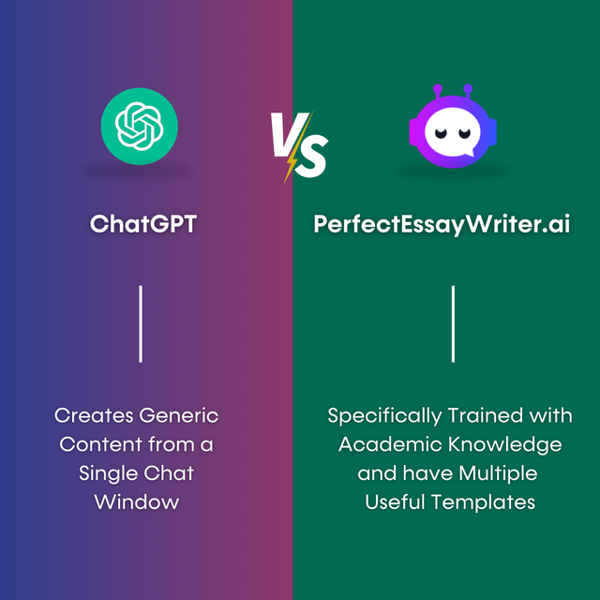

Conclusion
As we venture into the future of essay writing, essay writer ai is poised to play a significant role. This tool offers unparalleled assistance, empowering writers with time efficiency, enhanced creativity, and improved writing quality. With its advanced algorithms and user-friendly interfaces, AI-powered writing tool is reshaping the writing landscape, making essay composition more accessible, efficient, and enjoyable. Embrace the future of essay writing by harnessing the capabilities of AI-powered writing tools like PerfectEssayWriter.ai, and experience the transformative impact they can have on your writing journey.

