**NIGERIA STRATEGY FOR IMMUNISATION AND PHC SYSTEM STRENGTHENING [NSIPSS]**

**INTRODUCTION**

The Government of Nigeria in collaboration with partners and donors developed the Nigeria Strategy for Immunization and PHC System Strengthening (NSIPSS) to guide and galvanize efforts aimed at achieving sustainable immunization outcomes and strengthening the primary healthcare system. This strategy document describes the programmatic decisions that have been made by Nigeria and outlines how the program will be managed and financed. It presents the country’s plan for transitioning to financial ownership of the immunization and primary health care health system over a ten-year period, from 2018-2028 – in line with Nigeria’s proposed timeline for graduating from Gavi alliance support. It further lays out potential areas of support from Gavi alliance during the transition. Although Nigeria is one of the largest recipients of GAVI grants in Africa having received ~ US$770 million and US$707 million in approvals and disbursements respectively from 2001 to June 2017, the relationship between the Nigeria and Gavi alliance continues to be an important and valuable partnership, with the goal of reaching those millions of children whose lives can be saved by immunization.

Additionally, it is also important to consider that routine immunization is a public health emergency in Nigeria with over 4.3 million unimmunized children – the country with the highest number of unimmunized children in the world – more than a quarter of all unimmunized children globally. After Gavi’s huge investment in the past, the country has finally been making demonstrable progress towards reaching them, but this progress will inevitably be threatened if Nigeria must remain within the agreement previously discussed. Gains will undoubtedly be reversed, with a lot of lives lost. Routine immunization in Nigeria is projected to save millions of lives over the period from 2018 to 2028. Underperformance in this area for Nigeria can thus only be counted in the hundreds of thousands. This is a sobering reflection for the government of Nigeria, whose primary responsibility this is, and will of course also be for Gavi.

The NSIPSS builds on progress that has already been made in recent times and also on strategies that have the best potentials to achieve sustainable immunization coverage, within the Nigerian context. While coverage has not moved forward in the last five years looking at survey data, some critical elements of the system have clearly demonstrated measurable improvements. There has been a heavy focus on the supply chain, and after a coordinated push from the National Emergency Routine Immunization Coordinating Centre(NERICC), vaccine availability at LGA level – the last level before facility – improved from ~30% in 2014 to ~80% today. This is a remarkable improvement in performance and is a pre-requisite to any realistic chance of a change in coverage. Now that vaccines are actually available at states and LGAs, 26 states (in addition to 8 already implementing) have also signed up to a program of direct vaccine delivery to health facilities, replacing the old ad-hoc collection system, which largely involved out of pocket payment by healthcare workers. This strategy ensures vaccines get to the health facility.

**DIAGNOSIS**

In Nigeria, RI data is collected at health facilities, using tally sheets, RI registers and vaccine utilization forms Hard copy paper forms. These are then summarized into the monthly NHMIS, supplementary immunization and vaccine utilization summary forms and submitted to the LGA level for review and entry on to the DHIS2 platform by the LGA M&E officer, LIO, CCO, and RIO as per assigned schedule by the LGA team, on/before 15th of the following month to meet timeliness and within 90days for completeness. The LGA level also makes hard copy summaries and transmits the same to the State level. Data electronically entered at the HF level is available to users based on assigned privileges after data entry is marked complete.

In Nigeria, there are monthly technical review meetings at the LGA level (for HFs) and State level (For LGAs) where monthly RI processes and performance are discussed. Feedback is usually provided and action points to be followed agreed upon.

Routine Immunization Supportive supervision and quarterly DQA/DQS are also conducted with a review of primary data collection tools and summary tools as part of data quality checks.

If data is wrong, the HF is expected to submit updates. Updates within 90days are easily updated when sent to the LGA level. But updates for data after 90days usually require special approval and communication has to be made for the DHIS2 platform to be enabled to receive such updates.

**SWOT**

**Program Management**

**Strength**

* Availability of legislation (NPI, NPHCDA Act, NHA). Clearly defined roles and responsibilities in NHA
* Availability of policies and guidelines (NIP, NRISP)
* Availability of functional coordination committees and working groups
* Accountability framework in place (2013-2015)
* Regular high-level advocacy with the legislature
* Good pool of skilled health care workers (though concentrated mostly around the urban areas)
* Establishment of PHCUOR concept: To address PHC manpower (harmonized remuneration) and management of bottlenecks.
* Signing into law the National Health Act would provide additional financing for primary health care health services (immunization inclusive)
* Political will and financial commitment, especially at the Federal level.

**Weakness**

* Existing legislature focuses more on immunization financing
* Weak ICC at the state level
* Weak implementation of the accountability framework
* Inadequate skilled health care workers in rural areas
* Mal-distribution of health workers (HWs): > 70% of the HWs are in the urban areas leaving <30% of HWs in the rural areas. There are also more health workers in the southern states compared to the northern states
* Frequent transfer/retention of health workers
* Inadequate budgetary and resource allocation for RI at national and sub-national levels
* Inadequate and delayed releases of appropriated funding for immunization with the resultant delayed implementation of planned RI activities.
* No system to evaluate CMYP itself.
* Inadequate engagement of the community members in RI services.

**Opportunities**

* NTLC as a high-level advocacy platform for strengthening accountability for RI

Growing PPP on immunization (e.g. private Alliance on health)

* Donor support for in-service training.
* Volunteer health care workers.
* Involvement of the private sector (e.g.Dangote) in RI
* Performance-based financing.

**Threats**

* The general view that the National Health Act will solve all health challenges
* The exit of GAVI and rebasing of the economy
* Frequent and protracted health worker strike
* Brain drain/Migration
* States / LGAs are not employing staff (HWs)
* The attitude of some health workers
* Insecurity in some regions
* High out of the pocket expenditure
* Poor economy (Diminishing/dwindling oil revenue)

**ROOT CAUSE ANALYSIS**

**Non-representative denominators:**

The target population (denominator) currently used in Nigeria is extrapolated from the 2006 national census figures, using a growth rate for each state and LGA provided by the Nigerian National Statistics Bureau. Doubts, however, surround the accuracy of the 2006 census figures as conflicting interests skewed the census. Additionally, these total coverage figures do not take into account domestic Nigerian inter-state and intra-state migration, which have a significant impact on the population of certain communities. For instance, Suleja LGA in Niger state; and Keffi and Karu LGAs in Nasarawa state have seen a high in-migration of people over the last few years due to the proximity of these LGAs to Abuja, yet their growth rates have been pegged as 3.4% for Niger and 3% for Nasarawa state (while LGAs in FCT are at an average of 9.3%).

Niger and Nasarawa states have persistently recorded >100% penta3 coverage since 2014 despite having areas with systemic RI challenges (including cold chain, vaccine handling and administration, and demonstrated incidence of poorly trained health workers), see figure. There is currently planned by the Federal Government of Nigeria to conduct the 2018 census. In the interim, NPHCDA will support the Pilot GIS mapping of the population in selected states to improve the quality of the RI micro-planning census and collaborate with National Population Council (NPoC) to improve civil birth registration and vital statistics.

**Trend of Penta3 cumulative coverage in Nasarawa and Niger states (December 2013 – 2016)**

The national DP1-DPT3 dropout rate decreased from 11.9% in 2010 to 7.4% in 2015. Negative BCG-Measles dropout rate was recorded during the period, though there was an improvement from -28% in 2010 to -1% in 2015. (Refer the figure below). The analysis of reported data on negative drop-out highlighted existing problems in terms of data quality and accuracy of data related to the target population (denominator issue). Taking into account that the target population rates (denominators) are based on the 2006 census data and establish population growth rates, it is hoped that during the next census planned for 2018, these issues would be precisely addressed.

**Trends in the DTP1 – DTP3 and BCG – Measles drop out rates (2010 – 2015)**

**Why do these problems persist?**

**Denominator issue:** In response to the recurring concerns about the faulty target populations, in 2015, the ICC set up an inter-sectoral committee. This committee consisting of the NPHCDA, FMOH and the National Population Commission was charged to consider the denominator issue and advice on a way out. The approaches to addressing the denominator issue include the Population estimation committee, the GIS mapping and the Walk-through micro-plan. GIS mapping is currently being applied in 2 states to assist in target population estimates. Efforts are on-going to scale up the GIS mapping to more states, while also applying other interventions to address denominator issues.

Clearly, a few efforts are underway to address aspects of the data problem. However, there is yet no comprehensive evidence-based data quality improvement plan to tackle the likely multifaceted causes of poor data. It is against this backdrop that the RIWG constituted a data quality subcommittee to examine reasons for poor RI data quality and proffer recommendations to address the challenges

**Why low-quality data?**

Routine immunization data quality issues can potentially arise from three areas: Data Quality Plan, Data Quality Policies and Data Quality Processes. (Refer to figure. All these issues contribute to either over and/or under-reporting of the actual number of clients reached (in most instances, there is over-reporting of over 100% coverage).

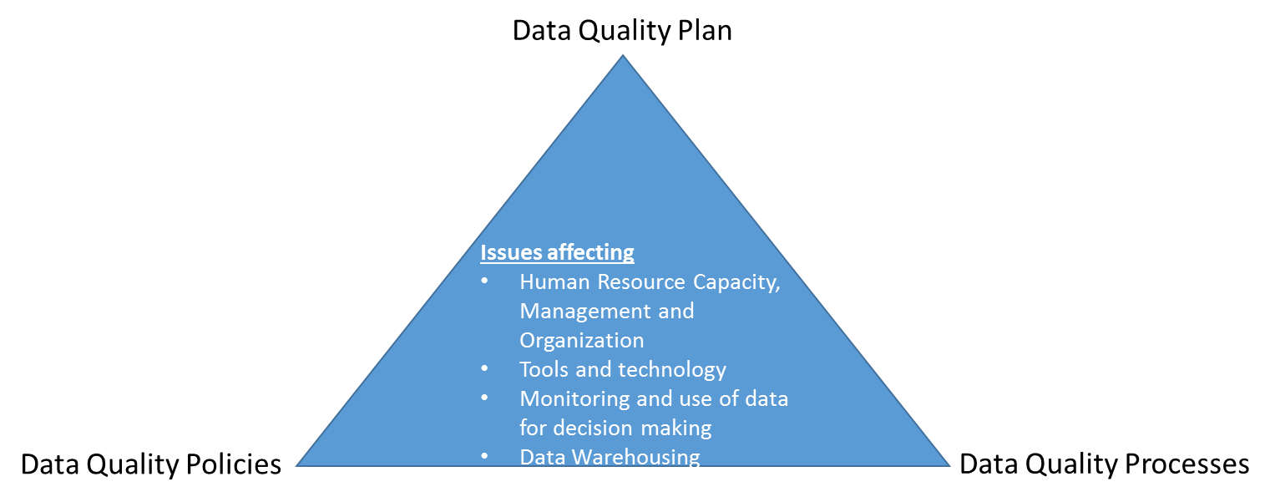

**Framework on data quality and issues affecting**

A desk review undertaken by the data quality subcommittee revealed that data quality in the country is affected by a multiplicity of factors (see figure) with key issues centered around:

1. Data Quality Policies
2. Data Quality Plan
3. Data Quality Processes
4. Human Resource Capacity, Management, and Organization
5. Tools and Technology
6. Monitoring and use of data for decision making
7. Data Warehousing

In addition to the identified issues, poor data quality, weak data management and lack of data use for action at the operational level are widely acknowledged problems in the RI system. Not much of triangulation is done between the administrative and coverage data for decision making in the reports presented. Surveillance and logistics components are not routinely included in the RI performance reports. And, there is currently no strategic data quality plan in line with other plans; and having clear timelines.

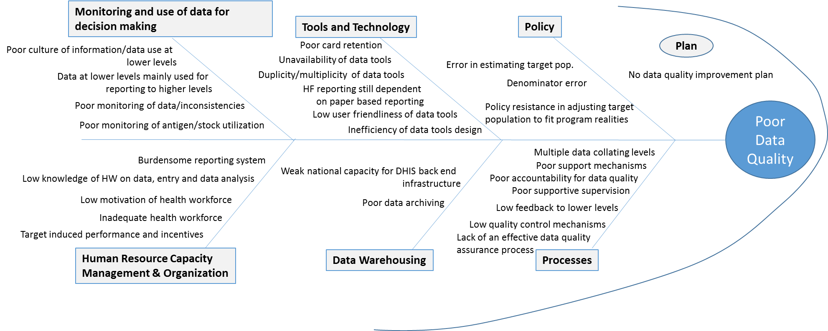

1. Lack of internal and external accountability for data quality
2. Multiple data collating levels which create more room for errors
3. Lack of an effective data quality assurance process
4. Lack of feedback from national to state to LGA to health facility
5. Poor support mechanisms. DQS is heavily dependent on donor funding with weak implementation of results
6. Poor supportive supervision

**ACTIONABLE RECOMMENDATIONS**

1. Policy resistance to adjusting population denominator and numerator issues to fit program reality:

Denominator Issues: Immunization coverage estimates in Nigeria are based on 2006 Census projections; the census Estimates are based on fixed GRs, fixed proportion of age groups which we do know are correct, and since census figures stopped only at LGA levels wards populations can only be extrapolated with the potential of huge bias.

Numerator issues: At Facility level (capacity, time and attitude of health workers and resource challenge); and at the system level (pressure to meet up target, accountability issues, inadequate resources, poor coordination leading duplicity, complex reporting system).

Beyond the system, socio-political issues (population dynamics); Governance and ownership issue; and poor integration of private health sector providers

1. Good feedback to lower levels following the conduct of data quality self-assessment.
2. Frequency of conduct of DQS is regular at all levels, with the low implementation of recommendations.
3. Strong linkage between actual surveillance and coverage data.
4. Availability of a coordinated guideline for EPI related survey.
5. Resources availability of sustainability plan for HMIS related activities in the country.

**Data Quality Plan*:***

A data quality plan outlines key actions, timelines and responsibilities in the implementation of outlined interventions. Prior to now, Nigeria is yet to have a holistic data quality improvement plan in line with other plans; and having clear timelines. Consequently, data quality improvement efforts have been implemented Adhoc with low follow up on outlined recommendations.

**Data Quality Processes:**

Support for improving data quality has usually been implemented through the Government, which ensures the country has the required infrastructure including data tools. Of key importance in assessing data quality are scheduled data quality self-assessments (DQS). Government staff at national and subnational levels usually conducts this with support from partners.

**4. Human Resource Capacity, Management, and Organization:**

1. Good knowledge of the use of tools, both paper and electronic. Contributing to these are:

* Poor practice and protocols for data entry; and
* Poor understanding of basic analytics such as coverage and drop out the calculation and of data interpretation.

1. The moral attitude of health workers and EPI managers on data collation. These contribute to accurate reporting, good data capturing complete submission of immunization data from the HFs/LGAs. A deep dive field assessment conducted in October 2016 revealed consistencies in the data reported at each level with deliberate alterations of data observed in some sites.
2. good attitude by frontline health care workers to use data for action (e.g. to track and immunize children) leads to a substantial number of immunized children, drop-outs and missed opportunities. These gaps are further widened by additional challenges in data transmission and obsession with reporting to target coverage.
3. adequate and high motivation of the health workforce due to delayed payments of salaries and appropriate working conditions are contributory. In some primary health facilities.
4. low attrition rates of health workers.
5. Capacity building that is relevant training(s), or the alignment between the individuals that are trained and the roles they perform.

**ACTIVITIES**

|  |  |  |
| --- | --- | --- |
| Objectives | Strategies | Activities |
| 1. To facilitate the implementation of interventions to the identified data quality issues and achieves at least 95% timeliness and completeness of reporting on DHIS2 by 2020. | * 1. Strengthen coordination structures for data reporting, warehousing, management and use of data for action | * + 1. Establishment of a national (and states) data quality implementation teams (to facilitate   Implementation of the DQIP)   * + 1. To support coordination through the conduct of monthly TWG meetings (RIWG, LWG, MEWG,   SMWG, TrWG) |
| * 1. Provision of appropriate technologies (equipment) and data capturing tools at all levels | * + 1. Procure computers for data reporting for States and LGAs     2. Procure mobile phones for data reporting from the health facilities     3. Provide DHIS storage infrastructures and warehousing     4. Revision of EPI data tools for data capture, field visits/supervisions by government and   partners   * + 1. Provide and distribute appropriate EPI data tools to States, LGAs and HFs     2. Conduct advocacy to community leaders, religious leaders & WDCs on data ownership and use   of data for action   * + 1. Develop community data tools to improve RI reporting     2. Renew signing of MOU on PPP for RI data with private health facilities     3. Collaborate with NPoC to improve birth registration and redefine denominator for Birth   registration   * + 1. Produce and disseminate quarterly bulletins on RI performance to States and LGAs     2. Harmonization of the multiple reporting tools at all levels     3. Introduce the use of data tools, data capture and analysis; and using data for action in pre-   service institutions Review of tools |
| * 1. Complete the Rollout of DHIS to all 19 States by December 2017 | * + 1. Conduct advocacy and needs an assessment on DHIS roll out to the remaining 14 states     2. Conduct training of health workers on DHIS in 14 states     3. Conduct refresher of health care workers on DHIS in all states     4. Strengthen State / LGA levels monthly review meeting on RI to include M&E/HMIS Officers     5. Link LIOs and M&E Officers meetings with capacity building including Directly Observable Data Entry     6. Provide monthly feedback on DHIS reports at all levels     7. Develop and implement DVD-MT phase-out transition strategy for the country |
| * 1. Strengthen human resource capacity, management, and organization | * + 1. Training and retraining of frontline health workers and managers on the use of DHIS mobile phones, data tools, monitoring techniques, use of data for action(s), etc     2. Conduct quarterly supportive supervision so that each HF is visited including ODK enabled community survey     3. Engage TA to support the implementation of the DQIP     4. Tour of two (2) well-performing states / one (1) country (for possible replication of good practices) |
| Objectives | **Strategies** | **Activities** |
|  | * 1. The regular and sustained data validation system | * + 1. Conduct quarterly DQA to LGA and health facilities     2. Establish and strengthen integrated data management teams at the States     3. Conduct monthly meetings of data validation for all PHC programs at LGA levels     4. Disseminate findings and Implement the recommendation of 2016 NICS / MICS     5. Conduct SMART survey on RI     6. Institutionalize monthly community survey through the ODK enabled supportive supervision and on-the-job mentorship (within the broader RISS) by government and partners     7. Annual evaluation of the status of implementation of the DQIP |
| 2. To ensure/pass enabling laws an develop appropriate guidelines to identify/address key issues (or challenges) affecting data quality in Nigeria | * 1. Pass enabling laws and develop appropriate guidelines | * + 1. Revision of the National Immunization Policy to accommodate appropriate     2. Free primary school enrollment social services for children with evidence of full immunization policies on data quality     3. Printing and distribution of the revised policies and guidelines to all levels / Partners |
| * 1. To conduct population estimate studies/assessments to address denominator issues | * + 1. Conduct GIS population estimates (study) in all the states + FCT     2. Finalize walk-through micro-plan (HH enumeration) in 17 southern states + Kogi and Kwara     3. Hold engagement meetings with relevant stakeholders on the rationale/implication of the revised denominator     4. Appoint an independent statistician as a consultant for aggregation and triangulation of the different data sources     5. Set up an inter-agency technical committee (5 members) to collect and compile all the final reports of population estimation from different sources.     6. Finalize and share report of the inter-Agency population estimates committee     7. Begin early meetings with NPopC to re-configure the age structures to accommodate the health demographics in the 2018-planned census. |
| * 1. To establish data consultative forums at national and subnational levels | * + 1. To conduct zonal level consultative meetings to identify poor data quality influencers at subnational levels     2. To review data quality gaps and the implementation of strategies to resolve them |
|  | * 1. To strengthen data quality audit, assurance, and assessment mechanisms | * + 1. Conduct quarterly data quality self-assessments (DQS)/data quality audits (DQAs) using tally sheets, LGA summary sheets, and immunization registers     2. Harmonize conduct of quarterly data quality audits (DQAs)/data quality self-assessments (DQS) at all levels using tally sheets, LGA summary sheets, and immunization registers     3. Conduct data quality spot checks assess issues with data at lower levels in selected states and LGAs     4. Conduct data quality deep-dive assessments to assess interrelationships with data use and deeper level assessments of data gaps at various levels |
|  | * 1. Improve evidence-based for decision making and planning on the immunization program | * + 1. Assessment of the perception and acceptance of the card by the community, including factors influencing car retention     2. Conduct an assessment to determine the training needs of the health workers as it relates to data quality |
| 3. To improve routine immunization performance through the availability of clean, reliable, accurate and timely RI data for decision making | * 1. To focus on the data of the actual number of clients reached pending the finalization of all processes to address numerator issues | * + 1. Collate and analyze administrative data from all states using DVD-MT (until Dec 2018) and DHIS2 platforms base on absolute numbers vaccinated to arrive as agreed estimated numbers per antigen per month     2. Hold zonal / state level engagement meetings for discussion and buy-in on the NUMERATOR emphasis     3. Institute bi-monthly state-level DQS focusing on the Child Health Register (CHR) as the primary data source     4. Establish Accountability mechanism with clear reward and sanction measures from national to health facility levels     5. Triangulate immunization data with surveillance and logistics data |
| * 1. To strengthen feedback mechanisms and follow up of identified interventions | * + 1. Harmonized monthly meeting LIOs & M&E officers at the state / LGA levels |
| * + 1. Support states/ LGAs for RI performance feedback reviews. |
| * 1. To develop and strengthen accountability frameworks, data reviews, and mechanisms for ensuring data use at all levels | * + 1. Develop and implement quarterly data reviews |
| * + 1. Support states identify and implement key areas for strengthening data use for action |
|  | * 1. To strengthen home-based records and improve card retention at community levels | * + 1. Revision/pilot placement of the home-based records in 6 states |
| * + 1. Printing, distribution, and placement of the HBRs in all the states |

**QUALITY OF EVIDENCE**

**Recognizing Routine Immunization Data Quality as a challenge in Nigeria:**

The quality of data arising from the routine immunization system (administrative/admin data) has been a long-standing concern of the government and partners. The immunization coverage estimate comprises of a numerator (number of children vaccinated) and a denominator (target population of children eligible for vaccination). Errors in coverage rates could arise from a numerator error (willful manipulation of figures or un-intended errors); or from a denominator error (faulty estimation of the target population). In Nigeria, it is not clear where the weight of the problem lies.

It is common to see admin vaccine coverage rates of 100% or more reported by states or LGAs and observe a wide gap between admin and survey coverage. Household surveys like the Demographic and Health Surveys, or the SMART surveys are regarded as the gold standard for immunization coverage estimates, so large admin/survey gaps are a sign of poor quality data.

Available data suggests there has always been a wide disparity between administrative immunization coverage data, UNICEF-WHO estimates, and survey data. While the national routine immunization (DPT3) administrative coverage increased from less than 50% about a decade ago to over 90% in the last 3 years[1], coverage estimates from survey data remain low. Comparing administrative, official and WUENIC Penta-3 coverage from 2013 – 2015 also reveals these marked disparities (figure ). The continued outbreaks of measles despite high administrative coverage of above 100%[2] are pointers to gaps in data quality.

Comparison between admin, WUENIC and corrected admin data for Penta3 (2013 – 2015)

In 2014 for instance, the 2014 national administrative coverage of Penta3 was reported as 96%, while the 2015 SMART survey estimated Penta-3 as 49%. The SMART survey looked at the same cohort of children born in 2014, which was reported on DHIS as 56% ( figure ).

Comparison between admin (DVD-MT), DHIS and SMART Survey Data (2014 Birth Cohort)

This gap is magnified at the sub-national data level and varies from 21 to 134% (comparing the most recent data pair of 2014 admin and 2015 SMART). Northern states and states with lower survey coverage have larger admin/survey gaps, suggesting a systematic bias (see figure ). In addition, denominator issues are more severe in the North than the South.

**Comparisons on different data sources (Admin vs survey) in Nigeria**

From the different platforms, there are also observed disparities in the coverage across the zones and within states from one LGA to the other, as seen on the NDHS 2003-2013 reports (see figure). Northern states have lower coverage rates than the southern states from survey results. Immunization coverage is also higher in urban areas compared to rural areas. There is also an observed disparity between the DPT3 and measles immunization coverage across the country****.

**ALIGNMENT**

1. Nigeria RI & Logistics Monthly Feedbacks 2009 - 2015
2. Nigeria RI and Logistics Monthly Feedback, Oct 2016