NATIONAL PRIMARY HEALTH CARE DEVELOPMENT AGENCY

NIGERIA ROUTINE IMMUNIZATION
DATA QUALITY IMPROVEMENT PLAN

(DQIP: 2019 – 2023)
Final Draft

Developed and revised in collaboration with Immunization Partners
July 2019

Contents
1. Background 4
2. Situational Analysis 5
2.1. Routine Immunization Reporting in Nigeria 5
2.2. Recognizing Routine Immunization Data Quality as a Challenge in Nigeria 6
2.3. Factors Affecting Routine Immunization Data Quality in Nigeria 9
2.4. Outside Barriers that Might be Affecting RI Data Quality in Nigeria 11
2.5. SWOT Analysis 11
2.6. Current Efforts to Address RI Data Quality Issues in Nigeria 12
3. Strategic Interventions to improve RI Data Quality 15
3.1. Strengthen coordination structures for data reporting, warehousing, management and use of data for action 15
3.2. Provide appropriate technologies, equipment and data capturing tools at all levels 16
3.3. Strengthen human resource capacity, management, and organization 16
3.4. Improve data quality on DHIS and the use of data for action 17
3.5. Pass enabling law and develop guidelines 17
3.6. Determine appropriate population estimates that address denominator issues across all states and FCT 17
3.7. Strengthen data quality audit, assurance, and assessment mechanisms 18
3.8. Strengthen feedback and validation mechanisms to follow up on identified data quality issues 18
3.9. Strengthen home-based records and card retention at the community levels 19
3.10. To introduce electronic vaccine registry to capture individual immunization record 19
4. Six Month Action Plan 20
5. Timeline 24
6. Monitoring and Evaluation of DQIP 27
6.1. M&E Framework 28
7. Budget 30

Acronyms
CDC | Centers for Disease Control and Prevention
CHAI | Clinton Health Access Initiative
cMYP | Comprehensive Multi-Year Plan
DHIS2 | District Health Information System
DPT | Diphtheria Pertussis Tetanus
DQA | Data Quality Improvement Plan
DQIP | Data Quality Assessments
DQS | Data Quality Self-Assessment
DVD-MT | District Vaccine and Devices Monitoring Tool
EIR | Electronic Immunization Register
EPI | Expanded Program on Immunization
EU-Delegation | European Union Delegation
FCT | Federal Capital Territory
GIS | Geographic Information System
ICC | Inter-Agency Coordinating Committee
IVAP | International Vaccine Access Center
LGA | Local Government Area
M&E | Monitoring and Evaluation
MCSP | Maternal and Child Survival Program
MICS | Multiple Indicators Cluster Survey
NERICC | National Emergency Routine Immunization Coordination Centre
NHMIS | National Health Management Information System
NPC | National Population Commission
NPHCDA | National Primary Health Care Development Agency
NPoP | National Population Commission
NSIPSS | National Strategy for Immunization and PHC System Strengthening
ODK | Open Data Kit
PCV | Pneumococcal Conjugate Vaccines
PHC | Primary Health Care
RI-LQAS | Routine Immunization Lot Quality Assurance Sampling
RI-SMS | Routine Immunization Short Message Service
RIWG | Routine Immunization Working Group
SDGs | Sustainable Development Goals
SMART | National Nutrition and Health Survey
UNICEF | United Nations Children’s Fund
WHO | World Health Organization

Background
Nigeria’s Expanded Program on Immunization (EPI) was established in 1979, witnessing significant progress during the last two decades. The polio eradication efforts brought substantial technical and financial investments into the immunization space. The introduction of new life-saving vaccines such as Pneumococcal Conjugate and Inactivated Polio Vaccines infused new funding and program enhancements. While other targeted efforts like routine immunization (RI) intensification interventions, cold chain expansion, and EPI training served to improve the immunization system. Consequently, EPI program has also contributed to a reduction in infant mortality rate (127 per 1,000 live births in 1990 to 70 in 2016) and in the under-five mortality rates (from 214 per 1,000 live births in 1990 to 120 in 2016).
The long-term goal of the immunization is an integrated data system - including service delivery and supply chain indicators - that is accurate, timely and actively used for data-driven programme management. Despite programmatic enhancements, poor data quality and suboptimal use of vaccination data for action remain major challenges for the national Expanded Programme on Immunization. One clear example is the persistent gap between administrative and survey vaccination coverage rates, which remains substantial despite repeated efforts to understand and address this discrepancy.
Against this backdrop, the RIWG constituted a task team to identify challenges and reasons for poor RI data quality and data use for action and proffer recommendations to address the challenges by government and partners. Desk review conducted by the RIWG Data Quality Task Team revealed data quality is affected by multiple factors. These include weak coordination structures to guide data quality activities, poor attitude of healthcare workers and EPI managers on data management, inaccurate denominator figures, and high attrition of HBRs by caregivers, etc. The country was represented at the Regional Data Quality Improvement Workshop at Uganda in November 2016, and there was also an in-country team working on the GIS mapping and Walk-Through micro-plan to improve denominator/numerator issues. Key Partners put together the reports and recommendations from the RIWG Task Teams, Uganda Workshop, and GIS Mapping Task Team to develop this Data Quality Improvement Plan (DQIP) to improve EPI programme implementation.
Since the establishment of the National Emergency Routine Immunization Coordination Centre (NERICC) in July 2017, NPHCDA developed various quick-win strategies (i.e.: Optimized Integrated Routine Immunization Strategy, intensive supportive supervision, community engagement strategy, etc.) to improve RI coverage from 33% to 80%. In order to monitor the impact of these interventions and to guide the quality programmatic decision, the NERICC has ensured that core data management activities are articulated in the country’s ten-year Strategy for immunization and PHC System Strengthening (NSIPSS, 2018-2028). As a result, this necessitated the need to review the DQIP to ensure streamlined implementation of both strategic documents. To this end, a joint review of the DQIP with partners will be conducted in 2023 to inform the structure of the subsequent DQIP (2024 - 2028), in line with the NSIPSS. Current efforts by the national government and partners to improve data quality and use of data for action include the institutionalization of the Routine Immunization Lot Quality Sampling (RI-LQAS), RI-SMS reporting to provide real-time visibility into immunization data at the health facility level and other interventions to address data management issues.
The total estimated sum of N 9.8 billion naira would be needed over the next five years to implement the developed data quality improvement plan (1.5 billion naira in the first year, 3.1 billion naira in the second year, 1.2 billion naira in the third year, 1.2 billion naira in the fourth year and 2.7 billion naira the fifth year).
The Agency wishes to sincerely appreciate, namely: Federal Ministry of Health, NPC, and NPoPC, Representatives of the states / LGAs; and other Partners (CHAI, AFENET, WHO, UNICEF, BMGF, EU-Delegation, CDC, IVAC, MCSP, Solina Health) for their sponsorship, participation and contributions to the development of this DQIP.
The DQIP is a dynamic document and is subject to reviews as new information emerges about the baseline performance, program situation and costs, and evidence on interventions relevant to achieving the set targets for RI data quality.

Situational Analysis

Routine Immunization Reporting in Nigeria
In 1999, the National Health Management Information System (NHMIS) became operational. This system collects [1] data across multiple health service programs. During its inception, the NHMIS was paper-based hence, there were problems with efficiency, timeliness, collation, and reporting of data. In 2010, NHMIS was launched on the DHIS2 platform, a cloud-based system. DHIS2 platform store data health programs. Prior to the introduction of DHIS2 RI module, DVD-MT served as the main data collection tool for RI in Nigeria until 2014. However, due to the offline design of DVD-MT, data sharing and accessibility were a major challenge within this system.

The DHIS2 platform was mandated by the 56th National Council on Health to serve as the nation’s sole warehouse for all routine health data in 2013. Data collected from the health facilities are submitted to the LGA Monitoring and Evaluation (M&E) and RI data officers (see Figure 6), who then enter the monthly reports in the DHIS2, from where further aggregation and analysis can occur. In November 2014, pilot and roll-out of the DHIS2 RI module were commenced in Kano while national rollout commenced in 2015 Bauchi, Enugu, and Akwa Ibom. In December 2017, the DHIS2 RI module roll out in 36 states plus FCT was completed. In December 2018, DHIS2 was adopted as the only reporting platform for RI data by the Inter-Agency Coordination Committee (ICC).

The country plans to archive all historical DVD-MT to on the National DHIS2 platform as part of the transition process while all states in the country have been notified that DHIS2 is the official reporting platform for the RI activities in the country.

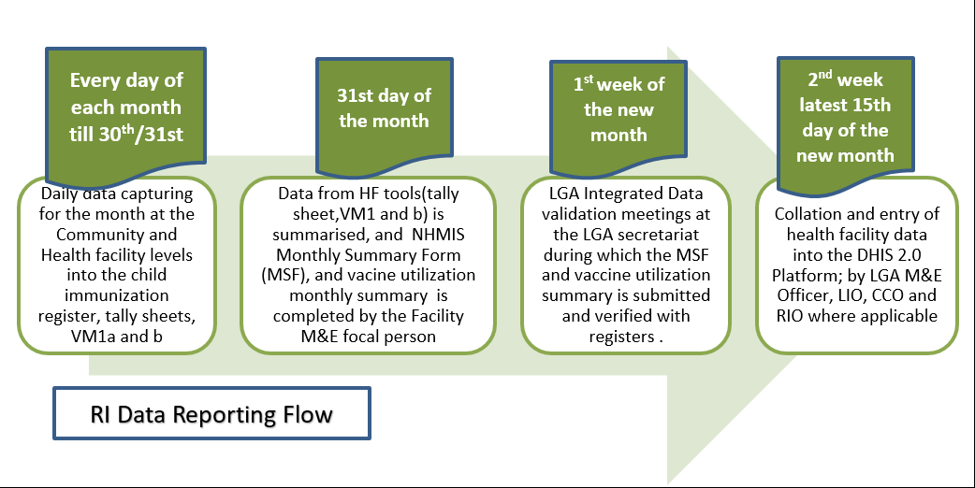
Figure 4 Routine Immunization Data Reporting Flow in Nigeria
Following the scale-up of the DHIS2 RI module in some states, timeliness, and completeness of reporting on DHIS2 platform have also improved from 59% and 70% in December 2016 to 76% and 81% in 2018 (See figure 5 below). The target is to achieve above 95% timeliness and completeness of DHIS2 reporting by 2019/2020.
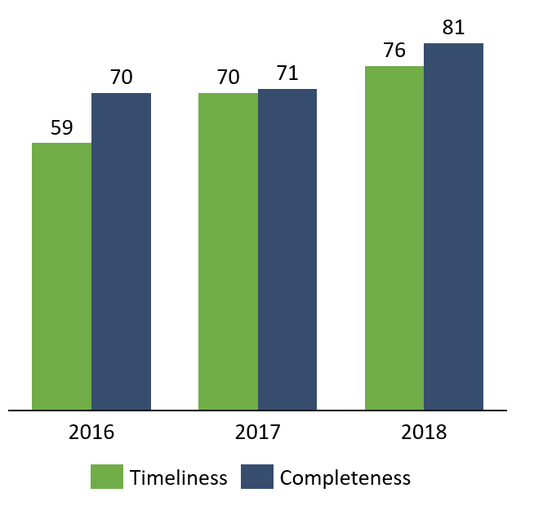
Figure 5 Progress of DHIS Reporting Rate in Nigeria, 2014 – 2016
Despite these programmatic enhancements, vaccine coverage shows a mixed picture. The 2016 MICS/NICS national Penta 3 coverage of 33% differs significantly from the 96% administrative coverage rate reported in 2015. This brought to light the discordance between qualitative assessments of program performance and quantitative evidence of coverage gains.

Recognizing Routine Immunization Data Quality as a Challenge in Nigeria
The quality of data arising from the routine immunization system (administrative/admin data) has been a long-standing concern of the government and partners. Household surveys like the National Immunization Coverage Survey (NICS), Multiple Indicator Cluster Survey (MICS), Demographic and Health Surveys, or the SMART surveys are regarded as the gold standard for immunization coverage estimates.
It is common to see administrative coverage rates of 100% or more reported by states or LGAs while outbreaks of vaccine-preventable diseases (VPDs) occur. Similarly, a wide gap between admin and survey coverage has been observed indicating poor quality data as evidenced by available data. In 2017 for instance, the national administrative coverage for Penta 3 was reported as 96%, while the 2018 SMART survey estimated Penta-3 coverage as 57%. The SMART survey looked at the same cohort of children born in 2014, which was also reported on DHIS as 84% as seen in figure 6 below.
The immunization coverage estimate comprises of a numerator (number of children vaccinated) and a denominator (target population of children eligible for vaccination). Errors in coverage rates have been noted to arise from a numerator error (wilful manipulation of figures or unintended errors); or from a denominator error (faulty estimation of the target population). Factors responsible for numerator errors include; a low capacity for data entry, high workload, target-driven falsifications, and healthcare worker behavior amongst other causes.

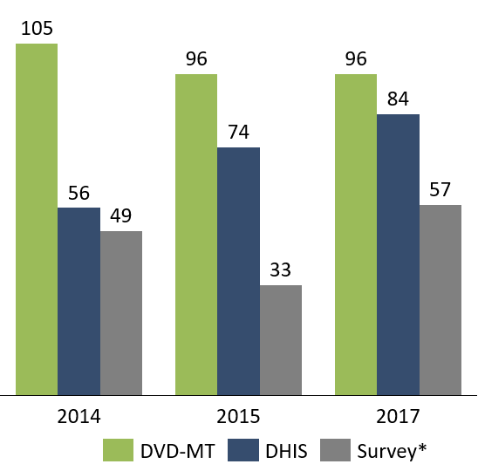
Figure 6 Comparison of Penta 3 coverage between admin (DVD-MT, DHIS) and Survey Data
This gap is magnified at the sub-national data level. On average, there is a 27 point percentage difference between Penta 3 coverage SMART survey results and DHIS2 results across the country, highlighting data quality issues. Only eight states have a variance of less than or equal to 10%: Anambra, Cross River, Delta, Ebonyi, Ekiti, Imo, Osun and Rivers. While Penta3 coverage from DHIS2 is higher than SMART 2018 in 78% (29) of all states. Northern states have larger admin/survey gaps, suggesting a systematic bias (see Figure 7). In addition, denominator issues are more severe in the North than the South.
The NDHS 2003-2013 reports also revealed lower coverage in Northern states compared to Southern states. In 2013, a DPT3 coverage of 65.5% and 13.9% were reported in the South West and North West zones respectively (see figure 8, page 10). Immunization coverage is also higher in urban areas compared to rural areas. There is also an observed disparity between the DPT3 and measles immunization coverage across the country. The continued outbreaks of measles despite high administrative coverage of above 100% further point to the gaps in data quality.
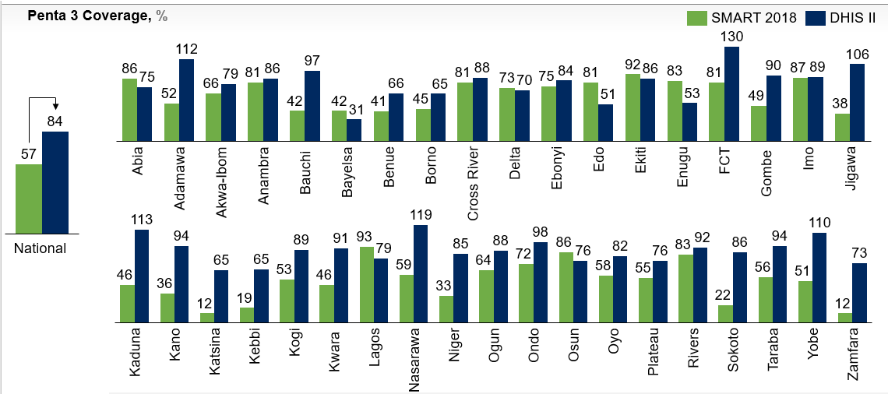
Figure 7 Comparison of Penta 3 coverage from different data sources (DHIS2 vs SMART 2018) in Nigeria
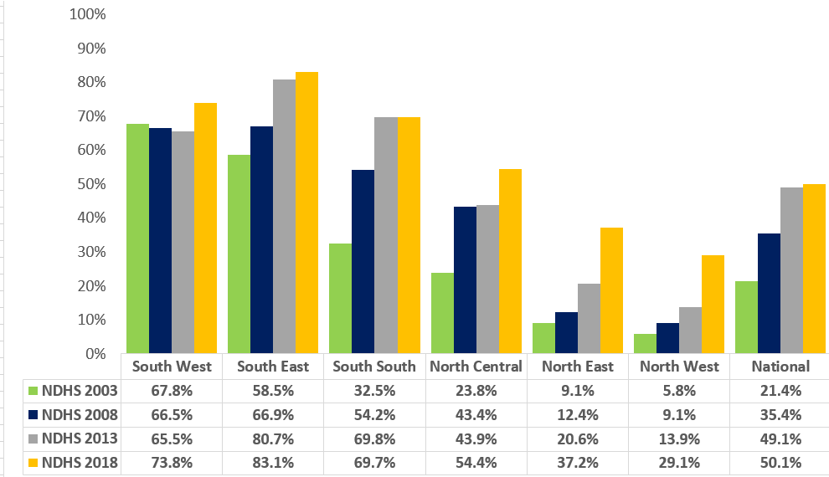
Figure 8 NDHS Penta 3 antigen coverage zones (2003, 2008, 2013 and 2018)

These disparities between the administrative and survey data sources could be attributed to the quality of immunization data at LGA and HF levels, which remains a challenge. However, we also acknowledge the differences in the methodology used for both including different sample size; periodicity (admin is more regular, SMART annually, DHS – every 5 years); use of Enumerators for surveys; and reliance on effective communication between enumerators and communities.

Challenges with the Denominator: The target population (denominator) currently used in Nigeria is extrapolated from the 2006 national census figures, using a growth rate for each state and LGA provided by the Nigerian National Statistics Bureau. Doubts, however, surround the accuracy of the 2006 census figures as conflicting interests skewed the census. Additionally, these total coverage figures do not take into account domestic Nigerian inter-state and intra-state migration, which have a significant impact on the population of certain communities. For instance, Suleja LGA in Niger state; and Keffi and Karu LGAs in Nasarawa state have seen a high in-migration of people over the last few years due to the proximity of these LGAs to Abuja, yet their growth rates have been pegged at 3.4% for Niger and 3% for Nasarawa state (while LGAs in FCT are at an average of 9.3%).
Taking into account that the target population rates (denominators) are based on the 2006 census data and established population growth rates of 3.2 %; it is hoped that more accurate data on the immunization reach of the target population will be achieved with the conduct of a national census. In the interim, NPHCDA will support the Pilot GIS mapping of the population in selected states to improve quality of RI micro-planning census and collaborate with National Population Council (NPC) to improve civil birth registration and vital statistics.
The findings from Pentavalent vaccine Post Introduction Evaluation (PIE) showed that only 36% of HFs recorded prior doses of Penta 3 in registers, and only 56% reported updating registers with information from a child’s immunization card. Furthermore, only 48% of local immunization officers (LIOs) could explain anomalies in monitoring charts at their sites. Thus, the likelihood of discrepancies when compared with survey reports is high.
The large disparity between the RI administrative and survey coverage estimates has been a long-standing concern of the NPHCDA and RI partners, because of the increased program effort in the last two years and the uncertainty of what the actual coverage is. This is attributable to inaccurate denominator leads to over and under-reporting across the country which, in turn, leads to an inaccurate understanding of coverage and vaccine procurement needs. Therefore, there is an urgent need to coordinate a meaningful integration of EPI data within the HMIS (e.g. DHIS2) that would consider coverage, stock and surveillance data for the long-term integration.

Factors Affecting Routine Immunization Data Quality in Nigeria
Routine immunization data quality issues can potentially arise from three areas: technical determinants, organization determinants and behavioural determinants (Refer figure 12 below)
Figure 9 Framework on data quality and use of information for decision making
Adapted from Health Policy Plan. 2009 May; 24(3): 217–228

Figure 10 Determinants of Data Quality
Organizational Determinants
In July 2017, a declaration was made by NPHCDA to establish the NERICC, a national coordinating body that mandated to develop and implement strategies that would strengthen routine immunization coverage levels across Nigeria. Since the advent of NERICC, data quality improvement has been prioritized as an area of improvement, particularly in 18 priority states. Organizational determinants are factors highly influenced by key decision-makers at the national and state levels. The way in which decision-makers’ value RI data and the use of data for action is visibly demonstrated in their commitment and support for proliferating an information-based culture. This can be defined as “the capacity and control to promote values and beliefs among health care workers for collection, analysis, and use of quality data to improve RI performance.” Data quality issues arise due to the following:
- Inadequate number of qualified healthcare workers resulting in an increased burden of healthcare workers for upward reporting
- Weak management and coordination roles by supervisors result in poorly supervised RI health workforce with little attention to data quality.
- Irregular supportive supervision visits to lower levels due to insufficient funding
- The perceived value of immunization program by decision-makers resulting in deprioritization of availing resources (financial and non-financial) for immunization

Behavioural Determinants
Due to the labor-intensive nature of immunization service delivery, RI data quality is co-dependent on the attitude, motivation, and capacity of health care workers. Due to the constant change in healthcare workers’ environs, they are required to adopt individual practices to satisfy both personal and program objectives. Consequently, the design of human-centered interventions to improve data quality remains challenging. Delayed remittance of healthcare worker’s salary and poor working conditions are attributed to suboptimal reporting, poor data capturing and delayed/incomplete submission of immunization data from the HFs/LGAs. In some primary health facilities, shortage of RI staff impact on data quality due to an overwhelming workload especially on immunization days. A deep dive field assessment conducted in October 2016 revealed inconsistencies in the data reported at each level with deliberate alterations of data observed in some sites. Further studies on the drivers of data falsification are required to design interventions for corrective action. However, some of the issues which trigger data falsification include:
- Deliberate inflation of vaccination data by RI service providers facilitated by set health facility immunization target. In turn, this promotes a culture of over-reporting in deference to accuracy.
- Political inference at the sub-national levels resulting in the coercion of HCWs to under/over-report.
- Poor data capture practices
  - Use of only one data tool in capturing vaccination record (for convenience) with the consequent disparity in reported data across health facility tool

Technical Determinants
Factors such as data collection tool design, development of indicators and procedural guidelines for data processing and analysis has a major impact on RI data quality. If RI data tools are complex for data to be computed, and indicators are redundant, this will also undermine the confidence and motivation of healthcare workers to collect data. As a result, the data available will be prone to inaccuracy and incompleteness. This, in turn, will not provide EPI managers meaningful findings for decision making further affecting data use for action. While the government at all levels is responsible for prioritizing data collection and its analysis, the use of data for decision making is weakest at the lower levels. Challenges that arise with data tools fall into five categories:
- Lack of availability of paper tools (53% of state reported required data tool were not available) as seen in Figure 11 below;
- The multiplicity of tools from different partner programs in the countries (and some of these tools have overlapping functions);
- Inefficient design of the paper tools leading to the need for multiple tools and a larger burden on healthcare workers.
- Limited relevant training and/or misalignment of training curriculum and the data management functions performed by health care workers.
- Lack of required infrastructure and poor access to the Internet to submit non-paper-based tools.
- Low user-friendliness of paper tools.
- Low knowledge of the use of tools, both paper and electronic. Contributing to these are:
  - Poor practices for data entry; and
  - Poor understanding of basic analytics (i.e. coverage calculation) and data interpretation including data triangulation.
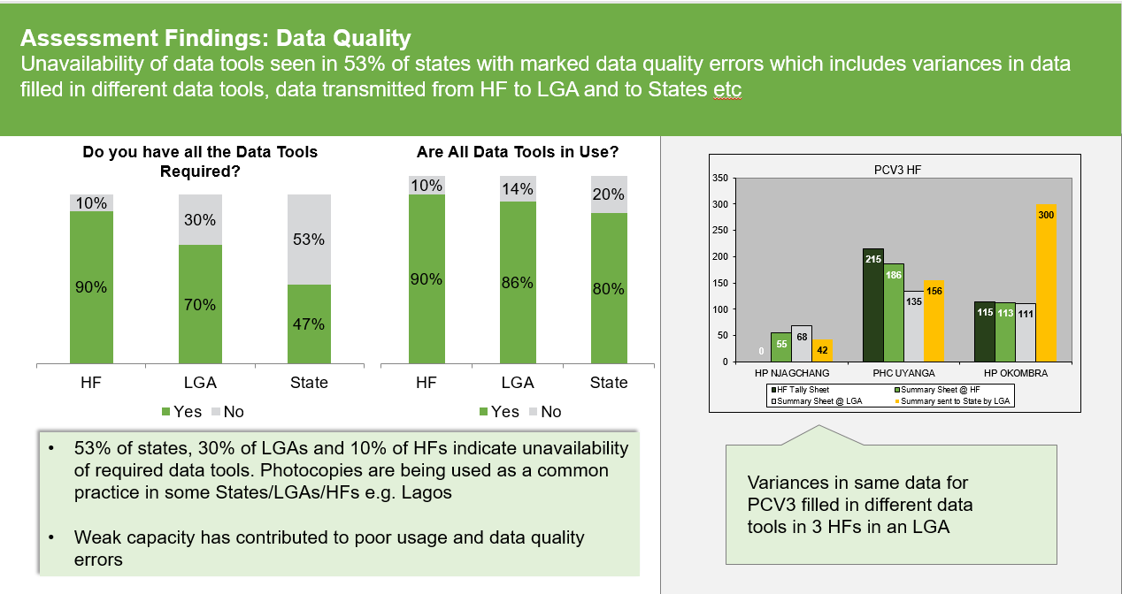
Figure 11 Unavailability of required data tools seen in 53% of states (n=15)
Source: 2: PCV Deep Dive Assessments, Nov 2016

Outside Barriers that Might be Affecting RI Data Quality in Nigeria
All environmental factors that affect the general immunization system would also affect the data quality in the country. Other specific outside barriers that would affect data quality in the country include:
- Insecurity in some parts of the country: Due to the limited access to such areas, the quality of RI service delivery and supportive supervisory visits are not optimal, which further undermine the quality of data transmitted from such localities.
- Health workers strike: Implementation of activities are suspended during strikes; and when the health workers resume there are reported cases of falsification of data at the HF, or LGA or State level to meet up with targets.
- Lack of enforcement of accountability measures: Usually the culpable officers are not punished for malpractice even when the cases are proven.

SWOT Analysis
Strengths | Weaknesses
- Availability of staff responsible for data management (M&E officers) at States and LGA  - Existence of a coordinated Health Management Information system – DHIS2  - Availability of agreed harmonized RI data collection tools, namely: forms, registers, tally sheets, Summary sheets, databases (DHIS), etc.  - Availability of a web-based real-time database in DHIS2 for periodic data collection and reporting across all States.  - Regular monthly RI review meetings conducted for feedback at State and LGA levels  - Annual HDPU forum and quarterly HDCC meetings.  - Availability of HMIS tools for reporting all health facilities  - Use of ODK for RISS data management at all levels  - Availability of routine data for making informed decisions | - High attrition of health workers  - Data quality still poor nationwide (e.g. RI administrative data very high compared to survey data; DHIS completeness and timeliness of reporting are 75.5% and 66.3% respectively for the year 2018.  - Irregular conduct of data validation meetings and national DQAs.  - Denominator issues: Varying target populations for RI and campaigns in the same population, most times making planning and reporting difficult  - Inadequate data entry personnel at health facilities  - Inadequate revised data collection tools at LGAs and HFs (especially private HFs)  - Inoperative community HMIS  - Dependency on partners for the monthly RI review and feedback systems at the State and LGA levels.  - The inadequate government-led supportive supervision (SS) especially at the subnational levels  - Suboptimal feedback from the States to LGAs; and LGAs to the health facilities  - Lack of implementation of the accountability framework  - The poor motivation of health workers  - Falsification of reported data  - Stock out of data tools  - Inadequate capacity to manage data at State and LGA levels  - Existence of parallel data collation platforms in some states
Opportunities | Threats
- Availability of DHIS2 RI module to re-orient staff on data management  - Leveraging on RI meetings to re-orient staff on data management  - Real-time RI SMS reporting ensures immediate use of data for action  - Collaboration with NBS during surveys for improved reporting  - Collaboration with NPopC for birth registration and determination of appropriate denominator  - The willingness of Partners to support the government to improve data quality and provide TA  - Inclusion/integration of DQIP into the national HMIS plan  - Institutionalize Health data management courses e.g. NHMIS/DHIS at schools of health technology and nursing | - Nonavailability of the network for electronic reporting in some areas  - Non-payment of health workers resulting in a strike  - Insecurity in some parts of the country  - Inadequate political commitment to support RI quality data  - Resources limitations  - Poor data management orientation for health workers

Current Efforts to Address RI Data Quality Issues in Nigeria
The country’s response to the data quality is beginning to yield positive results, though the results are yet to be optimal. A few routine processes are in place to assess the quality of immunization data and improve quality across all reporting levels for routine immunization. While these activities have contributed to the detection of data quality gaps, the lag in the implementation of several recommended actions still hinders the achievement of optimal data quality. Some of the activities included:
Efforts to Address Organizational Determinants
Monthly Data Validation Meeting: In each LGA, a monthly M&E validation meeting is convened by the LGA M&E officer in the first week of each month for the purpose of collecting MSF’s from each facility. These meetings are to be chaired by the Medical Officer of Health (MOH) or PHC Coordinator. Facility M&E focal persons attend these meetings and are expected to submit the full range of required MSF’s based on services delivered at their health facility. Copies of the MSFs are kept in duplicate and one copy should always remain appropriately filed at the Health facility. Validation exercises are undertaken prior to and during this meeting to ensure that the data submitted on MSF’s is an accurate reflection of services delivered and activities undertaken in the facilities. Funding has been a major challenge in ensuring validation meetings held regularly at the LGAs

Monthly Review Meeting: The review meetings, conducted at State and LGA levels monthly has been an opportunity to discuss RI performance using all RI indicators including completeness and timeliness of reporting. The meeting is very important as LGAs leverage on it to conduct data validation, give feedback, track performance issues and build the capacity of health workers. State-level meetings are consistent however LGA level meetings are quite irregular and consistency in addressing data issues remain varied due to funding. At the LGA meeting, all RI providers from HF within the LGA are present to review their monthly submission and how it contributes to LGA overall performance. RI focal person can get feedback on how to prevent errors in future data submissions. While these meetings have contributed to strengthening routine immunization data use to varying degrees, the optimal situation is yet to be achieved. Current efforts are aimed at ensuring that these meetings are consistently conducted and address prevailing data management issues.

Intensified Routine Immunization Supportive Supervision (RISS): This process promotes the sustainable management and efficient use of resources by encouraging communication, as well as planning and monitoring results. It assists health workers to improve their skills and increase their performance in the provision of quality services, it also provides supervisors and supervisees/HW the opportunity to work as a team to meet common goals and objectives, which includes quality data management. Effective RISS is one of the strategic interventions of the Optimized Integrated Routine Immunization Session (OIRIS), an approach that aims at revamping RI coverage, data quality inclusive. The intensified Routine Immunization Supportive Supervision (RISS), happens from the national to the states, states to the LGAs and LGAs to the health facilities. During such visits, issues on data quality are addressed and on-the-job mentoring provided to RI data officers at health facility levels. Information on RISS are reported real-time on the ODK platform for effective follow up on issues highlighted and this is being analysed weekly and monthly at all levels for appropriate urgent actions. On-the-job mentoring was adopted as part of the RISS process to help HW improve their skills on data quality.

Data Quality and Use Supportive Supervision (DQUSS): Some States conduct monthly DQUSS activities at LGAs and health facilities for real-time monitoring of data quality, review, and correction of routine immunization data. It involves sampling LGAs and facilities to review the consistency of reported data on vaccine management and RI data tools at the facility with the LGA level using paper and electronic checklists on ODK. Improvements have been made to the process including the development of a revised ODK checklist.

Efforts to Address Behavioural l Determinants
Accountability Framework Implementation: An accountability framework for routine immunization is in place and has been disseminated to all States. The aim of the accountability frame is to encourage excellence through rewarding good conduct and discouraging poor conduct by providing rewards and sanctions. This also to apply to data issues. Although this is not fully operational across all States, there are examples of a few states that have implemented elements of the framework to reward and sanction health staff. This is expected to yield demonstrated results when applied consistently.

Data Amnesty: Efforts to improve data quality was extended to giving HW amnesty on data falsification. This was done to help HW understand the implication of data falsification and its effect on RI data quality. Each LGA was notified through their LERICC’s on data amnesty while efforts are in place to improve supervision visits which includes data consistency checks at the HF level. Data amnesty was declared for HW in July 2017 for data entered prior to July 2017 after which hailing health workers would be punished when identified.

Elimination of Target Population: To resolve data falsification at health facilities, the use of target population at health facilities was stopped. This was intended to remove external pressures on health workers to falsify data and re-channel their focus to the provision of quality immunization services. Community resource persons have roles to play to support health workers to report accurate data as data from the facility is cross-referenced with line lists of community resource persons. Health workers are monitored during RISS visits to enforce accurate reporting of vaccinated children without the need to compute against target population figures.

Efforts to Address Technical Determinants
Data Quality Assessments (DQA): Nigeria conducts annual national Data Quality Self-Assessments (DQS) for periodic review and correction of routine data. This activity samples health facilities across selected states to check for consistency between the data at the health facility level (immunization tally sheets and monthly reporting forms) and those at the LGA level. Annual DQSs have been conducted for a couple of years, and modifications to improving the process that includes using the immunization register are now adopted. This gives an additional check since the register is the best record of services given, provided health workers are consistent and conscientious with recording all new and returning clients. The register is also difficult to falsify because each entry requires the demographic and contact information of the child and the parents, as well as the types and dates of vaccines received. As part of efforts to enhance the DQAs, for the last few years survey of communities around target facilities have been included to provide further measures to adjust or correct the admin data. Efforts are being instituted to ensure regular conduct of self-assessment and implementation of recommendations thereof to aid improvement in data quality.

DHIS2 scale-up: Recognizing the potential of the DHIS2 to solve the data accessibility problem and possibly address the quality issues, NPHCDA in 2013 launched the routine immunization module with funding support from Gates Foundation and CDC. The project called RI module on the national DHIS2 platform helped to train and equip RI data managers at state and LGA levels on using data for action. The goal was to scale up RI data reporting on the DHIS2 platform and transition out of the DVDMT. Currently, all states and LGAs have been trained and have begun reporting their RI data on the DHIS 2. The national scale-up of the DHIS2 was achieved in December 2017 and on May 2019, letters were sent from the office of the Minister of Health to states declaring DHIS2 as the official reporting platform for RI data. As reporting rates on the DHIS2 continue to rise data quality issues have been emerging and interventions have been designed to address them. Some states continue to have coverage rates greater than 100% due to data entry errors, inaccurate denominator for calculating coverage on the platform, incomplete reporting in some LGA’s due to network challenge, poor attitude of responsible staff towards using the platform for reporting, inaccurate health facility list from most states and poor use of the data to drive action. To address these issues, the country working with partners have attempted to develop realistic denominators using triangulated figures (from census, household enumeration and mostly immunized children), the use of SMS texting as a quick way to identify and address data reporting gaps, received a revised list of health facilities from different states which has been updated on the DHIS2 platform, conduct data quality and use supportive supervision training across states, training designated government staff in each state to monitor and analyse data on the platform monthly to drive data use, develop strategies for ensuring responsible health workers are able to enter data monthly by identifying best network in the LGA and ensuring data is available for entering data amongst other. Even though these efforts are in place, the quality of data on the DHIS2 is yet to be optimal. Efforts need to be intensified to ensure that the quality of data on DHIS2 is improved.

Denominator issue: In response to the recurring concerns about the faulty target populations, in 2015, the ICC set up an inter-sectoral committee. This committee consisting of the NPHCDA, FMOH and the National Population Commission was charged to consider the denominator issue and advice on a way out. The approaches to addressing the denominator issue include the Population estimation using the 2006 census, the GIS mapping and the household enumeration/Walk-through micro-plan. GIS mapping is currently done in all the 36 states and FCT and estimates can be generated up to ward level. Currently, the centre has triangulated the three main sources of the denominator and is being used to guide the programme operation. In additional to the above, a robust community engagement strategy was developed and rollout in 11 out of the 18 NERICC states, the remaining 7 will be completed this year and will successful model in Bayelsa the remaining 20 states will likely adopt the strategy. One of the strategies of CES is to address the denominator issues through line-listing of all the infant in the communities.

Real-time reporting through SMS:

Strategic Interventions to improve RI Data Quality
The focus on strategic interventions are part of a theory of change that believes in identifying and tackling key causes of poor data quality and use of data for action, changing health worker behaviour and creating/strengthening enabling coordination and accountability systems at all levels, as the pathway to overcome existing challenges and lead Nigeria to achieve its immunisation and PHC objectives. This theory of change provided a framework for selecting and prioritizing interventions across RI data management.
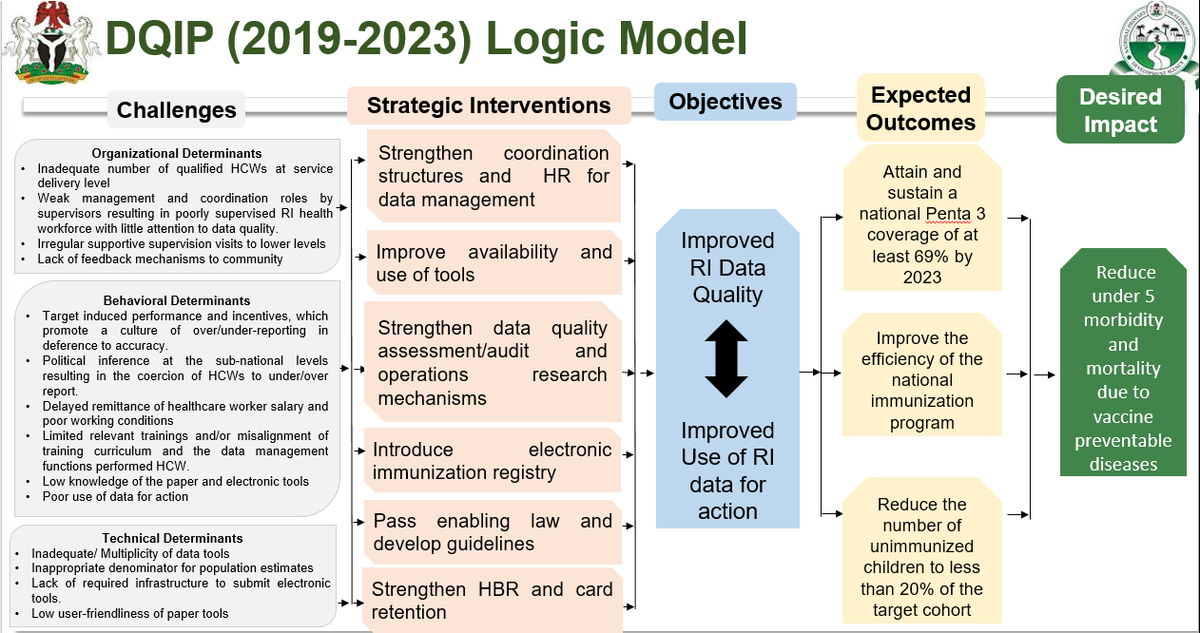

Strengthen coordination structures for data reporting, warehousing, management and use of data for action
Existing coordinating structures at National, state and LGA levels will be strengthened to effectively and efficiently data reporting, warehousing, and management interventions. Existing data/monitoring and evaluation working groups at national and state levels to implement the data quality improvement plan in addition to other functions. At the national level, a biannual data review meeting will be conducted with state RI teams in attendance. Highlights of review meeting will include triangulation of existing data sources and monitoring of disparities between administrative and survey coverage. At the state level, all technical working groups will be part of the monthly data review meetings. Data from all thematic areas will be triangulated and trends identified. To further strengthen the coordinating structure at the LGA level, the NERICC data team will revise and disseminate the SOP on effective conduct of LGA monthly RI review meetings which encapsulates review of RI performance, data validation, capacity building for health workers. In addition, the NPHCDA and partners will facilitate collaboration between the FMoH and the NPopC to improve birth registration and definition of the vaccination coverage rate denominator, by adopting technology for data capture at all levels. Key activities include: Strengthen national (and states) data teams (to facilitate the implementation of the DQIP)
- Conduct National Bi-annual data review meetings with States
- Strengthen data review meetings (to include all TWGs) at the state and LGA levels
- Develop SOPs/guidelines for the conduct of data review meetings at the LGA level

Provide appropriate technologies, equipment and data capturing tools at all levels
An assessment in November 2016 found that paper-based data tools were not available in 19 (53%) of the states and that partners were supporting ad-hoc printing. Current data capture tools are complex – health facility staff fill up to 16 forms for RI activities in a single month often with multiple calculations and transcription errors.
To further improve data reporting, warehousing, and management, computers will be procured for state RI teams while mobile phones will be procured for health facilities. The DHIS2 storage infrastructures and warehouse at the central level will be routinely maintained. List of health facilities offering routine immunization services will be reviewed and updated on DHIS biannually. The reviews will also capture names of newly activated health facilities for the provision of RI services. In addition, NPHCDA will ensure the regular development and revision of EPI data tools based on current practices, strategies, and interventions. Additionally, they will produce and data tools, including tools for home and community – based data capture, field visits, and supervisions. This support will include simplifying and streamlining multiple reporting tools at all levels. In addition, the NPHCDA will undertake the following actions:
- Collaborate with NPoPC to improve birth registration and redefine denominator for Under-1 Population
- Produce and disseminate quarterly bulletins on RI performance to States and LGAs
- Introduce RI data management in pre-service institutions curriculum

Strengthen human resource capacity, management, and organization
Human resource factors inadequate number of health workers, weak capacity of existing human resource in the use of data tools and the DHIS2, poor attitude of health workers and EPI managers towards data collection and the use data for action, collectively impact data quality as a staff is poorly motivated to record accurate data. Findings from the Pentavalent Vaccine Post-Introduction Evaluation (PIE) showed that only 36% of HFs recorded any prior doses of DPT in their new registers, and only 56% reported updating registers with information from a child’s immunization card.²¹ Strategies to address these include:
- Review of job descriptions and terms of references of healthcare workers to ensure necessary skill sets on data science at every level including basic data generation, analysis, interpretation, and use of data for informed decision making
- Training and retraining of frontline health workers on the use of EPI tools for data entry, analysis and decision making.
- Capacity building for EPI managers on the use of the DHIS2 platform, electronic data reporting using SMS or other strategies, use of EPI data tools, data monitoring techniques for RI, use of data for action and monthly supportive supervision.
- The reward for health facilities with the most complete and timely RI reporting through bonuses, certificates, and recognition of high performing healthcare staff.
- Task shifting of health care workers for data management
- Understand the key drivers of healthcare worker behaviour with respect to data falsification at the operational and policy levels for corrective action.
- Collaboration with Youth empowerment schemes to fill human resource gaps such as NPOWER
These approaches to deal decisively with both the numerator and denominator issues will significantly improve the estimation and use of immunization data. In addition, it will provide information to monitor the programme’s progress over time and improve its effectiveness in reaching every child. In the long term, our vision is interoperability between DHIS2, logistics and other relevant data platforms, allowing comprehensive view and advanced analytics of what is really driving immunization coverage in the states of Nigeria.

Improve data quality on DHIS and the use of data for action
Poor data quality, weak data management and non – use of data for action at the operational level, are widely acknowledged problems in the routine immunization system. A key intervention to address many of the data quality issues at the health facility level is the introduction of electronic data capture and reporting using the DHIS2 platform. The country had finalized the rollout of the electronic data capturing using the SMS real-time reporting platform and other strategies 18 NERICC priority states. Based on the lessons learned from the NERICC priority states, the plan is to scale up across remain states and FCT in the upcoming years. This will provide an additional form of data reporting that can be compared with those reported on the DHIS2 platform.
Other activities proposed to improve data timeliness and completeness are:
- Continuous update of the master list of health facilities on the DHIS2 platform.
- Continuous development and implementation of interactive dashboards and scorecards for each level, using DHIS2 data.
- Monthly triangulation of immunization data with vaccine utilization and disease surveillance data.
- Production and dissemination of quarterly bulletins on RI performance to States and LGAs, using data from the DHIS2.
- MoU on data accountability to be negotiated between the states’ ministries of health and partners since many of the data entry errors happen at the HF level and LGA level.
- Clear communication with HF workers on the importance of data accuracy over coverage targets, with emphasis on the accountability measures for data falsification. This may involve some degree of refresher training, which can be combined with the OIRIS.
- Additional capacity building of LGA staff on the use of DHIS2 platform for more detailed analysis and data triangulation.
- Supportive supervision focused specifically on data quality, with the incorporation of ODK- enabled community surveys to assess vaccination coverage and identify bottlenecks for the catchment areas.

Pass enabling law and develop guidelines
Manipulation of data by health workers and lack of enforcement of accountability measures at all levels is a big challenge. The NPHCDA will work to review the National Immunisation Policy to incorporate regulations on data falsification. This will be printed and circulated to all stakeholders. There will also be the establishment of an accountability mechanism with clear reward and sanction measures from national to health facility levels, to help to address data quality issues in the country. Key strategies include:
- Revise and monitor the implementation of the National Immunization Policy to include appropriate rules and regulations on data falsifications (ensure communication of data falsification). Levering various platforms to ensure continued apt messaging to the healthcare workers on the need to report an actual number of children immunized to eliminate data falsification.
- Support States to implement culturally appropriate accountability mechanisms (reward and sanctions around data quality.

Determine appropriate population estimates that address denominator issues across all states and FCT
The target population (denominator) currently used in Nigeria is extrapolated from the 2006 national census figures, using a growth rate for each state and LGA provided by the Nigerian National Statistics Bureau. However, the accuracy of these estimates is in doubt as they do not account for inter and intra-state migration, which have significantly impacted the size of populations in certain communities. Getting an accurate denominator for estimation of immunization coverage is a global issue but particularly severe in Nigeria going by the high number of states that in the last two to three years have reported over hundred percentage immunization coverages. In addition, conducting a well-designed small-scale enumeration in a few LGAs will help provide an additional reference point for micro plans and GIS estimate data. The country plans to continuously update GIS population estimates in all the states and FCT and conduct the walk-through micro-planning (household enumeration) every 3-5 years to address denominator issues.

Strengthen data quality audit, assurance, and assessment mechanisms
The quality of routine immunization administrative data has been a long-standing concern of the government and partners. In Nigeria, errors from coverage rates could arise from numerator factors such as manipulation of figures or data entry; or due to denominator factors such as the wrong estimation of the target population. The wide variation between administrative and survey data reflects these data quality issues. Intervals between surveys are often long drawn and inconsistent and there is the challenge of comparing coverage from studies with different methodologies. Surveys that currently provide immunization coverage include NDHS, NICS, MICS, and SMART. In the last decade, no single survey type has been conducted more than twice. The last MICS/NICS which provided baseline data for this strategy was conducted 2 years ago so changes to the programme and coverage since they could only be modelled based on assumptions. Nigeria plans to conduct an annual evaluation of the status of implementation of the country DQIP to ensure that all the proposed strategies are being resourced and implemented
Strategies to resolve these include:
- Annual coverage surveys with a methodology that is acceptable to government and partners. The plan is to use either an existing survey such as SMART – which is relatively cheaper than the other surveys – but expand its scope to meet the annual immunization information needs or create a new survey that can be conducted annually. A joint committee of NPHCDA and partners was set up to review the needs of the immunization programme, methodologies of existing studies and recommended a preferred option for the annual survey.
- The MICS/NICS will be conducted every three years, to provide much more details.
- Conduct of sero-surveillance to ascertain the true immunization status of children especially in environments where immunization coverages are low.
- Quarterly implementation of the RI Lot Quality Assurance Sampling (LQAS) to monitor performance across selected LGAs and states. The first RI-LQAS has been successfully conducted in 18 low performing states. Plans are underway to conduct the RI – LQAS in all the states before the end of 2018.
- Providing supervision and data audit support to the lower levels of the healthcare system to improve the accuracy of the data recorded. This process includes leading Data Quality Surveys (DQS) and Data Quality Assessments (DQA) on a regular basis. A recent intervention is the revision of DQS/DQA procedures to include the use of child registers at the health facility level, to reduce the discrepancies between the registers and tally sheets.
- Using data quality review meetings to build interest and capacity in the use of the data and supporting NERICC and SERICCs to better structure their discussions and indicator review processes around using RI data.

Strengthen feedback and validation mechanisms to follow up on identified data quality issues
The 2016 NICS/MICS survey results revealed that only Lagos state had RI coverage >80%. 16 states had coverages between 50-79.9% while 19 states had coverages <50%. This revealed huge gaps in service delivery, demand generation and data management masked by administrative coverage which was higher than the survey figures. To address these issues and guide quality programmatic decision making at the state, LGA and health facility level, a program assessment was instituted which seeks to:
- Periodically gauge the performance of RI implementation in identified communities
- Identify drivers of good and poor performance
- Guide EPI managers and health workers to deploy targeted interventions to address identified gaps within the RI system
- Monitor the dissemination of routine feedback to all levels on data quality issues
PAPA (Program Assessment for Action) is a systemic approach to addressing program challenges through data monitoring for action. PAPA comprises of five principal components:
- Conduct of Survey - Measurement of program indicators e.g. RI, MNCH, etc
- Data Analysis - Analysis of elements that enhance or affect program i.e appropriately immunized for age, HF delivery; data triangulation (including post-survey data triangulation)
- Data Dissemination - Dissemination to policymakers, health, and traditional systems
- Deployment of Interventions - Post-assessment action plan; Deep dive visits; Identification of best practices; Peer learning
- Monitoring of Interventions - Tracking of implementation of developed action plans; Performance appraisal
The findings will stimulate action with both the State/LGAs showing consistently poor results, and the stronger State/LGAs as potential peer learning opportunities.

Strengthen home-based records and card retention at the community levels
Although there have not been national level stock-outs of the Home-based record, there have been subnational stock-outs across states. In some cases, the stock-outs occurred over the course of multiple years. Regardless of the locality of occurrence, stock-outs are a problem. Home-based record stock-outs may affect the continuity of care, quality of RI services delivery and demand generation, resulting in high drop-outs and low coverage. Strategies to address this include:
- Revision of the child health card that can be used for by the child for 5 years
- Forecasting, printing, distribution, and placement of the HBRs in all the states
- Design, produce and distribute child health card pouches for caregivers and community leaders
- Use of LGA RI review meetings and vaccine delivery vendors to monitor stock balances of HBRs and replenish where necessary

To introduce electronic vaccine registry to capture individual immunization record
Many deliveries are not recorded in the birth registries especially in areas with a high rate of home deliveries, which is where low immunization coverages are predominant. Furthermore, the current paper-based child immunization registration and tally contributes to the data quality problems. Electronic immunization recording is a strategy that can help in tracking children from birth to the point of immunization completion and more. Since the country has adopted the DHIS2, the electronic vaccine registry can be deployed on the tracker module to assign a unique ID to each child delivered, register him/her immediately, and track to ensure that the vaccination schedule is completed. The system with its unique ID will also allow for updating a child’s record irrespective of the service delivery point in the country where the child is vaccinated. Nigeria plans to introduce electronic immunization registry. It has been implemented in many countries Nigeria will commence introduction after a team of experts have reviewed the existing Electronic Immunisation Records (EIR) module in various settings and recommend suitable solutions for Nigeria. The EIR technology will be piloted in two to three states before it is scaled up to other states.

Six Month Action Plan
Pursuant with the declaration of the State of Public Health Concern on Routine Immunization program based on the 2016 MICS/NICS, NPHCDA (in collaboration with Partners) identified high impact data quality interventions to deploy within the first six months of implementing the DQIP. These quick win interventions are highlighted in the table below:
S/N | Activity | Task | Timeline |  |  |  |  |  |  |  |  |  |  |  |  |  |  |  |  |  |  |  |  |  |  |  |  |  |  |  | Level | R. Person
 |  |  | Jul-19 |  |  | Aug-19 |  |  |  | Sep-19 |  |  |  | Oct-19 |  |  |  | Nov-19 |  |  |  |  | Dec-19 |  |  |  | Jan-20
 |  |  | Wk  3 | Wk  4 | Wk  5 | Wk  1 | Wk  2 | Wk  3 | Wk  4 | Wk  1 | Wk  2 | Wk  3 | Wk  4 | Wk  1 | Wk  2 | Wk  3 | Wk  4 | Wk  1 | Wk  2 |  | Wk  3 | Wk  4 | Wk  1 | Wk  2 | Wk  3 | Wk  4 | Wk  1 | Wk  2 | Wk  3 | Wk  4
1 | Enforce accountability measures among healthcare workers on RI data management | Define sanctions and rewards mechanisms |  |  |  |  |  |  |  |  |  |  |  |  |  |  |  |  |  |  |  |  |  |  |  |  |  |  |  |  | National | NERICC Data Team/ DPRS
2 |  | Define process indicators and validation mechanisms to ensure compliance |  |  |  |  |  |  |  |  |  |  |  |  |  |  |  |  |  |  |  |  |  |  |  |  |  |  |  |  | National | NERICC Data Team
3 |  | Re-orient State teams on AF leveraging recurrent OIRIS visits |  |  |  |  |  |  |  |  |  |  |  |  |  |  |  |  |  |  |  |  |  |  |  |  |  |  |  |  | State | NERICC Data Team/ DPRS
4 |  | Re-orient State teams on AF leveraging MCV2 State level and LGA cascade training |  |  |  |  |  |  |  |  |  |  |  |  |  |  |  |  |  |  |  |  |  |  |  |  |  |  |  |  | National, State and LGA | NERICC Data Team/ DPRS
5 |  | Develop a dashboard to monitor set indicators |  |  |  |  |  |  |  |  |  |  |  |  |  |  |  |  |  |  |  |  |  |  |  |  |  |  |  |  | National | NERICC Data Team
6 |  | Leverage on other planned NPHCDA (i.e. NERICC, PRS, etc.) activities to provide feedback to key stakeholders on state performance¹ |  |  |  |  |  |  |  |  |  |  |  |  |  |  |  |  |  |  |  |  |  |  |  |  |  |  |  |  | National and State | PM NERICC/ Head of PRS
7 |  | Evaluate the effectiveness of the AF system |  |  |  |  |  |  |  |  |  |  |  |  |  |  |  |  |  |  |  |  |  |  |  |  |  |  |  |  | National, State,LGA and HF | NERICC Data Team/ DPRS

S/N | Activity | Task | Timeline |  |  |  |  |  |  |  |  |  |  |  |  |  |  |  |  |  |  |  |  |  |  |  |  |  |  |  | Level |  | R. Person
 |  |  | Jul-19 |  |  | Aug-19 |  |  |  | Sep-19 |  |  |  | Oct-19 |  |  |  | Nov-19 |  |  |  | Dec-19 |  |  |  | Jan-20
 |  |  | Wk  3 | Wk  4 | Wk  5 | Wk  1 | Wk  2 | Wk  3 | Wk  4 | Wk  1 | Wk  2 | Wk  3 | Wk  4 | Wk  1 | Wk  2 | Wk  3 | Wk  4 | Wk  1 | Wk  2 | Wk  3 | Wk  4 | Wk  1 | Wk  2 | Wk  3 | Wk  4 | Wk  1 | Wk  2 | Wk  3 | Wk  4
8 | Enhance conduct of supportive supervision and on-the-job mentoring | Routine dissemination of RISS feedback during State and LGA RI review meetings |  |  |  |  |  |  |  |  |  |  |  |  |  |  |  |  |  |  |  |  |  |  |  |  |  |  |  | National, State and LGA |  | NERICC Data Team
 |  | Strengthen DQA component of RISS checklist |  |  |  |  |  |  |  |  |  |  |  |  |  |  |  |  |  |  |  |  |  |  |  |  |  |  |  | National |  | NERICC Data Team
9
 |  | Ensure states and LGAs use revised ODK for RISS |  |  |  |  |  |  |  |  |  |  |  |  |  |  |  |  |  |  |  |  |  |  |  |  |  |  |  | National and State |  | PM NERICC/  Head of PRS
10

S/N | Activity | Task | Timeline |  |  |  |  |  |  |  |  |  |  |  |  |  |  |  |  |  |  |  |  |  |  |  |  |  |  |  |  | Level |  | R. Person
 |  |  | Jul-19 |  |  | Aug-19 |  |  |  | Sep-19 |  |  |  |  | Oct-19 |  |  |  | Nov-19 |  |  |  | Dec-19 |  |  |  | Jan-20
 |  |  | Wk  3 | Wk  4 | Wk  5 | Wk  1 | Wk  2 | Wk  3 | Wk  4 | Wk  1 | Wk  2 | Wk  3 | Wk  4 | Wk  1 |  | Wk  2 | Wk  3 | Wk  4 | Wk  1 | Wk  2 | Wk  3 | Wk  4 | Wk  1 | Wk  2 | Wk  3 | Wk  4 | Wk  1 | Wk  2 | Wk  3 | Wk  4
8 | Enhance conduct of supportive supervision and on-the-job mentoring | Routine dissemination of RISS feedback during State and LGA RI review meetings |  |  |  |  |  |  |  |  |  |  |  |  |  |  |  |  |  |  |  |  |  |  |  |  |  |  |  |  | National, State and LGA |  | NERICC Data Team
 |  | Strengthen DQA component of RISS checklist |  |  |  |  |  |  |  |  |  |  |  |  |  |  |  |  |  |  |  |  |  |  |  |  |  |  |  |  | National |  | NERICC Data Team
9
 |  | Ensure states and LGAs use revised ODK for RISS |  |  |  |  |  |  |  |  |  |  |  |  |  |  |  |  |  |  |  |  |  |  |  |  |  |  |  |  | National and State |  | NERICC Data Team
10

S/N | Activity | Task | Timeline |  |  |  |  |  |  |  |  |  |  |  |  |  |  |  |  |  |  |  |  |  |  |  |  |  |  | Level | R. Person
 |  |  | Jul-19 |  |  | Aug-19 |  |  |  | Sep-19 |  |  |  | Oct-19 |  |  |  | Nov-19 |  |  |  | Dec-19 |  |  |  | Jan-20
 |  |  | Wk  3 | Wk 4 | Wk 5 | Wk 1 | Wk 2 | Wk 3 | Wk 4 | Wk 1 | Wk 2 | Wk 3 | Wk 4 | Wk 1 | Wk 2 | Wk 3 | Wk 4 | Wk 1 | Wk 2 | Wk 3 | Wk 4 | Wk 1 | Wk 2 | Wk 3 | Wk 4 | Wk 1 | Wk 2 | Wk  3 | Wk  4
14 | Strengthen conduct of monthly RI review and validation meetings at LGA level | Develop national SOPs for the conduct of monthly LGA RI review and ward/LGA validation meetings – |  |  |  |  |  |  |  |  |  |  |  |  |  |  |  |  |  |  |  |  |  |  |  |  |  |  |  | National | NERICC Data Team
15 |  | Disseminate SOPs to states and LGAs |  |  |  |  |  |  |  |  |  |  |  |  |  |  |  |  |  |  |  |  |  |  |  |  |  |  |  | National, State, and LGAs | PM NERICC/ Head of PRS
16 |  | Monitor implementation of the conduct and quality of RI review and validation meetings |  |  |  |  |  |  |  |  |  |  |  |  |  |  |  |  |  |  |  |  |  |  |  |  |  |  |  | National, State and LGAs | NERICC Data Team

Timeline
Strategies | Key Activities | 2019 | 2020 | 2021 | 2022 | 2023
1 Strengthen coordination structures for data reporting, warehousing, management and use of data for action | 1.1 Strengthen national (and states) data teams (to facilitate the implementation of the DQIP)
 | 1.2 Conduct National Bi-annual data review meetings with States
 | 1.3 Strengthen data review meetings (to include all TWGs) at the state and LGA levels
 | 1.4 Develop SOPs/guidelines for the conduct of data review meetings at the LGA level
2 Provide appropriate technologies, equipment and data capturing tools at all levels | 2.1 Procure computers and in-focus equipment for SERICC/RIWG to support data-related activities
 | 2.2 Procure mobile phones for electronic (SMS) data reporting from health facilities
 | 2.3 Strengthen DHIS storage infrastructures and warehousing (Conduct annual reviews and updates of DHIS storage infrastructure and warehousing)
 | 2.4 Conduct 2-yearly reviews of EPI data tools including supervisory checklists
 | 2.5 Coordinate the production and distribution of appropriate EPI data tools to States, LGAs and HFs
 | 2.6 Collaborate with NPoPC to improve birth registration and redefine denominator for Under-1 Population
 | 2.7 Produce and disseminate quarterly bulletins on RI performance to States and LGAs
 | 2.8 Introduce RI data management in pre-service institutions curriculum
3 Strengthen human resource capacity, management, and organization | 3.1 Facilitate States to implement task Shifting of data management for health workers as required
 | 3.2 Collaborate with Youth empowerment schemes e.g. NPOWER to fill HR gaps relating to data management.
 | 3.3 Conduct training needs an assessment on data management and quality for health care workers
 | 3.4 Training and retraining of frontline health workers and managers on the use of mobile devices, data tools, monitoring techniques, use of data for action(s), etc.
 | 3.5 Develop annual capacity building plan on data management and ensuring data quality for health workers
 | 3.6 Conduct training on data management and quality assurance for state M&E officers and representatives
 | 3.7 Conduct monthly supportive supervision visits to HFs focusing on improving the quality of generated and collated data using ODK supervision checklists
 | 3.8 Review TORs of M&E officers and data officers to include basic data generation, analysis, interpretation, and use of data for action
4 Improve data quality on DHIS and the use of data for action | 4.1 Develop and implement interactive dashboards and scorecards for each level using DHIS data
 | 4.2 Biannual updates and integration of states' master list of health facilities on DHIS 2
 | 4.3 Provide routine feedback to states on data entry performance (completeness and timeliness of reporting) at all levels
 | 4.4 Strengthen the conduct of data validation meetings at the LGA level
 | 4.5 Strengthen and ensure the conduct of Joint LIO and M&E review meetings at the State Level
5 Pass enabling laws and develop appropriate guidelines | 5.1 Revise and monitor the implementation of the National Immunization Policy to include appropriate rules and regulations on data falsification (ensure communication of data falsification)
 | 5.2 Support states to implement culturally appropriate accountability mechanisms (rewards and sanctions) around data quality
6 Determine appropriate population estimates that address denominator issues across all states and FCT | 6.1 Update GIS population estimates using desk review and assessments across all states + FCT at least quarterly
 | 6.2 Conduct walk-through micro-plan (Household enumeration) every 3-5 years
 | 6.3 Engage NPopC to re-configure the age structure used for population estimation in order to accommodate health demographics in the 2019 planned census
7 Strengthen data quality audit, assurance, and assessment mechanisms | 7.1 Support states to fully implement quarterly data quality self-assessment (DQS) per recommended guidelines using child immunization registers
 | 7.2 Conduct boosted SMART survey
 | 7.3 Conduct NICS/MICS
 | 7.4 Conduct quarterly RI Lots Quality Assurance Sampling (LQAS)
 | 7.5 Annual evaluation of the status of implementation of the DQIP
 | 7.6 Perform routine assessments of data quality across states by triangulating all data sources (i.e. comparative analysis and to target SMS and DHIS2 which are admin data sources; triangulation with Child register, tally sheets, summary forms, and other data sources)
8 Strengthen feedback and validation mechanisms to follow up on identified data quality issues | 8.1 Monitor the dissemination of routine feedback to all levels on data quality issues
 | 8.2 Conduct monthly RI data validation for HFs during LGA review meetings
 | 8.3 Deploy and monitor the implementation of PAPA across all levels
9 To strengthen home-based records and improve card retention at community levels | 9.1 Assess the perception and acceptance of child health cards in communities and identify factors influencing card retention
 | 9.2 Revise and update the child health card to a version that can be used by each child for 5 years
 | 9.3 Coordinate the forecasting, printing, distribution, and placement of health-based records (HBRs) in all states
 | 9.4 Engage caregivers and community leaders to design protective child health card pouches
 | 9.5 Design, produce and distribute child health card pouches to caregivers and community leaders across states
 | 9.6 Leverage LGA RI review meetings and direct vaccine delivery vendors to monitor stock balances of HBRs and replenish where necessary across all states
10 To introduce electronic vaccine registry to capture individual immunization record | 10.1 Scale up electronic data capture using SMS platform
 | 10.2 Pilot deployment of DHIS2 tracker
 | 10.3 Scale-up of DHIS2 tracker in other states

Monitoring and Evaluation of DQIP
The DQIP 2019 – 2023 provides a comprehensive overview of the data quality issues in the country and also provides guidance to national and sub-national levels for incorporation into their annual plans. It informs national policies in setting national targets for all RI data indicators. NPHCDA, states, partners and other stakeholders will conduct annual monitoring of the DQIP through an annual joint review.
The monitoring framework has been developed with a set of relevant indicators to measure the performance of the DQIP (see Annex 3). These indicators would be monitored and feedback would be provided to policy and programme managers. Data for measuring these indicators would be collected routinely and supplemented with periodic reviews and surveys. Data for measuring these indicators would be collected routinely and supplemented with periodic reviews and surveys. Under the guidance of the Director PRS and the PM NERICC, NERICC Data Team and Department of PRS will be responsible for collection and reporting progress against indicators on a bi-annual basis. PM RIWGs and SERICCs will be responsible for providing supervisory support to state MEWGs to ensure timely data collection and reporting performance to national. The data from national and states will ensure compliance to data quality-related key performance indicators captured in the NSIPSS Accountability Framework and other strategic documents.
The DQIP would also be monitored indirectly with data from periodic surveys NDHS, NICS, Multiple Indicator Cluster Surveys (MICS), SMART Survey and National Nutrition and Health Survey. In 2021, a mid-term evaluation will be organized to evaluate progress and performance in the implementation of the plan and the progress towards achieving set targets and objectives.
Final evaluation of the DQIP 2019 – 2023 will be done in 2023 in collaboration with key stakeholders. This evidence obtained through the monitoring and evaluation will help EPI in identifying the root causes of data quality failures and underachievement to gaps in implementation and learning lessons from best practices of high achievers so that implementation processes can be modified or improved, where and when required.

M&E Framework
Indicator | Baseline |  |  | Target |  |  |  |  | Data source | Reporting frequency | Responsible agency  (data collection) | Reporting
 | Data | Year | Source | 2019 | 2020 | 2021 | 2022 | 2023 |  |  |  | Whom | When
Variance (% gap) between DHIS2 and survey Penta3 coverage | 72% | 2016 | MICS/NICS; DVD-MT | 63.1% | 54.3% | 45.4% | 36.6% | 27.7% | DHIS2, Immunization coverage survey  (NICS, SMART,NDHS, MICS) | Annually | DPRS NPHCDA | NERICC PM and Director, DPRS NPHCDA | Annually
Variance (% gap) between SMS and survey data Penta3 coverage | TBC | 2019 | SMS server; Immunization coverage survey | 63.1% | 54.3% | 45.4% | 36.6% | 27.7% | DHIS2, Immunization coverage survey (NICS, SMART,NDHS, MICS) | Annually | DPRS NPHCDA | NERICC PM and Director, DPRS NPHCDA | Annually
Proportion of states with variance between DHIS2 and survey coverages within recommended values | 5% | 2016 | MICS/NICS; DVD-MT | 10% | 20% | 30% | 40% | 50% | DHIS2, Immunization coverage survey (NICS, SMART,NDHS, MICS) | Annually | DPRS NPHCDA | NERICC PM and Director, DPRS NPHCDA | Annually
% of health facilities reporting complete data on the DHIS2 | 81% | 2018 | DHIS2 | 85% | 90% | 90% | 95% | 95% | DHIS2 | Monthly | NERICC PM and Director, DPRS NPHCDA | DPRS NPHCDA | Monthly
% of health facilities reporting DHIS2 data in a timely manner | 76% | 2018 | DHIS2 | 80% | 85% | 90% | 90% | 95% | DHIS2 | Monthly | NERICC PM and Director, DPRS NPHCDA | DPRS NPHCDA | Monthly
The proportion of states where 80% of LGA conduct quality LGA RI monthly data review meetings  - Government-driven  - Routine Feedback  - Data triangulation including NISC-MIS, SMS, DHIS2, RISS, etc.)  - Follow-up | N/A | N/A | N/A | 50% | 60% | 70% | 80% | 90% | LGA RI Data Review Meeting Minutes, Spot checks) | Monthly | NERICC PM | NENERICC PM | Monthly
The proportion of states disseminating RI data/feedback to LGAs on monthly basis | N/A | N/A | N/A | 40% | 50% | 60% | 70% | 80% | Spot Check (OIRIS, LGA RISS checklist) | Quarterly | NERICC PM | NENERICC PM | Quarterly
The proportion of states reporting improvements in HWs using data for action. | N/A | N/A | N/A | 10% | 20% | 30% | 40% | 50% | DQA/S | Biannually | NERICC PM | DPRS NPHCDA | Biannually

Budget
Strategies | Key Activities | 2019 (N) | 2020 (N) | 2021 (N) | 2022 (N) | 2023 (N) | 2019 – 2023 (N)
1 Strengthen coordination structures for data reporting, warehousing, management and use of data for action | 1.1 Strengthen national (and states) data teams (to facilitate the implementation of the DQIP) | 0 | 0 | 0 | 0 | 0 | N0
 | 1.2 Conduct National Bi-annual data review meetings with States | 14,332,000 | 14,332,000 | 14,332,000 | 14,332,000 | 14,332,000 | N71,660,000
 | 1.3 Strengthen data review meetings (to include all TWGs) at the state and LGA levels | 333,960,000 | 333,960,000 | 333,960,000 | 333,960,000 | 333,960,000 | N1,669,800,000
 | 1.4 Develop SOPs/guidelines for the conduct of data review meetings at the LGA level | 1,040,000 |  |  | 1,040,000 |  | N2,080,000
2 Provide appropriate technologies, equipment and data capturing tools at all levels | 2.1 Procure computers and in-focus equipment for SERICC/RIWG to support data-related activities | 14,800,000 | 0 | 0 |  |  | N14,800,000
 | 2.2 Procure mobile devices for electronic (SMS) data reporting from health facilities | 300,000,000 | 0 | 0 |  |  | N300,000,000
 | 2.3 Strengthen DHIS storage infrastructures and warehousing (Conduct annual reviews and updates of DHIS storage infrastructure and warehousing) | 3,000,000 | 3,000,000 | 3,000,000 | 3,000,000 | 3,000,000 | N15,000,000
 | 2.4 Conduct 2-yearly reviews of EPI data tools including supervisory checklists | 0 |  |  | 0 |  | N0
 | 2.5 Coordinate the production and distribution of appropriate EPI data tools to States, LGAs and HFs | 0 | 0 | 0 | 0 | 0 | N0
 | 2.6 Collaborate with NPoPC to improve birth registration and redefine denominator for Under-1 Population |  | 0 |  |  |  | N0
 | 2.7 Produce and disseminate quarterly bulletins on RI performance to States and LGAs | 300,000,000 | 300,000,000 | 300,000,000 | 300,000,000 | 300,000,000 | N1,500,000,000
 | 2.8 Introduce RI data management in pre-service institutions curriculum |  | 1,117,000 | 1,117,000 |  |  | N2,234,000
3 Strengthen human resource capacity, management, and organization | 3.1 Facilitate States to implement task Shifting of data management for health workers as required | 0 |  |  |  |  | N0
 | 3.2 Collaborate with Youth empowerment schemes e.g. NPOWER to fill HR gaps relating to data management. |  | 0 |  |  |  | N0
 | 3.3 Conduct training needs an assessment on data management and quality for health care workers | 0 |  |  |  |  | N0
 | 3.4 Training and retraining of frontline health workers and managers on the use of mobile devices, data tools, monitoring techniques, use of data for action(s), etc. |  | 280,490,000 |  |  |  | N280,490,000
 | 3.5 Develop annual capacity building plan on data management and ensuring data quality for health workers |  | 0 |  |  |  | N0
 | 3.6 Conduct training on data management and quality assurance for state M&E officers and representatives |  | 0* |  |  |  | N0
 | 3.7 Conduct monthly supportive supervision visits to HFs focusing on improving the quality of generated and collated data using ODK supervision checklists | 0 | 0 | 0 | 0 | 0 | N0
 | 3.8 Review TORs of M&E officers and data officers to include basic data generation, analysis, interpretation, and use of data for action |  | 0 |  |  |  | N0
4 Improve data quality on DHIS and the use of data for action | 4.1 Develop and implement interactive dashboards and scorecards for each level using DHIS data | 0 | 0 | 200,000 | 0 | 0 | N200,000
 | 4.2 Biannual updates and integration of states' master list of health facilities on DHIS 2 | 0 | 0 | 0 | 0 | 0 | N0
 | 4.3 Provide routine feedback to states on data entry performance (completeness and timeliness of reporting) at all levels | 0 | 0 | 0 | 0 | 0 | N0
 | 4.4 Conduct of Joint LIO M&E meetings in all States | 0 | 0 | 0 | 0 | 0 | NO
5 Pass enabling laws and develop appropriate guidelines | 5.1 Revise and monitor the implementation of the National Immunization Policy to include appropriate rules and regulations on data falsification (ensure communication of data falsification) | 0 | 0 | 0 | 0 | 0 | N0
 | 5.2 Support states to implement culturally appropriate accountability mechanisms (rewards and sanctions) around data quality |  | 0 |  |  |  | N0
6 Determine appropriate population estimates that address denominator issues across all states and FCT | 6.1 Update GIS population estimates using desk review and assessments across all states + FCT at least quarterly |  | 0 |  |  |  | N0
 | 6.2 Conduct walk-through micro-plan (Household enumeration) every 3-5 years |  |  | 0 |  |  | N0
 | 6.3 Engage NPopC to re-configure the age structure used for population estimation in order to accommodate health demographics in the 2019 planned census | 0 |  |  |  |  | N0
7 Strengthen data quality audit, assurance, and assessment mechanisms | 7.1 Support states to fully implement quarterly data quality self-assessment (DQS) per recommended guidelines using child immunization registers |  | 21,338,750 | 21,338,750 | 21,338,750 | 21,338,750 | N85,355,000
 | 7.2 Conduct boosted SMART survey | 244,000,000 |  | 244,000,000 | 244,000,000 |  | N732,000,000
 | 7.3 Conduct NICS/MICS |  | 1,830,000,00 |  |  | 1,830,000,000 | N3,660,000,000
 | 7.4 Conduct quarterly RI Lots Quality Assurance Sampling (LQAS) | 117,358,500 | 117,358,500 | 117,358,500 | 117,358,500 | 117,358,500 | N469,434,000
 | 7.5 Annual evaluation of the status of implementation of the DQIP | 400,000 | 400,000 | 400,000 | 400,000 | 400,000 | N2,000,000
 | 7.6 Perform routine assessments of data quality across states by triangulating all data sources (i.e. comparative analysis and to target SMS and DHIS2 which are admin data sources; triangulation with Child register, tally sheets, summary forms, and other data sources) | 0 | 0 | 0 | 0 | 0 | N0
8 Strengthen feedback and validation mechanisms to follow up on identified data quality issues | 8.1 Monitor the dissemination of routine feedback to all levels on data quality issues | 0 | 0 | 0 | 0 | 0 | N0
 | 8.2 Conduct monthly RI data validation for all HFs | 0 | 0 | 0 | 0 | 0 | N0
 | 8.3 Conduct of monthly RI review meetings at the LGAs | 0 | 0 | 0 | 0 | 0 | N0
 | 8.3 Deploy and monitor the implementation of PAPA across all levels | 0 | 0 | 0 | 0 | 0 | N0
9 To strengthen home-based records and improve card retention at community levels | 9.1 Assess the perception and acceptance of child health cards in communities and identify factors influencing card retention |  | 0* |  |  |  | N0
 | 9.2 Revise and update the child health card to a version that can be used by each child for 5 years |  | 0 |  |  |  | N0
 | 9.3 Coordinate the forecasting, printing, distribution, and placement of health-based records (HBRs) in all states | 0 | 0 | 0 | 0 | 0 | N0
 | 9.4 Engage caregivers and community leaders to design protective child health card pouches |  | 0 |  |  |  | N0
 | 9.5 Design, produce and distribute child health card pouches to caregivers and community leaders across states |  | 0* | 0* | 0* | 0* | N0
 | 9.6 Leverage LGA RI review meetings and direct vaccine delivery vendors to monitor stock balances of HBRs and replenish where necessary across all states |  | 0 | 0 | 0 | 0 | N0
10 To introduce electronic vaccine registry to capture individual immunization record | 10.1 Scale up electronic data capture using SMS platform | 0 | 0 | 0 | 0 | 0 | N0
 | 10.2 Pilot deployment of DHIS2 tracker | 200,000 | 200,000 | 200,000 | 200,000 | 200,000 | N1,000,000
 | 10.3 Scale up of DHIS2 tracker in other states | 0 | 0 | 0 | 0 | 0 | 0
 | Total | N1,528,890,500 | N3,101,996,250 | N1,235,706,250 | N1,235,429,250 | N2,703,030,750 | N9,805,053,000

WHO Global Health Observatory Data Repository, MICS/NICS 2016
RI monthly feedbacks October 2016
For the 2014 birth cohort, survey coverage data is sourced from SMART 2015. For the 2015 birth cohort, survey coverage data is sourced from MICS/NICS 2016/2017. Survey coverage data for 2017 birth cohort is sourced from SMART 2018. Survey data samples children aged 12-23 months, while admin data samples children aged 0-11 months.
National Demographic Health Survey: 2003, 2008 & 2013.
Nigeria RI and Logistics Monthly Feedback, Oct 2016
Post-Introduction Evaluation (PIE) of Pentavalent Vaccine in Phase 1 states. WHO 2013 / NPHCDA Assessment Reports
Anwer Aqil, Theo Lippeveld, Dairiku Hozumi, PRISM framework: a paradigm shift for designing, strengthening and evaluating routine health information systems, Health Policy and Planning, Volume 24, Issue 3, May 2009, Pages 217–228, https://doi.org/10.1093/heapol/czp010
Better Immunization Data, Literature Review on Improving Data Quality and Promoting the Use of Data for Decision Making, John Snow, 2014
Challenges with data tools: Feedback from data quality improvement team
World Health Organization, Practical Guide for the Design, Use and Promotion of Home-based Records in Immunization Programmes, WHO, Geneva, Switzerland, 2015
Brown DW, Gacic-Dobo M. Reported national level stock-outs of home-based records—A quiet problem for immunization programmes that needs attention. World J Vaccines. 2017; 7:1–10. Available online at https://doi.org/10.4236/wjv.2017.71001. Accessed 24 May 2018.
These include NERICC Accountability Framework and Accountability Framework for Routine Immunization in Nigeria.
Proportion of state MEWGs/data teams that that scored >10 on the functionality index; Functionality index is a composite of performance based on the following matrix and is graded on a scale of 1-3 for each category: meetings are led by the government, there is routine feedback given to health facilities on their performance, triangulation of data is occurring and there is follow up on previous issues highlighted.
Minimum of 80% of LGAs in the state; Data/Feedback includes (RISS, RI-SMS, DHIS2, NISC-MICS, surveillance data and other RI when appropriate including routine assessments/ immunization coverage survey data such as RI-LQAS, etc.)
DQA/DQS qualitative assessment component: Evidence of using data for action) - States reporting improvements in the scoring of Evidence of using data for action. Eight Questions with a weighting of 3 points each

