Gameification in Learning – How games affect the brain

Gameification is the idea that we need to imitate the structure of games for training and education. Since games provide a reward system that encourages players to continue to overcome obstacles to move through different levels, and this foments strong motivation which is essential to learning.
According to a study directed by Matthias Gruber, a University of California investigator, the expectation generated by a specific subject matter puts the brain in a state that allows it to learn and to retain any type of information(1). It is like when a kindergardener comes home from school full of excitement and they want to tell us all about what they learnt… That seems to decline when children start primary school and the traditional education system takes over.
If games can cause that excitement and curiosity needed to improve the brain’s ability to retain information (endorphins), gameification can be just what we need for kids to learn easily and at their own pace.
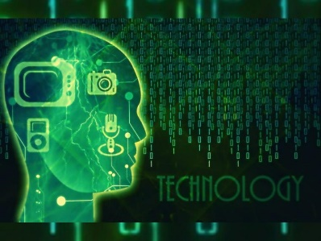
Games have also been proven to change our brains and our behavior. A team of scientists in the Universidad Oberta de Cataluña (Spain) and Massachusetts General Hospital in Boston (US) conducted 116 scientific studies to evaluate the influence video games have in our behavior and our brains. The results show that the greater the time destined to games throughout life, the greater the volume of gray matter in various structures of the brain, mostly responsible for visual attention and spatial information processing in navigation tasks. (2)
Some types of games have more positive effects on our brains that others. For example, puzzles, problem solving and logic games, have a positive effect; while action and role playing games, have a more detrimental effect on our brains, causing a stronger “addictive” behavior.
Although students can be content developers, in the case of games as learning tools, it is necessary to have a level of pedagogical knowledge that comes from experience and training. It is the responsibility of the educators to choose the right games to generate the most desired effect on the students.
- Sarah Romero
https://www.muyinteresante.es/ciencia/articulo/la-curiosidad-aumenta-la-actividad-del-hipocampo-y-facilita-la-memorizacion-581412585339 Reference: Neural Basis of Video Gaming: A Systematic Review. Frontiers in Human Neuroscience. doi.org/10.3389/fnhum.2017.00248. 2017
- Marisa Fernández, Neuropsicóloga Senior, Unobrain
https://www.muyinteresante.es/tecnologia/articulo/asi-afectan-al-cerebro-los-videojuegos-461499861915

