# Week 1 Community assignment

## Instructions

1. Download the Vacciland package…
2. Complete all seven tasks below (*see below, Part 1 and Part 2*)
3. Post your assignment in a Community Update in the IMA Level 1 Scholar community. **DO NOT POST ON YOUR PERSONAL PROFILE**. (You will find instructions how to do this in the Scholar community.)

## Part 1. Data analysis

Before you head into the meeting with the Minister, you want to make sure your data are solid. Most of the cases occurred in the capital, Grandtown, where reported coverage is high. You want to ensure that the data for Grandtown don’t contain any mistakes, so you requested this table with reported doses of MR1 for last year.

Task 1. Flag all the suspicious values. (Outliers, repetitions, etc.) (spend max 15 minutes) Done on Excel sheet

Task 2. Review the national and subnational coverage for MR1. Your data manager produces the following tables. What can you conclude from the administrative data?

Conclusion from Administrative data

National and subnational coverage for MR1



* The national MR1 coverage has since 2011 been sustained above 90% except in 2015 when it dropped to 89% but generally this is far below the target of at least 95% annually
* From 2011 to 2017 the some regions like Alu, Grandtown, and Remo have consistently reported coverages above 100% but on a declining trend. While the others have low coverages but on an increasing trend
* The data is unreliable for one to base on to draw a meaningful conclusion so as to guide the program on the action to take as this could be due to incomplete, non-reporting or poor data handling at the various levels of reporting
* The denominator is not accurate in some regions leading to coverages above 100%, it was reported that there was adjustment in the denominator done based on the recent census that showed decrease in some fertility proportions and this can account for Grandtown, Remo, and Alu that have above 100% coverage necessitating mini census or household count to determine a more reliable denominator, while regions like Westtan, Grandtan,Chello and Eastan have low coverages

Task 3. Review coverage evaluation survey data. You remember that in 2013, there was a coverage evaluation survey. You pull up the data for that. Does this change your view about coverage at national level? For any of the regions?

|  |  |  |  |  |  |  |
| --- | --- | --- | --- | --- | --- | --- |
| 2013 DHS |  |  | 95% Confidende Interval | | Admin data |  |
| MR1 | Estimate | 2013 | Lower Limit | Upper Limit | **2015** |  |
| Alu | 83.1% | 100.1% | 75.6% | 90.6% | 96% | 9.0% |
| Eastan | 92.5% | 90.2% | 87.0% | 98.1% | 92% | 6.0% |
| Grandtown | 89.0% | 118.3% | 80.1% | 97.9% | 115% | 10.0% |
| Nemo | 91.9% | 70.4% | 78.1% | 100.0% | 71% | 15.0% |
| Remo | 84.6% | 105.5% | 77.8% | 91.4% | 98% | 8.0% |
| Chello | 93.6% | 79.6% | 85.2% | 100.0% | 81% | 9.0% |
| Grandtan | 82.1% | 77.1% | 73.1% | 91.1% | 81% | 11.0% |
| Westtan | 92.4% | 67.9% | 81.3% | 100.0% | 73% | 12.0% |
| **National** | **89.2%** | **90.2%** | 86.5% | 91.9% | **89%** | 3.0% |

The survey estimated the national coverage to be 89.2% while admin was 90,2%, this implies that some regions would also have variations as seen above, in general regions that had high admin coverages all finally through survey got lower Survey estimates compared and these include (Alu, Grandtown and Remo) while the other regions which low admin data coverage instead had higher estimates by survey compared.

Task 4. Review the chart with the age distribution of measles cases. Does that tell you anything additional about coverage?

* From the age distribution it is clear the all age groups are affected by measles outbreak pointing to low immunity among the population
* Measles outbreak is highest among the 1-4 years age group, worse still it’s affecting the under 1yr meaning the routine MCV coverage is generally low
* From the graph is shows that this country has had low coverage for over a long time coupled with need to have a more that 95% coverage to offer hard immunity this would explain the frequent outbreaks

## Part 2. Brief the Minister

Task 5. Brief the Minister (spend max 1/2 hour on this section). Summarize the situation in three bullet points.

1. The national MCV coverage using to methods has some disparity although not very big as using the WHO survey method is 89.2%, while the administrative is 90.2%. The key observation between regions is that those regions which had high admin coverage have got low coverage through the survey method e.g Grandtown had the highest admin coverage of 117% but by survey its 89% and being 4th last among the regions, further analysis show that still the districts within Grandtown had significant variation in MRC coverage with some district scoring below 50% coverage

2. While all the 8 regions achieved at least 80% coverage by estimate none achieved more than 95% coverage for MCV1 that can offer protection based on the 85% seroconversion rate which would offer hard immunity

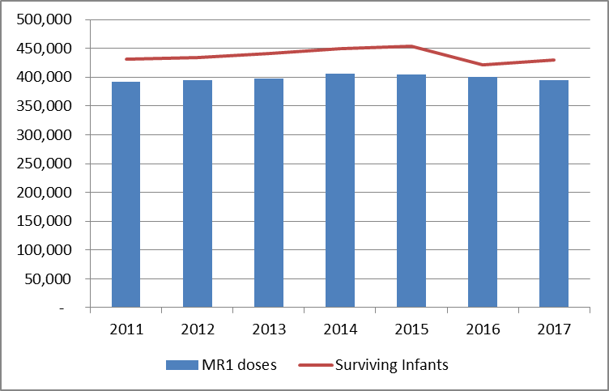

3. Through triangulation of the MR administered doses and comparing it with the surviving infants, since 2011 to 2017 doses administered have never equaled the surviving infants meaning that generally the national coverage is low and this has contributed to the measles outbreak as the population is not protected.

Task 6. Brief the Minister. Propose three actions to respond to the outbreak.

Actions to respond to outbreak

1. Conduct catchup campaign in the areas with outbreak targeting children below 15years if resources can allow, this should ensure that all eligible are vaccinated irrespective of the age group
2. Conduct RED/REC micro-planning to ensure that we address the inequities due to economic, geographical, ethnical, social and education difference and plan to reach the unreached, hard to reach by properly attaching catchment areas to health facility and they plan a strategy to address how to vaccinate all eligible in the catchment area
3. Develop an Urban strategy for Grandtown based on the fact that there is urban migration, existence of ethnic minority, limited access to government health facilities, the ministry should therefore use the private partnership to address gaps in the urban immunization services by supporting the private sector to provide free immunization services

Task 7. Formulate recommendations. List your top 3-5 recommendations specific to data strengthening you would prioritize as the EPI and surveillance teams in Vacciland

Recommendations for strengthening data

1. Build capacity for all staff in health facility, district, regional and national level to collect, manage, and use data for action
2. The ministry should implement data review mechanisms at regular intervals at all levels
3. The ministry should work with the statistical unit to discuss difficulties and potential adjustments in the denominator
4. The ministry should remove the outdated registers from the system as recommended by the previous reviews
5. The ministry should advocate to improve on the Human resource at all levels to match with the increasing work demand