Task 1. Flag all the suspicious values. (Outliers, repetitions, etc.) (spend max 15 minutes)

**Reporteddoses of MR1 for last year.**



Observatuions:

1: Feb & Mar is the same data

2:Sseptember coverage of District 1 is very low

3: District 3 May and Nov coverage very high

4:District 4 May too high

5: district 5 seems OK

6: District 6:low coverage

7:District 7: drop outs in May and June

8:District 8:Sep & oct low coverage or drop outs

9:District 9 Oct is low coverage

10:District 10 may and December may be shortage of vaccine

11:District11:june drop outs

12: District 11 and 12 same data in in Jan and Feb may be fake reportSeptember missing reports

13:Distritc 13 mach ,may ,june,nov missed reporting

14: district 14 june july August low coverage may be missing reports

15: District 15 Feb march missing reports

Task 2:

**National and subnational coverage for MR1**



National ans sub national dat shows mild variations as if data enterted is manupulated

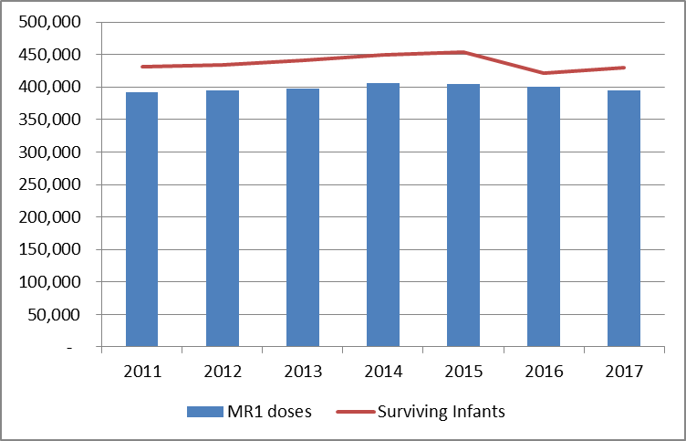



Task 3. Review coverage evaluation survey data. You remember that in 2013, there was a coverage evaluation survey. You pull up the data for that. Does this change your view about coverage at national level? For any of the regions?

**In 2016 national coverage seems low it does not include growth rate,coverage increases in 2014 and 2015, again decrese in 2016, may be due to impact of coverage analyisi survey for two years**

**Coverageevaluationsurvey data.**

|  |  |  |  |
| --- | --- | --- | --- |
| 2013 DHS |  | 95% Confidende Interval | |
| MR1 | Estimate | Lower Limit | Upper Limit |
| Alu | 83.1% | 75.6% | 90.6% |
| Eastan | 92.5% | 87.0% | 98.1% |
| Grandtown | 89.0% | 84.1% | 94.9% |
| Nemo | 91.9% | 78.1% | 100.0% |
| Remo | 84.6% | 77.8% | 91.4% |
| Chello | 93.6% | 85.2% | 100.0% |
| Grandtan | 82.1% | 73.1% | 91.1% |
| Westtan | 92.4% | 81.3% | 100.0% |
| **National** | **89.2%** | 86.5% | 91.9% |

Note: the surveyfound no meaningful differences in coverage among ethnic groups. However, the poorest were significantly less likely to be vaccinated.

Task 4 Review the chart with the age distribution of measles cases. Does that tell you anything additional about coverage?

**Age distribution of measles cases**

**Age distribution of measles cases shows children are covered only during SIAs not during routine immunizations because under one year coverage is only 10%.in 2012 measles confirmed cases were highest**

## **Part 2. Brief the Minister**

Task 5. Brief the Minister (spend max 1/2 hour on this section). Summarize the situation in three bullet points.

There is much data discrepancy in Grandten and Westine, vaccine dosage usage and coverage and survival of infants dose not match, valid reason of outbreak is failure to reach for vaccination.

Following could be the reasons of outbreak,

1: Due to migration in 2014, causes increase cases

2:Confirmed cases are unvaccinated

3: weakness in surveillance system

Task 6. Brief the Minister, propose actions

Conduct the quick mop-up round

Arrange vaccine

Training of health workers for proper microplaning, reporting

Task 7

Formulate recommendations. List your top 3-5 recommendations specific to data strengthening you would prioritize as the EPI and surveillance teams in Vacciland

**Recommendation:**

**1: Proper attention to Routine Immunization is mandatory to acchieve coverage of all antigens**

**2: Good surveilance system required for children above one yrear**

**3:Require data validation and varification on regular basus**