CUK Spring 2018: Methodology in International Studies
Coursera https://www.coursera.org/learn/qualitative-methods
Time & Place: IH260, Wednesday 9-10:00 AM, Friday 9-11:00 AM
Professor: Benedict E. DeDominicis, PhD
Office: #206, International Studies' office, 150 Anniversary Building, 43 Jibong-ro
E-mail: bendedominicis@gmail.com
Office tel: +82-2-2164-4393

Course Description: This is a practical, project-based course that is designed to help students better understand how perceptions, attitudes and values of political actors influence their political behavior. The course will examine how processes of political, economic and cultural globalization are connected to one another.

Students will work to gather information and data about a political actor, namely individuals and groups, focusing on their perceptions, attitudes and values, to understand their identity and behavior. Each student will make one class presentation, and students will write their own individual essays.

Projects will be explained at the beginning of the course, and students are to work with their assigned groups for class presentations and write their own individual essays.

- The Course Outcome Objectives in terms of student learning are the following:
- Demonstrate greater critical awareness of the predominant theoretical perspectives for orienting the analysis of cultural groups in relation to globalization.
- Demonstrate greater critical awareness of the roots and directions of political trends in world politics for the first half of the 21st century.
- Gain an understanding of the current state of qualitative approaches to social science analysis.
- Demonstrate greater critical awareness of the nature of the political phenomenon of identity as the most powerful force for conflict and change in politics, which has re-emerged with renewed intensity along with the disintegration of the Cold War to reshape the international political system, producing +30 new state actors since 1991.
- Demonstrate more effective written and oral communication skills for political analysis for distribution to different stakeholders.
- Demonstrate greater student ability to exploit new information technologies for student learning, community development and career advancement.
- Demonstrate greater political strategic analytical and negotiation skills.

Grading: Participation: 25% (including weekly 100-word paragraph electronic submissions before the debate, to bendedominicis@gmail.com or by Facebook Messenger responding to the debate topic for the week. Be sure to support your points by using and citing specific information from the assigned readings from the week to make the paragraph more persuasive. No homework should be more than 10% quoted text, so a 100-word paragraph should have no more than 10 words of quoted text. Put information into your own words, with the appropriate in-text source citation, to get the most benefit from this learning exercise.)
Take home mid-term essay: 25%
In-class debate presentation: 15%
Project presentation: 15%
Final exam: 20%

READING ASSIGNMENTS AND COURSE SCHEDULE
The course will use parts of two textbooks: Fons Trompenaars and Charles Hampden-Turner, Riding the Waves of Culture: Understand Diversity in Global Business, third edition (McGraw-Hill, 2012) and John W. Creswell and Cheryl N. Poth, Qualitative Inquiry and Research Design: Choosing Among Five Approaches, fourth edition (Sage, 2017). These textbooks have been translated into Korean. The reading assignments are to be completed by the first weekly class meeting under which they are listed. Of course, those individuals who are giving presentations that week will have completed the readings well before the class meeting at which they will present.

Friday, March 2, 2018: Introduction to Course

Week of March 5, 2018: “Introduction to Culture”
Reading assignment: Trompenaars & Hampden-Turner, chapter 1, “An Introduction to Culture”; Trompenaars & Hampden-Turner, chapter 2, “The One Best Way of Organizing Does Not Exist”
DEBATE TOPIC: To Koreans, western culture is the best culture.

Week of March 12, 2018: “The Meaning of Culture”
Reading assignment: Trompenaars & Hampden-Turner, chapter 3, “The Meaning of Culture”; Trompenaars & Hampden-Turner, chapter 4, “Relationships and Rules”
DEBATE TOPIC: To Koreans, the concept of culture is a product of imperialism.

Week of March 19, 2018: “The Group and the Individual”
Reading assignment: Trompenaars & Hampden-Turner, chapter 5, “The Group and the Individual”
DEBATE TOPIC: To Koreans, more individualistic cultures value ambition more than communitarian cultures.

Week of March 26, 2018: “Feelings and Relationships”
Reading assignment: Trompenaars & Hampden-Turner, chapter 6, “Feelings and Relationships”; Trompenaars & Hampden-Turner, chapter 7, “How Far We Get Involved”
DEBATE TOPIC: To Koreans, diffuse cultures are better at dealing with corruption than specific cultures.

Week of April 2, 2018: “How We Accord Status”
Reading assignment: Trompenaars & Hampden-Turner, chapter 8, “How We Accord Status”; Trompenaars & Hampden-Turner, chapter 9, “How We Manage Time”
DEBATE TOPIC: To Koreans, ascription is disintegrating amidst globalization.

Week of April 9, 2018: “How We Relate to Nature”
Reading assignment: Trompenaars & Hampden-Turner, chapter 10, “How We Relate to Nature”
DEBATE TOPIC: To Koreans, human civilization should value science over nature.

Week of April 16, 2018: “Philosophical Assumptions and Interpretive Frameworks”
Reading assignment: Creswell & Poth, chapter 1, “Introduction”
DEBATE TOPIC: To Koreans, social science is always a political tool.

Week of April 23, 2018: Mid-term exam week. Student-professor conference sessions (in the professor's office, IH206)

Week of April 30, 2018: “Philosophical Assumptions and Interpretive Frameworks”
Reading assignment: Creswell & Poth, chapter 2, “Philosophical Assumptions and Interpretive Frameworks”
DEBATE TOPIC: To Koreans, someday, all social sciences will follow the same methodological approach as physics.

Week of May 7, 2018: “Designing a Qualitative Study”
Reading assignment: Creswell & Poth, chapter 3, “Designing a Qualitative Study”
DEBATE TOPIC: To Koreans, qualitative data is more valuable than quantitative data.

Week of May 14, 2018: “Five Qualitative Approaches to Inquiry”
Reading assignment: Creswell & Poth, chapter 4, “Five Qualitative Approaches to Inquiry.”
DEBATE TOPIC: To Koreans, political advocacy of social change and social science research are inseparable.

Week of May 21, 2018: “Five Different Qualitative Studies”
Reading assignment: Creswell & Poth, chapter 5, “Five Different Qualitative Studies”
DEBATE TOPIC: To Koreans, quantitative research is more difficult than qualitative research.

Week of May 28, 2018: “National Cultures and Corporate Cultures”
Reading assignment: Trompenaars & Hampden-Turner, chapter 11, “National Cultures and Corporate Cultures”
DEBATE TOPIC: To Koreans, South Korea is weak in demonstrating how to overcome culture conflict dilemmas.

Week of June 4, 2018: Final Exam Preparation Student-Professor Conference Sessions (in the professor's office, IH206)

Week of June 11, 2018: Make up week & Final Exams

Week of June 18, 2018: Final Exams

Trompenaars and Hampden-Turner present a theoretical framework for values that employs a differentiation in effect between motivations, norms/attitudes and manifestations. It reflects the existence and functioning of psycho-social processes at different levels of analysis of the individual and group.

Norms and values

Artifacts and products, explicit
Basic assumptions, implicit

Figure 1: A Model of Culture (Tompenaars & Hampden-Turner 2012, 29)

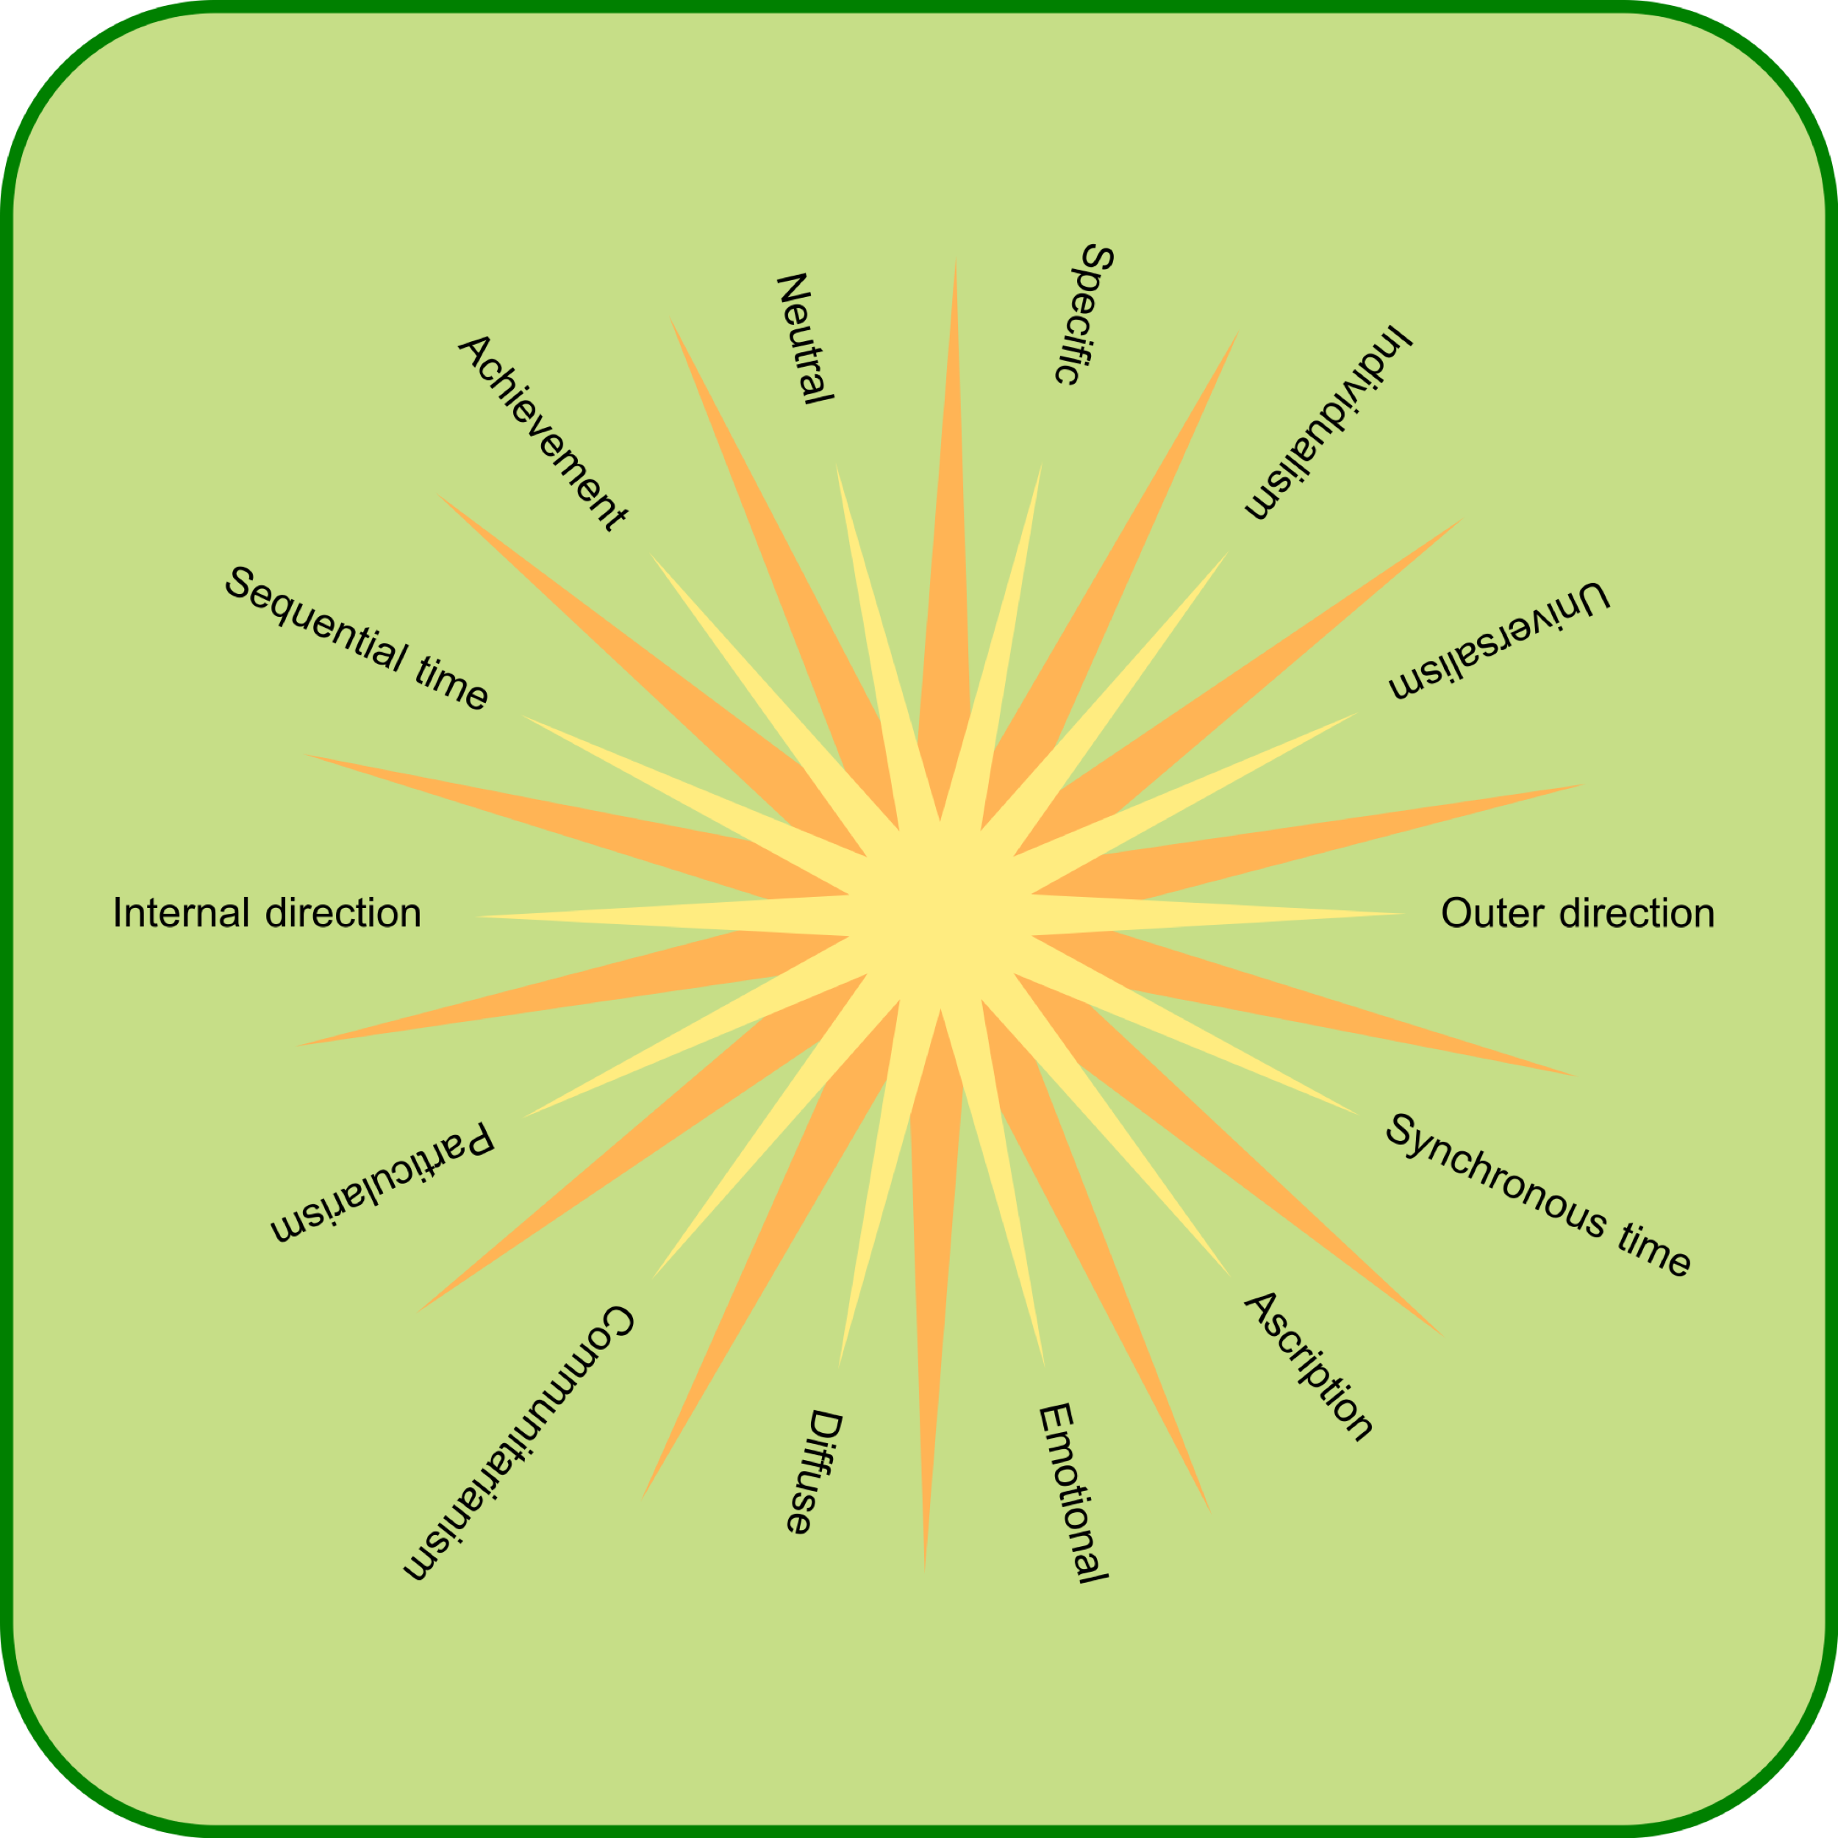

By © Nevit Dilmen, CC BY-SA 3.0, https://commons.wikimedia.org/w/index.php?curid=38462926

Figure 1: Abraham Maslow’s hierarchy of needs & Carl Jung’s typology of behavioral trait clusters

Trait: | Loyalty | Compassion | Compulsion | Aggression | Empathy
 | national | welfare | discipline (tertiary intensity) | property | introspection
 | religious community | generosity (humanism) | order | achievement | tolerance
 | ethnic community | frugality | authority | influence | freedom
 | racial community |  | recognition | equality
 | friends |  | honesty | Self-sufficiency
 | family |  | change/adventure

Need: | safety security love self-esteem self-actualization

Figure 1 above incorporates into it Jung’s typology of attitudinal behavioral trait clusters. This study postulates that a relationship exists between these needs highlighted by Maslow, and consequent changes in attitudinal behavioral norms of an individual. The causal mechanism relating an individual’s position on the needs hierarchy and his or her consequent changes in attitudinal behavioral patterns exists, but it is not clear. It needs to be conceptualized by introducing another conceptualization.

The claim is made that the impact of education and educational experiences may not be immediately evident, but rather unfold over time. This writer infers that this statement refers to the conceptual and social psychological equipment and capacities that an individual has acquired through life experiences, including education, to deal with personal crisis points, i.e. a life disturbance.

Figure 2: A model of value and attitudinal worldview change

Altered worldview |  | Altered value system
 | “disturbance”
Worldview |  | Value system
Early socialization |  | Genetic material

Perhaps modify to:

1) From Chapter 2: “The One Best Way of Organizing Does Not Exist”
- A) “One way is to see a company university as a system designed to perform functions and tasks to educate students in an efficient way. Professors People are hired to perform these functions to educate students with the help of books, machines computers and other equipment. They are paid for the tasks they perform.”
- B) “A second way is to see a company university as a group of people working learning together. They have social relations with other people and with the university organization. The functioning of the university is dependent on these relations.” (Trompenaars & Hampden Turner 2012, p. 22)
- Then, proceed with the interview on the basis of the answer. It is part of a semi-structured interview.

2) From Chapter 4: Relationships and rules: “Universalist Versus Particularlist Orientations in Different Countries”

- You are riding taking a final examination in a college class and you are one of the best students in the class . car driven by with a close friend. He hits a pedestrian. You can see that some of your friends start to cheat, bringing notes with the answers to the questions with him into the class. You know he was going at least 35 miles per hour in an area of the city where the maximum allowed speed is 20 miles per hour. There are no witnesses. His lawyer says that if you testify under oath that he was only driving 20 miles per hour it may save him from serious consequences. The instructor is suspicious about your friend’s very high score on the test, since students have been performing poorly in the class up until that point. Your professor asks you privately if you saw anyone cheating on the test (p. 45).

- What right has your friend to expect you to protect him?

  - A. My friends have a definite right as a friends to expect me to testify to the lower figure to deny I saw anyone cheating.
  - B. He has My friends have some right as a friend friends to expect me to testify to the lower figure to deny that I saw anyone cheating.
  - C. My friends have He has no right as a friends to expect me to testify to the lower figure deny that I saw anyone cheating.

- What do you think you would do in view of the question from the professor obligations of a sworn witness and the your obligation to your friends?
  - A. Testify that he was going 20 miles an hour Deny that you saw anyone cheating.
  - B. Not deny that you saw anyone cheating. testify that he was going 20 miles an hour
- Then, proceed with the interview on the basis of the answer. It is part of a semi-structured interview.

3) From Chapter 4: Relationships and rules

Keep the same?
- “You are a newspaper journalist who writes a weekly review of new restaurants. A close friend of yours has sunk all her savings in a new restaurant. You have eaten there and you really think the restaurant is not good. What right does your friend have to expect you to go easy on her restaurant in your review?” (p. 49)
  - A. “She has a definite right as a friend to expect me to go easy on her restaurant in my review.”
  - B. “She has some right as a friend to expect me to do this for her.”
  - C. “She has no right as a friend to expect me to do this for her.”

4) From Chapter 4: Relationships and rules
Keep the same?
- “You are a doctor for an insurance company. You examine a close friend who needs more insurance. You find he is in pretty good shape, but you are doubtful on one or two minor points that are difficult to diagnose” (p. 48).
  - A. My friend has a definite right as a friend to expect me to tone down my doubts in his favor.
  - B. He has some right as a friend to expect me to tone down my doubts in his favor.
  - C. He has no right as a friend to expect me to tone down my doubts in his favor.
- “Would you help your friend in view of the obligations you feel toward your insurance company and your friend?
  - A. Yes.
  - B. No.
- Then, proceed with the interview on the basis of the answer. It is part of a semi-structured interview.

5) Chapter 5: “The Group and the Individual”: “Does Modernization Imply Individualism”
Keep the same?
- “Which kind of job is found more frequently in your organization?” (p. 70).
  - “A. Everybody works together and you do not get individual credit.”
  - “B. Everybody is allowed to work individually and individual credit can be received.”
- Then, proceed with the interview on the basis of the answer. It is part of a semi-structured interview.

6) Chapter 5: “The Group and the Individual”: “Which Community?”
Keep the same?
- A defect mistake is discovered in an installation your class team project. It was caused by negligence of one of the members of your team. Responsibility for this mistake can be carried in various ways.”
  - A. The person student causing the defect by negligence is the one responsible and should be reported to the professor.
  - B. Because he or she happens to work in the class team, the responsibility should be shared by the group.
  - Which one of these two ways of taking responsibility do you think is usually the case in your society home university, A or B? (p. 71).
- Then, proceed with the interview on the basis of the answer. It is part of a semi-structured interview.

7) Chapter 5: “The Group and the Individual”: “Test Yourself”
Keep the same?
- Several managers students were discussing whether close cooperation or fierce competition was the most salient mark of the successful enterprise best university.
  - “Here are four statements:”
    - 1. Competition is the supreme value of any successful superior economy or company university or college. Attempts by major parties students to cooperate usually end in collusion against one or more of them and cheating.
    - 2. Competition is the supreme value of any successful economy or company superior university because this involves serving customers better than rivals the best graduates, thereby assuring the public interest.
    - 3. Cooperation among stakeholders university students is the supreme value because this shared aim makes companies universities fiercely competitive toward outsiders other universities, thereby fulfilling personal alumni interests.
    - 4. Cooperation among stakeholders university students is the supreme value. Personal rivalry and competing for self-advancement the highest grades are seriously disruptive of effective operations student education and learning.
  - Allocate 1 to the approach you prefer and 2 to your second choice. Then, indicate similarly what you believe would be favored by your closest colleagues at work your home university (end p. 83).
- Then, proceed with the interview on the basis of the answer. It is part of a semi-structured interview.

8) Chapter 6: “Feelings and Relationships”: “Affective Versus Neutral Cultures”
Keep the same?
- ‘Would they you express their your feelings openly if they you were upset by something at work in class?’ (p. 88).
- Then, proceed with the interview on the basis of the answer. It is part of a semi-structured interview.

9) Chapter 6: “Feelings and Relationships”: “Test Yourself” (p. 97)
Keep the same?
- In a meeting class team project you feel insulted because your business counterpart classmate tells you that your proposal is insane. What is your response?
  - “1. I will not show that this person has hurt or insulted me, because that would be seen as a sign of weakness and would make me more vulnerable in the future.”
  - “2. I will not show that I am hurt, because that would spoil our relationship. This restraint will allow me later to tell the counterpart how much I was hurt by the comment so that he or she might learn from it. I would rather show my emotions when the counterpart has more chance to improve our business relationship”
  - “3. I will show clearly that I am insulted so that my counterpart gets the message. I believe the clarity of my message will allow me to be able to control even greater emotional upset in the future.”
  - 4. I will show clearly that I am insulted so that my counterpart gets the message. If business partners classmates cannot behave themselves properly, they have to bear the consequences.
- Then, proceed with the interview on the basis of the answer. It is part of a semi-structured interview.

10) Chapter 7: “How Far We Get Involved”: “National Differences”
Keep the same?
- A boss professor asks a subordinate her students to volunteer to help him her paint his house outside class on the professor’s own research project. The subordinate A student, who does not feel doing it, discusses the situation with a colleague.
  - A. The colleague argues: “You don’t have to paint help if you don’t feel like it. He is your boss at work class professor. Outside he the class, she has little authority.
  - B. The subordinate student argues: Despite the fact that I don’t feel like it, I will paint it help her. She is my boss, and you can’t ignore that outside of work class either (p. 108).
- Then, proceed with the interview on the basis of the answer. It is part of a semi-structured interview.

11) Chapter 7: “How Far We Get Involved”: “Pitfalls of Performance Evaluation”
Keep the same?
- A. Some people think a company university is usually responsible for the housing of its employees students whose homes are far away. Therefore, a company university has to assist an employee a student whose home is far away in finding housing.
- B. Other people think the responsibility for housing should be carried by the employee student alone. It is so much to the good if the company university helps (p. 114).
- Then, proceed with the interview on the basis of the answer. It is part of a semi-structured interview.

12) Chapter 7: “How Far We Get Involved”: “Test Yourself”
Consider the following case:” (p. 122).
Keep the same?
- A group of managers and financial analysts college students and alumni were arguing about whether profitability student course teaching evaluations or ongoing stakeholder relationships financial support and contributions to their a university, most especially to between company the university from and customers its alumni and other sources, formed the best way of monitoring university organizational effectiveness. Four positions were advanced:
  - 1. Feedback Donations and financial support, like from the government and foundations, within closer customer relationships represents the timeliest advice about corporate university effectiveness. Its value is its inclusivity. Profits Student course teaching evaluations measure what is taken out of relationship, not what is staked or contributed.
  - 2. Feedback Donations and financial support within close customer relationships represents the timeliest advice about corporate university effectiveness. Because customers student tuition, alumni donations and external budget allocations and grants generate the funds used to pay profits operate and develop the university, the quality of these relationships anticipates profitability student course teaching evaluations.
  - 3. Profitability or shareholder value Student course teaching evaluations is are the prime criterion of corporate university effectiveness, because it distills in one precise and unambiguous measure the vitality and value of all activities by other stakeholders.
  - 4. Profitability or shareholder value Student course teaching evaluations is are the prime criterion of corporate university effectiveness, because it proclaims in one precise and unambiguous measure that labor works for capital educators work for students and that business universities exists to enrich educate individual owners students.
- Then, proceed with the interview on the basis of the answer. It is part of a semi-structured interview.

13) Chapter 8, “How We Accord Status”: “Status-by-Achievement and Economic Development” (p. 128)
Keep the same?
- “To measure the extent of achieving versus ascribing orientations in different cultures, we used the following statements, inviting participants to mark them on a five-point scale (1 = strongly agree, 5 = strongly disagree).”
  - “1. The most important thing in life is to think and act in the ways that best suit the way you really are, even if you do not get things done.”
  - “2. The respect a person gets is highly dependent on the person’s family background.”
- Then, proceed with the interview on the basis of the answer. It is part of a semi-structured interview.

14) Chapter 8, “How We Accord Status”: “Test Yourself”
Keep the same?
- There are different grounds for according status to employees students, based either on what people professors have succeeded in doing or on what qualities are attributed to them by the social system (end p. 142).
  - 1. Status should lie in permanent attributes of employees students– that is, their education, seniority, age, position, and level of responsibility ascribed. Status should not change according to occasion or just because of recent successes. It reflects intrinsic worth, not the latest forays.
  - 2. Status should lie in the permanent attributes of employees students – that is, their education, seniority, age, position, and level of responsibility ascribed. Such status tends to be self-fulfilling, with achievement and leadership resulting from what the corporation university values in you and expects of you.
  - 3. Status is a matter of what the employee student has actually achieved, his or her track record. Yet over time this deserved reputation becomes a permanent attribute, allowing success to be renewed and enabling more achievement to occur.
  - 4. Achievement or success is the only legitimate source of status in business the university. The more recent the achievement, the better and more relevant it is to current challenges. Achievement gets its significance from the humble nature of the individual’s birth and background and from success in beating the odds.
- Then, proceed with the interview on the basis of the answer. It is part of a semi-structured interview.

15) Chapter 9, “How We Manage Time”: “Measuring Cultural Differences in Relation to Time”
Keep the same?
- “Think of the past, present and future as being in the shape of circles. Please draw three circles in the space available, representing past, present, and future. Arrange these circles in any way you want that best shows how you (end p. 154)

- feel about the relationship of the past, present, and future. You may use different sizes of circles. When you have finished, label each circle to show which one is the past, which one the present, and which one the future.”
- Then, proceed with the interview on the basis of the answer. It is part of a semi-structured interview.

16) Chapter 9, “How We Manage Time”: “Time Horizon”
Keep the same?
- “Consider the relative significance of the past, present, and future. You will be asked to indicate your relative time horizons for the past, present, and future by giving a number:”
  - “7 = years”
  - “6 = months”
  - “5 = weeks”
  - “4 = days”
  - “3 = hours”
  - “2 = minutes”
  - “1 = seconds”
    - “My past started …… ago, and ended …… ago.”
    - “My present started …… ago, and ended …… from now.”
    - “My future started …… from now, and ended …… from now.” (p. 157)
- Then, proceed with the interview on the basis of the answer. It is part of a semi-structured interview.

Chapter 10: “How We Relate to Nature”:
Keep the same?
- “A. It is worthwhile trying to control important natural forces, such as the weather.”
- “B. Nature should take its course, and we just have to accept it the way it comes to and do the best we can" (p. 174).
- Then, proceed with the interview on the basis of the answer. It is part of a semi-structured interview.
&
- “A. What happens to me is my own doing.”
- “B. Sometimes I feel that I do not have enough control over the directions my life is taking” (p. 175).
- Then, proceed with the interview on the basis of the answer. It is part of a semi-structured interview.

I understand the meaning of the term, culture. N=12
Strongly agree agree neutral/cannot decide disagree strongly disagree mean
1 2 3 4 5 1.75
I understand the meaning of the term, value.
Strongly agree agree neutal/cannot decide disagree strongly disagree
1 2 3 4 5 2
The knowledge from this course has made me a happier person.
Strongly agree agree neutral/cannot decide disagree strongly disagree
1 2 3 4 5 2.08
The knowledge from this course has made me a more self-confident person.
Strongly agree agree neutral/cannot decide disagree strongly disagree
1 2 3 4 5 2.08
The knowledge from this course has made me a wiser person.
Strongly agree agree neutral/cannot decide disagree strongly disagree
1 2 3 4 5 2.17
The knowledge from this course has made me more confused.
Strongly agree agree neutral/cannot decide disagree strongly disagree
1 2 3 4 5 3.58
The knowledge from this course has made me less self-confident.
Strongly agree agree neutral/cannot decide disagree strongly disagree
1 2 3 4 5 3.83
The knowledge from this course has improved my social skills.
Strongly agree agree neutral/cannot decide disagree strongly disagree
1 2 3 4 5 2.08
The knowledge from this course has improved my social skills.
Strongly agree agree neutral/cannot decide disagree strongly disagree
1 2 3 4 5 2.08
The knowledge from this course has helped me better understand my country’s conflicts with other countries.
Strongly agree agree neutral/cannot decide disagree strongly disagree
1 2 3 4 5 1.92

