Fashion: protect is aesthetics

Alexandra Gonçalves

Abstract:
This article aims to reflect on some points that are believed to be necessary. If fashion expressed itself in socio-political-economic movements following historical events, this era of new technologies brings with it the feeling of a more effective need for its expression, in the sense of protecting citizens in their greatest vulnerabilities, which implies being in strong connection with the universes of information and recognition. It is in this context that several interactions will be discussed: from the skin to the type of fabrics; from the molecules that are released from the epidermis in contact with sensitive fabrics; from technological readings within freedoms; and speed of information with minimizing costs in solving problems: both for some institutions and for democratic states. My reflection is on the recognition/communication involving sensitive fabrics and, on how the most vulnerable people can defend themselves from aggression, assaults, and random attacks.

Key words: Fashion; new technologies; sensitive fabrics; vulnerabilities.

1. Introduction
If this article begins by talking about some points in the history of Fashion, however, the intention is not to present the history of it, but to reflect on some ideas that stand out from its landscapes, whether emerging from fantasy, dream, eroticism, desire, pleasure, depression, revolt, or inaccessibility. For this reason, some examples are given regarding this vast world of fashion landscapes, which are still marked, in large part, by the visuality of prepotency on sexualities. What ideas am I interested in, for example, about women’s fashion of the 18th century? At this point, I can mention how the idea of women’s fashion was taken by men, and how the idea of women was taken, (and still is) by them. The possession by women’s body, the fear of men in losing them, involving control over them all freedoms, involving both freedoms, those of men and women, alongside the will of women to conquer their freedoms have created a space of conflict between male and female, between solar nature and lunar nature, and between feminine spirit and masculin spirit. We can see how unsightly is this ancient fight that takes place on the same chess board game.
Lets see an example concerned French fashion. At the end of the eighteenth century there was a restriction of the freedom of women’s clothing, by Napoleon Bonaparte. He imposed to fashion designers several moral lines that they were required to follow, in creation of women’s fashion. As an attempt to divert women’s attention reinforcing their lack of freedom, the trade of jewellery begun to develop. Thus, the jewels marked women’s fashion, by imposing them a certain psychological status through it. At the same time, men’s fashion brings the notion of "style". It is interesting how it can be made a relationship between "style" and "psychological status". But it will not cover this issue here, because this is not the purpose of this reflection.
When we opened one of the first books published on Fashion (19th century), Un siècle de Modes Féminines, we came across something unusual:

“Les femmes, en général, vivant dans un désœuvrement funeste, s’étaient amollies, peu à peu.
Elles glissaient dans le plaisir, sans défense, n’ayant aucune foi, aucune notion du bien.”
(CHARPENTIER et FASQUELLE, p.10-11).

And this unusualness it is, certainly, not because we are far from the 19th century and its wishes and desires, but because it refers to, two essential points. First, the issue of legitimacy of the women’s will to dress freely, revealing herself love, knowing how to care for herself. Secondly, the idea pointed out, by a whole system of sexist mentalities in patriarchal societies, as moral jugments about women. In the period of the French Restoration (1814-1830), something changed. Women dressed in white, wearing fabrics with floral and light prints, silks, hats, and especially wearing few jewels. The book quoted above it can be read:

“ La femme du monde, en 1830, avait un charme pénétrant. Désireuse de conserver cette place de femme à la mode, dans un temps où la gloire était si capricieuse, elle ne songeait qu’aux hommages, et, pour maintenir son pouvoir, s’étudiait chaque jour à plaire advantage.” (CHARPENTIER et FASQUELLE p.15).

Through the representation of the women in ancient images and manuscripts, we can perceive the way the women were thought by men. And the fact is easily seen through the visuality of the codes of desires’ men.
In the last quarter of the eighteenth century, fashion seems to try to affirm the different age groups, from youth to more mature ages. And this desire spreads in newspapers, in periodicals, and other images, whose give indications about how those codes of different ages should be expressed. Moving forward to the 19th century, we see in women’s fashion, also, the difference between that conception of ages. We verify clearly the difference between the fashion of the young single woman and the fashion of the married woman. This aspect can be seen in several images which show those differences of garments, as Butazzi says: “The distinction between picking fruit and ripe fruit is determined by the fabrics and colours, and these in particular take on a symbolic value according to age.” . Nineteenth century brings some other interesting questions about luxury and elegance by the voice, for example, of Balzac who, in an aphorism expresses: "Luxury is worth less than elegance" or by the voice of Baudelaire who, in his work Écrits sur l'art, Morale du joujou, makes the parallelism of the poor child to the rich child and his world:

“Le luxe, l’insouciance et le spectacle habituel de la richesse rendent ces enfants-là si jolis qu’on ne les croirait pas faits de la même pâte que les enfants de la médiocrité ou de la pauvreté.”
(BAUDELAIRE, p.159)

Over time other questions have arisen highlighting also certain political-social positions. Then, the question of luxury will be considered in the universe of its representations, putting in motion socio-economic-political concerns. Twentieth century witnessed immense emancipations, both of peoples against colonialisms, imperialisms, racisms, women’s emancipation and other movements that will take place more firmly in 21st century.
In 20th century Mahatma Gandhi’s words: "There is no beauty in any fabric if it causes hunger and unhappiness", highlight the question of luxury, with the aim to protect Indian populations against their extremely vulnerabilities. Through all the simplicity of his garments, Gandhi clearly demonstrated to the Indian people that they could manufacture themselves their own clothes rejecting Western culture. Facing the colonizer, English empire, Gandhi succeeds in removing symbols that had drastically impoverished India. No one can forget the strike of the Ahmedabad weaver workers in 1917, which led to an increase in workers' wages.
At the end of the 20th century and beginning of the 21st century, fashion undergoes some changes due to the development of the internet, the support of the evolution of new technologies, the speed of information and creation, and a greater concern for the environment. However, there is also a nostalgic return to the past, which is deceptively safer. In this precise time of covid-19, the reduction of physical contact by the imperative of trying to resist the disease, is also at stake.
I don’t want to analyze the Clubber aesthetic, the underground culture, hip hop, the diffusion of tattooing and piercing, the limits of gender identities, the way the Tribalists wear their clothings, or other expressions of our era. Again, I want to emphasise I do not intend to relate history of fashion, as I’ve mentioned earlier. What matters is to reflect on the points related to vulnerabilities, which mirror the invisible part of fashion aesthetics. I say: there is no beauty in fashion if it omits its ability to protect and if it controls people.

2. Freedom and aggression
It is well known that the emergence of feminism boosted the question of the legitimacy of women’s freedom, due to the many forms of violence inflicted on them: the psychological and the physical. At the beginnings of feminism, there were enormous obstacles to women, in their access to knowledge, in their participation in society, on judgments about their moral, and, in extreme, the power over their lives and death. These problems still persist in some Western societies, and in many other civilizations, generated by the sexist mentalities of patriarchal and paternalistic societies. However, it is a fact that societies generate, not only female suffering, but also of the male’s; as well as the sacrifice of children and the suffering of other more vulnerable social groups. The huge problem is that societies have imposed, and still does, their codified standards, without knowing what it is ‘to act in common’.
It is true that, for a long time, the action of men has imposed itself on the control of the worlds, over women, on the control and destruction of the natural worlds. However, in the present era, it is neither justified, nor makes sense, to set aside the masculine nor other living and non-living beings of the worlds, universes and cosmos. The way in which ‘action’ of most human beings is expressed and is demonstrated, removes the ‘character from action’, and this can only be understood by the ignorance of what it is ‘to act’. Removing the power of ‘character from action’, ‘acting’ turns into something basic that drags on violence. In the rupture of relations: between living beings and between non-living beings; between individuals on Earth and other worlds; and between people in the same societies; we can hardly speak about existences. This impossibility of existences calls into question language. And this crise of language is strictly connect with a limited universes of experiences: as of lack of love; the presence of unlove; disaffections. All these anomalies will increase hatred. This is to say, that a society without ‘character’ is a society of desires which confuses love and desires. This lack of ‘character’ will undermine the social bodies and instigate hatred. With this social death the conscience fades. In his essay, To the Critique of Violence, Walter Benjamin says the following: "When one erases the consciousness of the latent presence of violence in an institution of law, it decays." An example of this, in this pandemic times, recently in the United States, is the invasion of the Capitol, by a group of people inspired only by hatred, revealing their total inability to know how ‘to act’. The image that appears, in most people’minds, face this weird situation, in which the lack of love reigns, is an image of devoided of language. As consequence, there is no possibility of dialogue, and by such impossibility of understanding, lies starting to add up, and, yet violence. To paraphrase Benjamin, with regard to dialogue: "(...) violence finds its expression explicitly in a significant relationship: there is no punishment for lying."
To speak of freedoms is to speak about human rights, is to speak about individual responsibility, and it is to speak about a place for the sensitive thought: which does not understand the worlds as ended nor the implementation of experiences devoid of affections. To know to take care, self-love and affections to the worlds, have a word to say. The conditions that provide for the maintenance of lives, their survival, and the glimpse of the beings' non-sacrifice, express aesthetic. Plus, freedom can never be disconnect from aesthetics. But, if the intention is to create distance from aesthetics, then we may face the absence of a social and individual peace, in which monsters emerge in apologies for triumphs – murders, rapes and tortures – that undermine the subsoil of the spirit of individuals. And when we perceive freedom as aesthetic it might be assumed the importance of individuals in societies, regardless of gender, religiosities and faiths, age levels, places of belonging, and places for thought. In this way, societies may cease to be deserts generated by certain dominant instincts that appeal only to appetites. David Benatar, in his work, The Second Sexism, makes a very thought-provoking reflection on how man is perceived by Western societies, how he is discriminated against, and how little is reflected and known such a problem.
Usually it seems that we perceive human beings as mythological machines, in the proper sense of mythological machine referred to by Furio Jesi. Machines that acquire strength through beliefs that provides the idea of a nuclear content, which, however, may not exist. In this age one should think that men is not a mythological machine, as not the women, nor children, nor the elderly, nor the natural worlds, nor the universes, nor the cosmos. All lives must be felt as supreme good. When I refer the idea of supreme good, I am pointing out tolerance in the sense of Ubuntu philosophy, related to recognition and valuation of identities. In Ubuntu philosophy there are no conditioning through value judgments, in the way of moral correction by the beliefs of the other. It is interesting the concept defined by Malomalo: “A person is a person through other persons”, which necessarily brings the principle of communalism, human relations, and the economy connected with the preservation of production methods that respond to the needs of social groups. As Malomalo says: "A human who makes people less human, he also dehumanizes himself." All this refers to various degrees of love, that can put in question the social degradation, in which our Western societies live.

3. From skin to sensitive fabrics
I imagine the possibility that all the various cell bodies can recognize each other and communicate in a specific way. The genesis of my thought has to do with all these moments lived by me with the consequent doubts, probabilities and improbabilities.
I assume these principles:
- we measure time because we have a sense of brain and not of mind. We have created
the concept for thought away from cellular thoughts, or organic-cellular thoughts, or from the thoughts of the cultures of the elements. That is to say away from the molecular worlds;
– sexual desire is a biochemical process that quickly imbalances the whole body. The body is stressed by pleasure, or by the anticipated image of pleasure that initiates an entire process of excitement. The promise of sexual satisfaction and short-term sexual excitement is far more powerful than any other need, because of the release of large amounts of endorphins that ward off pain and provide deep well-being. All manifestations of human action can be expressed in chemical terms;
– the dermis is composed of a dense mesh of collagen and elastic fibers whose characteristics and distribution guarantee its physical consistency, texture and elasticity. The functions of the dermis, besides firming a kind of mechanics that is expressed in the rigidity and thickness of the skin, also presents immunological functions through its dendítric cells and through the macrophages. Also dermal blood vessels provide nutrients to the skin being involved in thermoregulation, a function that is shared with the sweat glands. Small and large nerve plexuses participate in the innervation of different skin organs that are responsible for the detection of pain, pressure and temperature variations. As for the epidermis, it serves as a physical barrier that protects the skin against external agents. In addition to immonulogical function, epidermis produces melanin, through melanocytes that are natural protectors against the harmful effects of ultraviolet light, and keratinocytes that are responsible for the structural integrity of the epidermis. As the melanocytes produce melanin this is sent to the keratinocytes that will make the skin give a more effective response against solar aggression.
Starting from the above principles, I reflect on the possible communicability of the skin with the sensitive fabrics that can trigger intuition, for example. It is also worth saying that I am not an expert in any medical sciences, nor in molecular biology, nor in fabrics engineering, nor in other bioengineering.
I put this question: what if skin cells could recognize and communicate with the clothing that covers the body, or rather, if certain parts of the fabrics, that make up the garments, could recognize and communicate with skin in a way to prevent possible physical aggression, through information transmitted to the person?
Here are some ideas about how sensitive fabrics could ensure the protection of those who wear them. In this bias, I take into account the following factors: recognition/communication of sensitive fabrics with the cells that make up the human skin; the ability of molecular constituents of sensitive fabrics to defend a person against potential aggression, by linking with dendritric cells and macrophages; recognition/communication of dermal blood vessels expressing sweat glands with the molecules of sensitive fabrics; the communicability of the small and large nerve plexuses responsible for the detection of pain, pressure and temperature variations with the behavior of sensitive fabrics; recognition/communication between melanin-producing melanocytes and fabric molecules; the recognition/communication of keratinocytes (which are responsible for the structural integrity of the epidermis) and the protection requirement that sensitive fabrics emanate; and the multiple ways of the individual to read predictable external aggressions.
Through these images I’ve created, I try to give an illustrative example of how dendric cells can recognize/communicate with sensitive fabrics and endorphins.

Figure1
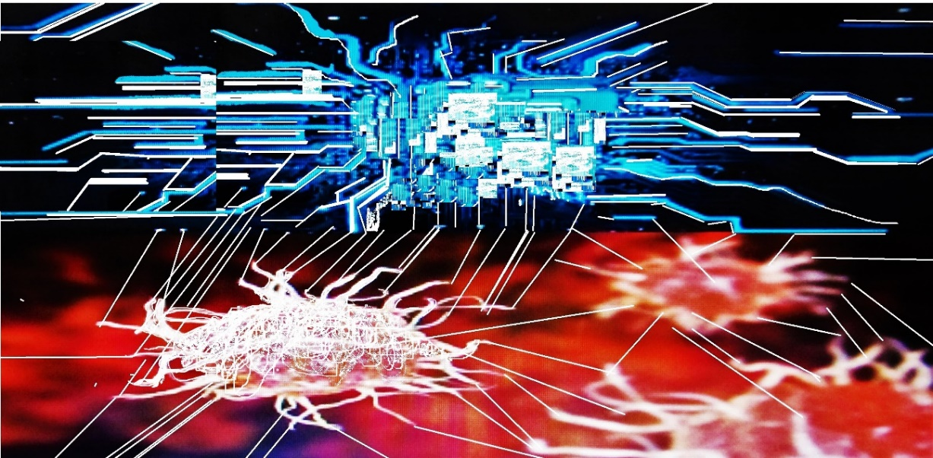[Dendritic cell in communication with other sensitive fabric information system]
Source: Alexandra Gonçalves, 20
Figure 2
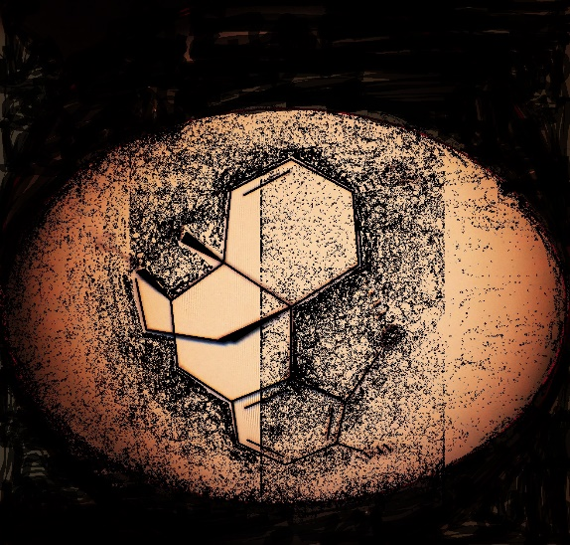
[Structural formula of Endorphin]
Source: Alexandra Gonçalves, 2021.

Figure 3 Figure 3 - A
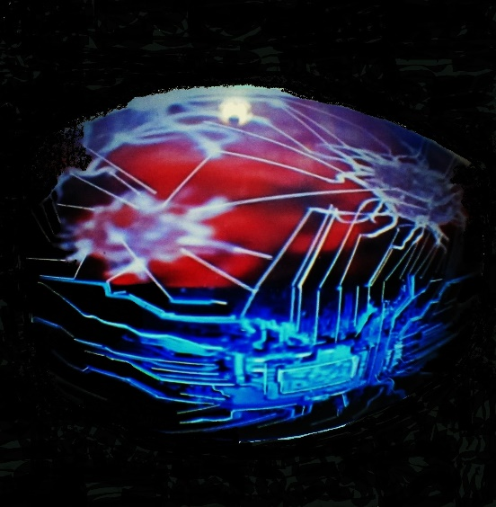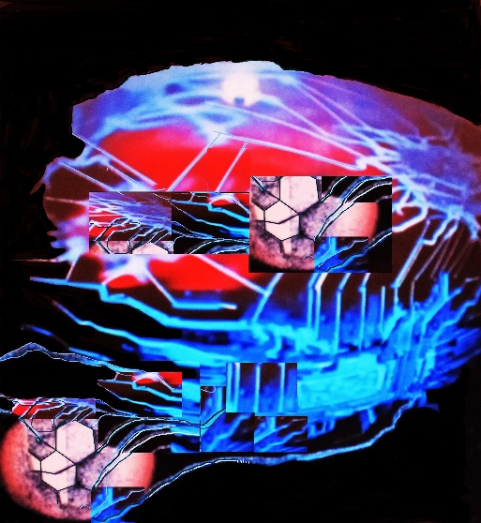
[Dendritic cell in communication with sensitive fabric.]
[Dendritic Cell in communication with sensitive fabric and with Endorphins]

Source: Alexandra Gonçalves, 2021.

My attention is focused on the recognition/communication of various sensitive fabrics that make up fashion.
Imagine someone in a daily situation: riding a bike, walking, running in a garden, or drinking a beer in a nightclub, or participating in some political demonstration, or at home watching television, or fighting in war. There is nothing unusual about these situations. Now, imagine that there are one or more possible aggressors and offenders who can approach that person. And imagine that this person’s clothing is made up of sensitive fabric which is able of sending a warning feedback about the danger. Imagine, also, the sensitive fabric able to detect danger informations from the environment surrounding the individual. Yet, imagine that those informations are communicated to the epidermal cells increasing the person’s ability to defend against external aggressors and offenders. And yet, sensitive fabrics could recognize/communicate with endorphins, and in doing so, reveal malevolent sexual arousal, for example, in the case of psychopathies.
By having a network of knowledge, able to generate the hypersensitivity of person’ senses allied with sensitive fabrics, the person could safeguard his/her integrity and freedom. In this way of possibilities, I think that it would be easier to protect vulnerabilities from aggressions and offenses.
But, what about the costs of this type of fashion that uses sensitive fabrics? And who can have access to this kind of fashion? How can this type of fashion minimize costs to institutions and states?
Talking about the police. Suppose there is a police department that is dedicated to reading languages formed through fear and danger of a person when facing aggression, or detect the danger of the individual’ surroundings. Will there not be a lower cost to society if police officers should be able to reach more quickly the places of possible aggression/offense? Or even if there is aggression, not solve the aggressor’s containment more quickly? What if sensitive fabrics will be connected to apps that families and schools could access? Will not greater safety for children, young people, women, and other vulnerabilities be promoted? In the current era, does advantage of the speed of information not expressed in nanoseconds? However, it is legitimate to ask about individual freedom. When I imagine these sensitive fabrics, I mean, on the one hand, their accessibility to many people. On the other, sensitive fabrics will, only, have access to relative knowledge, that is to say, its sphere of action will be the creation of languages which safeguard the integrity and respect for freedom of the human person (neither police, nor state can steal other personal data).

4. Conclusion
This reflection/proposal is related to the concern of the vulnerabilities of the citizens, from the observation, that the violence in societies express immeasurable sacrifices and consequent degradations. I realize that the majority of citizens are at risk.
In this sense, I imagine a way to provide greater security for people through a kind of sensitive fashion: in the possibility of linking sensitive fabrics within molecules released from the epidermis; in the availability of sensitive fabrics allowing readings through new technologies, ensuring the respect for individual freedoms; in speeding up resolution of problems concerned aggression and violent offenses; solving and minimising costs for some institutions and implicitly for democratic states themselves.
I suppose that dendritic cells of the skin have the ability to capture informations of the environment created by molecules released by the aggressor/offender, and activate responses of a kind of immunology to a specific physical aggression/offenses. In this process of recognition/communication, cellular and molecular mechanisms are therefore involved in capturing signals and languages, that will be sent to data centers or to computer apps.
Skin cells know how to read sweat molecules released by the aggressor/offender – for example, or read the excitation that emanates from the body of the aggressor/offender, or even read the dysfunction of the amygdala of the brain (due to absence of emotions) – associating them into a network of sensitive fabrics, hyper-sensitizing the senses of the vulnerable person. By capturing, processing, and presenting interacting languages, a possible violent act against the person could be avoided. This set of intracellular, intramolecular, extramolecular phenomena may be accompanied by behavioral modifications. The process of recognition/communication between dendritic cells, and consequent expression of the information, concerned the environment that surrounds the person, can lead to modulations of responses as a kind of immunology. However, it should be noted that people are different, so the answers may be different. Some being more intuitive than others, the relationships between information languages will be different, and sometimes it may happen, that a specific danger response is activated in a specific way.
Perhaps it can happen, also, that sensitive fabrics, in those relations of languages with cells and molecules, can positively stimulate those of the aggressor/offender. This is to say, it is possible to co-stimulate the amygdala of the brain, inhibit and soften the excitation caused by the image-sexuality of which it is a carrier, for example. I’m thinking about that fringe of people who reveal psychopathy. It may be that the creation of these fabrics can contribute to an improvement of social relations.
Fashion of the future must attend not only to ethical conditions related to the environment, but also, recognize that in the part of its invisibility there are values of the human person that it is necessary to defend. The multidisciplinary cooperation of fashion designers with different branches of physical and human sciences and engineering will be essential for the research and manufacture of these sensitive fabrics.

Bibliographic References

Arendt, H.: A Condição Humana. Tradução: Roberto Raposo. Editora Relógio D’Água. Lisboa (2001).

Baudelaire, C.:. Écrits sur l’art. Librairie Générale Française. Paris (1992).

Benatar, D.: Second Sexism: Discrimination against men and boys. Wiley-Blackwell. New Jersey (2012).

Benjamin, W.: Escritos sobre Mito e Linguagem. Tradução. Susana Kampff Lages e Ernani Chaves. 2.ed. Livraria Duas Cidades, Editora 34 Ltda. São Paulo (2013).

Butazzi, G.: La Mode: Art, Histoire & Société. Traduction: Bernard Guyader. Livre de Paris, Biblio-Club de France-Hachette et Cie Paris (1983).

Charpantier, G. et Fasquelle, E. ( Org.). Un siècle de Modes Féminines: 1794-1894 – [Quatre cents toilettes reproduites en couleurs]. G. Charpentier et E. Fasquelle. Paris (1896).

Jesi, F.: La fête et la machine mythologique. Traduit de l’italien par. Fabien Vallos. Éditions MIX. Paris (2008).

Malomalo, B.: I Only Exist Because We Exist: An Ubuntu Ethic. IHU Journal. Retrieved (http://www.ihu.unisinos.br/) (2015).

Racinet, A.: The Costume History; Die Kostümgeschichte; Le Costume Historique. Taschen. Köln (2009).

Images
Figure 1. Gonçalves, Alexandra. Dendritic cell in communication with other sensitive fabric information system. Digital Image. (2021).
Figure 2. Gonçalves, Alexandra. Structural formula of Endorphin. Digital Image. (2021).
Figure3. Gonçalves, Alexandra. Dendritic cell in communication with sensitive fabric. Digital Image. (2021).
Figure 3-A. Gonçalves, Alexandra. Dendritic Cell in communication with sensitive fabric and with Endorphins. Digital Image. (2021).

PhD Degree in Communication and Semiotics, achieved in jun 2020. Pontifícia Universidade Católica de São Paulo (COS | PUC-SP). E-mail: gabiabreu.abreu20@gmail.com.
Free translation: “The women, in general, living in dire of aimlessness, had gradually softened. They slipped into pleasure, defenseless, having no faith, no notion of good.”
3 Free translation: “The woman of the world, in 1830, had a penetrating charm. Desiring to retain her place as a fashionable woman, in a time when the glory was so capricious, she thought only of tributes, and, in order to maintain her power, studied every day to please the advantage.”
Butazzi, Grazietta. La Mode: Art, Histoire & Société. Traduction: Bernard Guyader. Paris. Livre de Paris, Biblio-Club de France-Hachette et Cie, 1983, p.271.
Free translation: “Luxury, carelessness and the usual spectacle of wealth make these children so beautiful that they would not be believed to be made of the same dough as children of mediocrity or poverty.”
Benjamin, Walter. Escritos sobre Mito e Linguagem. Tradução. Susana Kampff Lages e Ernani Chaves. 2.ed. São Paulo: Livraria Duas Cidades, Editora 34 Ltda., 2013, p. 137.
Ibid, p. 139
Interesting the article of Malomalo: “Ntu african philosophy and the defense of biocosmic rights”, Problemata: R. Intern. Fil. V. 10. n. 2 (2019), p. 76-92 ISSN 2236-8612 doi: http://dx.doi.org/10.7443/problemata.v10i2.49144. 2019.
Note: We are talking about innate immunity acting with adaptive immunity, which is characterized by the rapid response to aggression, regardless of previous stimulus, being the defense of the body. The immune system consists of an intricate network of organs, cells and molecules, and aims to maintain the body’s homeostasis, fighting aggression in general.

