The great enemy: the dissonance between what I teach and what I evaluate
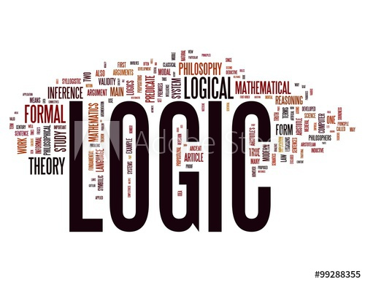
The development of the logical procedures of evaluation, refutation and demonstration, in the teaching-learning process of the subject, always depends on the quality of the pedagogical intervention carried out (from the curricular design of the subject, to its logic within the curricular framework). The analysis of the students' progress must be observed from the characteristics demonstrated through the behavior they develop in the actions comprising such procedures. That is, the student must be observed and evaluated in complexity, as a carrier of the teaching-learning process, not only as a result.The logical evaluation must be carried out through the evolution of the process and the way in which the designed tasks influenced its process.
L. S. Vygotski, Soviet psychologist, delved into the study of logical thinking: "Verbal thinking is not an innate, natural form of behavior, but is determined by a historical-cultural process and has specific properties and laws that cannot be found in natural forms of thought and speech" (Vygotski, 1968, p. 54). While Domínguez (2007) emphasizes that from the predominant interdependencies of psychic activity, thought becomes a guiding process during school activity
Since thought is the reflection of "conceptualized reality", "logical thinking" will then be able to direct the solution of problems and situations through the "logical" actions that integrate its own way of thinking (Travieso Valdés, 2017).
In evaluation and demonstration, as part of the logical process of the student's thinking, judgment is also part of the individual way of thinking influenced by the progress of learning. As part of the evaluation, the demonstration must respond directly to the logic of learning and, through it, be able to evaluate the process and support the veracity of a stipulation. The coherence of this process lies in the logical correspondence of evaluation with education.
This logic will only be guaranteed by logical actions, communicated to the student before, during and at the end of the process. The logical actions that accompany the above are: dichotomous classification, deduction of consequences and concept of obligatory properties (Travieso Valdés, 2017).
Dayana Travieso Valdés says that, in practice, most of the students are unaware of these actions and "they execute the demonstrations based on their previous experiences, they do not know the integration between the actions and they show a fragmented conception of the demonstration as a thinking procedure".
She herself, in the conclusions presented in her work published under the title of The development of logical thinking through the teaching-learning process, says that , The modeling of teaching tasks, supported by a developing teaching-learning process, as a way of pedagogical intervention, favors the development of logical thinking procedures. Thus, he points out, the value of teaching tasks in the development of logical procedures is manifested, as well as the significance acquired by diagnostic tests as instruments to measure students' progress (Travieso Valdés, 2017)

References
Domínguez, Laura (2007): Psicología del Desarrollo. Problemas, Principios y Categorías, Editorial Félix Varela, La Habana.
Vygotski, Lev (1968): Pensamiento y Lenguaje, Edición Revolucionaria, Instituto Cubano del Libro, La Habana.
Travieso Valdés, D. y. (enero-abril de 2017). El desarrollo del pensamiento lógico a través del proceso enseñanza-aprendizaje. Rev. Cubana Edu. Superior vol.36 no.1 La Habana ene.-abr. 2017, 36(1). Obtenido de http://scielo.sld.cu/scielo.php?script=sci_arttext&pid=S0257-43142017000100006

