Myanmar Ministry of Health and Sports, Expanded Programme For Immunization
DATA QUALITY SELF-ASSESSMENT
August 1-10, 2017

Contents
Background and objectives 1
Methodology 1
Protocol 2
The Coverage Monitoring System in Myanmar 4
Vaccination planning 4
Vaccination recording and reporting 4
System review 4
Findings from the data desk review 7
Internal consistency 7
Trend analysis 7
Triangulation 7
Findings from the field review 8
Data verification 8
Qualitative assessment 9
Community Check 10
Recommendations 11
1. Revise targets and denominators to ensure that all children are included 11
2. Further Align EPI and HMIS 11
3: Advance e-HMIS and e-LMIS integration 11
4. Ensure the availability of reporting forms and vaccination cards 11
5. Update and consolidate SOP’s for use of all tools 12
6. Integrate data quality in supervision practices 12
7. Develop a comprehensive training strategy 12
8. Consider recruitment of a designated data analyst at State and Region level 12
Next steps 13
Annex I: evaluation forms 14

Background and objectives
The availability of high quality immunization data is of prime importance for successful programme management. In Myanmar, data quality was assessed comprehensively in 2012 for the last time. Since then, the programme has been challenged by a large downward adjustment in population estimates, as well as by a coverage survey estimates that were inconsistent with the data the programme collects through its own system.
Therefore, central EPI decided to evaluate its system and data, and organize a data quality self-assessment (DQSA), with technical assistance from WHO. The assessment took place from 1-10 August with participation by central and regional staff at the Expanded Programme on Immunization (EPI) and the Health Management Information System (HMIS) groups, WHO, UNICEF and Gavi Alliance staff. The assessment had the following objectives:
- Assess the quality of information systems and data in Myanmar
- Start the development of a strategic data quality improvement plan
- Build capacity for the continued assessment and improvement of data quality in Myanmar
The assessment focused on coverage data, and included vaccine usage data for triangulation purposes. Surveillance data were not included at this time. Coverage data are collected by two groups at the Ministry of Health and Sports in Myanmar: EPI and HMIS. These groups work together, and the data they collect are reasonably aligned, but differences in reporting flows and timelines still exist. The assessment focused on the EPI system and data, but EPI data were compared to the equivalent data from HMIS where possible.

Methodology
The assessment followed the following framework, comprising 4 phases.
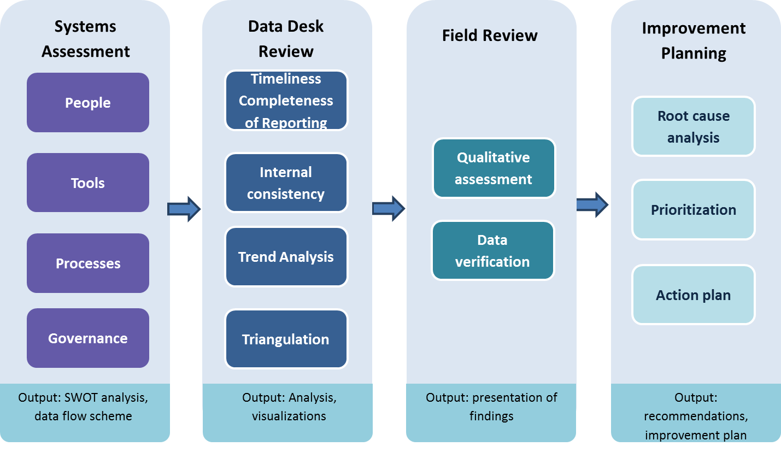
This report includes the assessment findings as well as high-level recommendations. These will be incorporated in a proper data quality improvement plan, to be developed later in 2017.

Protocol
Participants received one and a half day training on the methodology to be used. This included the development of a questionnaire and data collection forms that are adapted to the current system and that aim to provide more information needed to address data quality priorities in Myanmar. Please refer to these forms in annex 1.
Participants were then assigned to 16 teams which covered 8 Regions and States. The team composition was mixed, with central EPI and Regional/State EPI managers, HMIS focal points, WHO and UNICEF country offices. To minimize bias, team members were assigned to different States or Regions than the ones they work in.
Myanmar is divided in 16 States and Regions, which are further divided in Townships. Each Township has a number of Rural and Urban Health Centres, which in turn oversee sub Rural Health Centres and Wards respectively. This sub-centre level is the service delivery level.
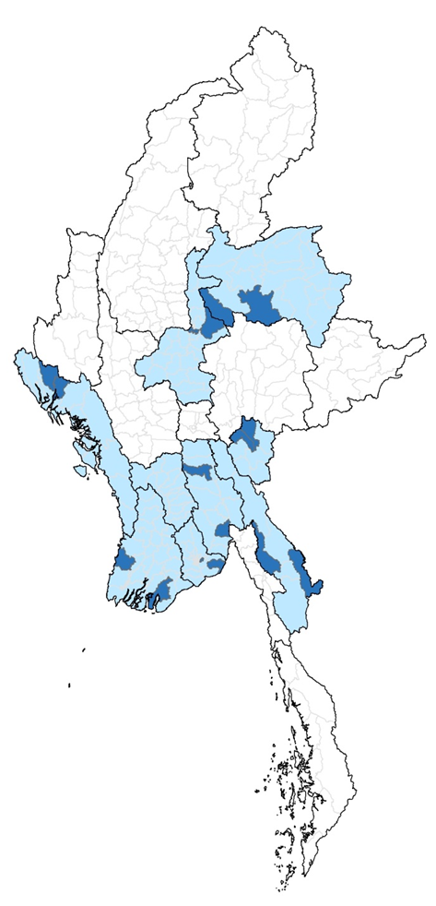
State/Region |  | Township
Ayeyarwady |  |  | Bogale
 |  |  | Pathein
Bago |  |  | Oktwin
 |  |  | Waw
Kayah |  |  | Demoso
 |  |  | Loikaw
Kayin |  |  | Hpa-An
 |  |  | Myawady
Mandalay |  |  | Amarapura
 |  |  | Pyinoolwin
Rakhine |  |  | Kyauktaw
 |  |  | Mrauk-U
Shan (North) |  |  | Hsipaw
 |  |  | Naung Khio
Yangon |  |  | Thongwa
 |  |  | Dagon-seikkan

A sampling protocol for the review was developed, with the following criteria:
- 8 Regions/States were selected with the following criteria:
- plain, delta, costal and hilly areas to be included
- equal proportion of States and Regions
- dense and scare population density
- 16 Townships (2 in each R/S) were preselected with the following criteria:
  - good and bad data consistency among 3 years reported DPT3 coverage
  - no travel limitation due to security
- 16 Rural Health Centres (1 for each township) were selected by random sampling, as well as 2 additional Urban Health Centres for Yangon and Mandalay.
- 32 Sub- RHC/UHC were selected by random sampling
- 160 children were randomly selected from child immunization registers.

The Coverage Monitoring System in Myanmar

Vaccination planning
Each of the sub-centres and wards performs a yearly headcount in December, and produces an enumeration of all the households in their respective catchment area. This headcount is used by HMIS as a denominator for the past year, and by EPI to set a target for the next year (applying a growth rate). This target is then typically adjusted upward in January and February as people that were missed by the headcount are identified. After that, the yearly target is frozen, and it is reported up the chain through the monthly reporting form. Denominators for coverage monitoring are then established at the RHS, Township, State and Region, and national levels, as the sum of these local enumerations.
At the sub-centre level, the headcount, as well as birth and death registration, are then used to draw up monthly due lists of children to be immunized. These due lists turn are in turn used to organize the sessions, order vaccines, etc.

Vaccination recording and reporting
Vaccinations are recorded in child immunization registers which are kept by ward or village. Each sub centre then compiles a monthly reporting form based on the due lists, which are also used as a way to tally vaccinations. The compilation form also include the vaccines used and balances. This monthly compilation form is used to report vaccinations, detailed by village or ward for the sub-centre, by sub-centre for the RHC or UHC, by RHC/UHC for the township, and by township for the State or Region.
At the township level, the immunization data are entered by RHUC/UHC into a web based health management information system, DHIS2, along with the data for all other programmes. It is also forwarded to the State and Region, where it is entered by township into an EPI specific excel tool, which is then shared with the national level. At the State and Regional level, data entry is often performed by the data assistant to the Regional Surveillance Officer, a WHO staff funded through the polio eradication programme.
This data flow is depicted below.
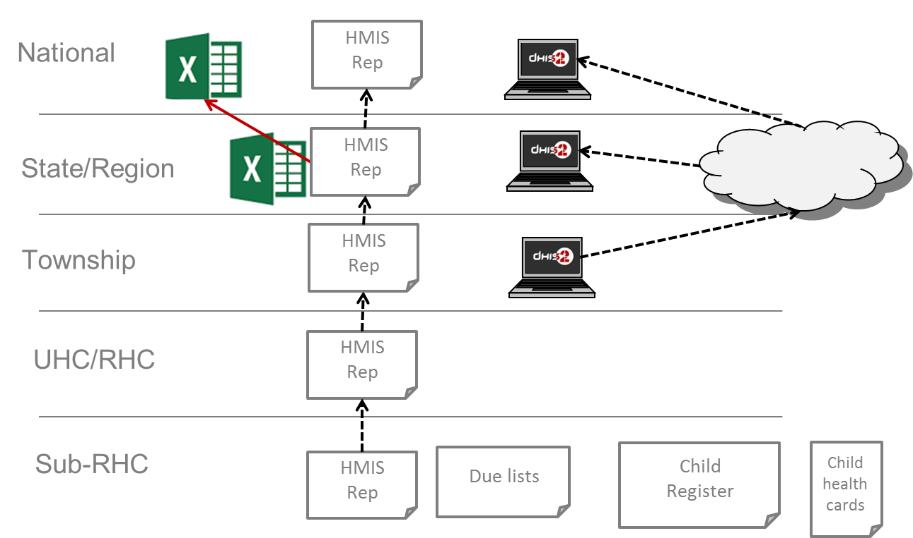

System review
Before the field review, participants were asked to assess the Strengths, Weaknesses, Opportunities and Threats of the system. The following paragraphs provide a summary

Strengths
- Standardized user-friendly forms for service delivery and logistics at Township level and below
- Useful software (Excel) for data management at State and Regional level
- RSO network
- Proper paper record mechanism at RHC and SC
- Awareness and responsibility of Midwife
- DHIS2 available at Township and State/Region level (251/330)
- Electronic devices (Computer, printer and fax etc.) are available at Township and State/Region
- Motivated health staff

Weaknesses
- Denominator problems
- No SOP and guidelines (e.g compilation data flow and using the forms)
- Reporting forms for S/R are not standardized
- Delays in reporting and incomplete data
- No assigned person for data management in some S/R and townships
- No regular training for data assistant and EPI focal point
- Forms are not updated for newly introduced vaccine
- No regular supervision and monitoring in some S/R
- Regular data analysis and feedback are absent in some townships
- Regular stock outs of reports, vaccination cards, recording forms
- Cascade training sometimes fails
- Lack of frequent supervision in every level
- High workload for midwifes, with too many forms and paperwork
- -any change in focal person of EPI can affect in the process of data compilation/consistency

Opportunities
- Roll out of DHIS 2 and integration of EPI data
- Regular and supportive supervision improving the data quality
- World Bank and Gavi funds
- Linkage between DHIS2 and eLMIS

Threats
- Unstable social climate
- Lack of skillful data assistants and uncertainty around support from polio programme
- Data manipulation
- How to manage data from uncover areas
- Unstable target population due to mobility

Findings from the data desk review

Internal consistency
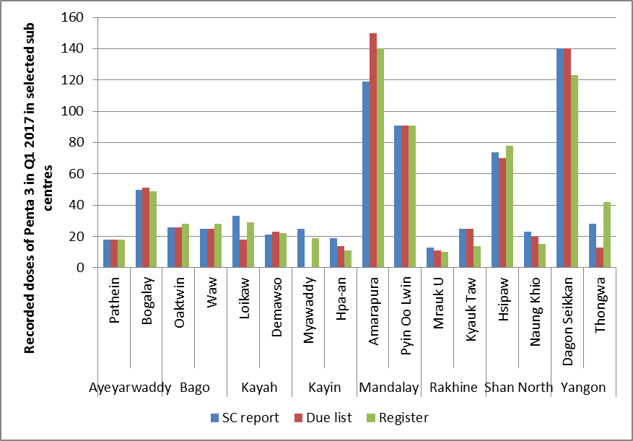

Minor inconsistencies between registers, due lists, and reports were observed

Trend analysis

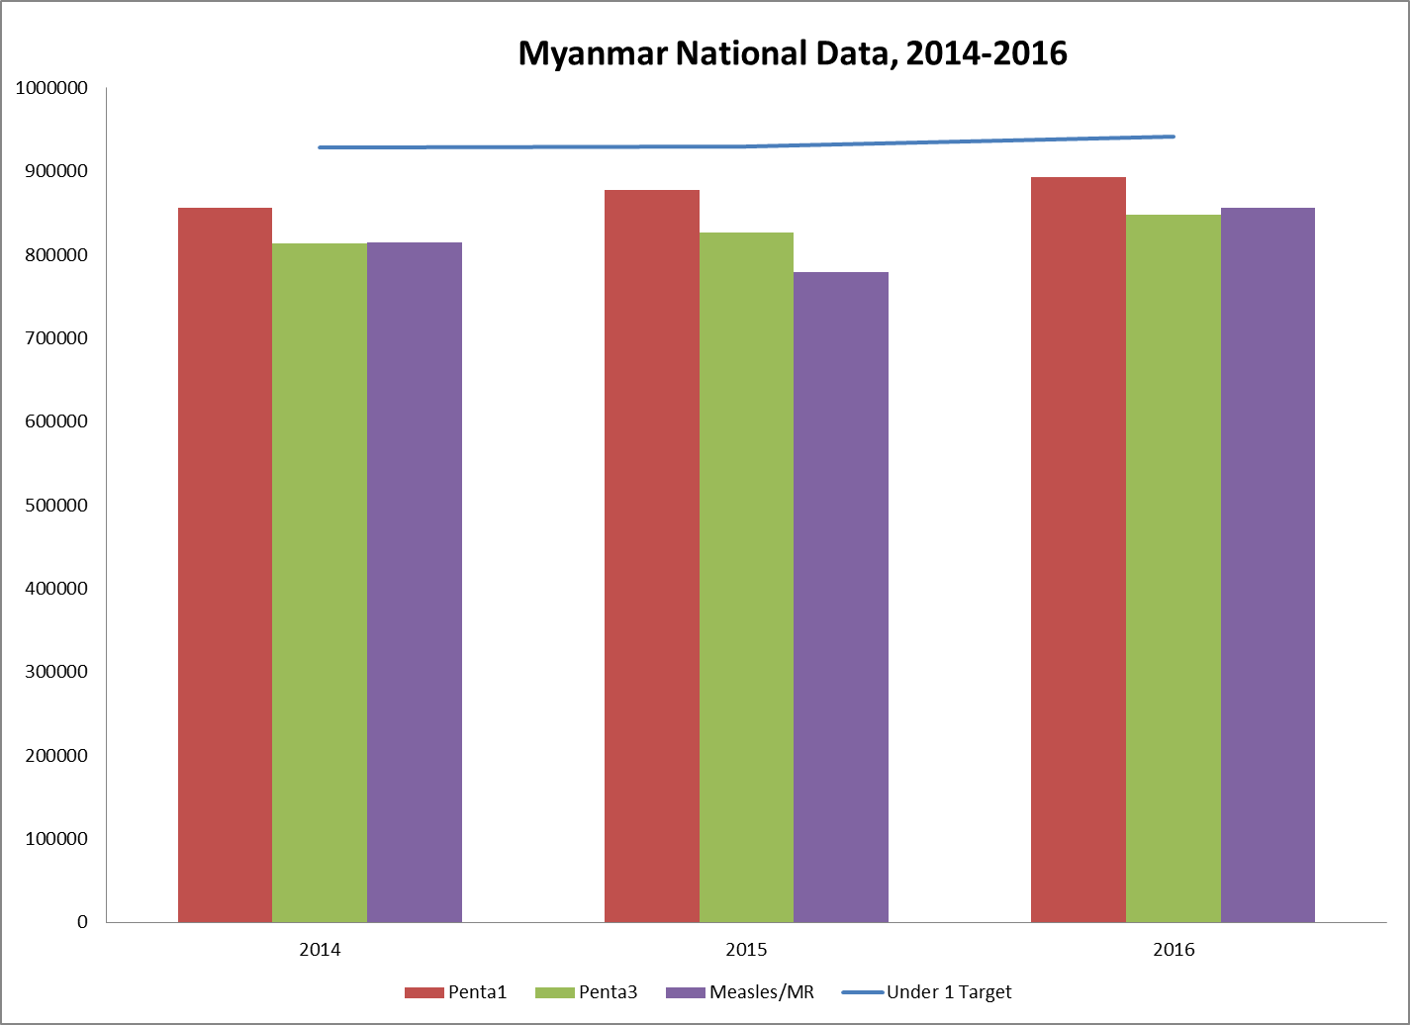

The target population and immunization achievement in 2014-2016 seems to be stable at national level however the analysis of sub-national trend revealed instability. This may be explained by inconsistency in growth projection, migration and weakness in data monitoring and feedback mechanism.

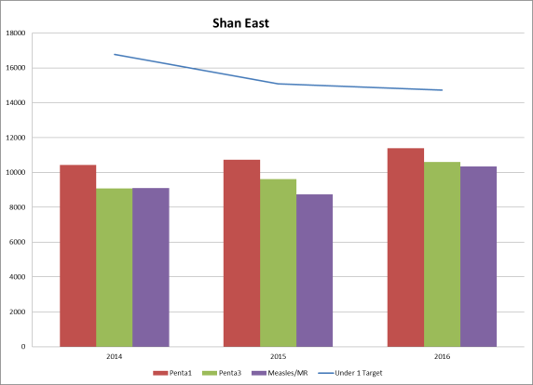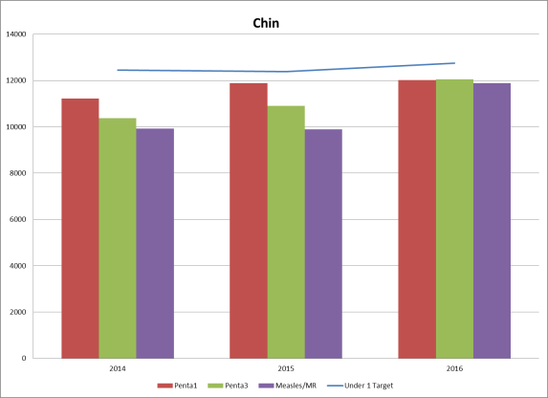

Triangulation

Comparison of different sources of denominators
EPI and HMIS both use local enumeration as the main method to estimate target populations, but EPI projects this target at the beginning of the year, while HMIS uses the end-of-year enumeration. This leads to slight differences; EPI estimated about 27 thousand children less for 2016 than the HMIS headcount at the end of the year, 2.6% of that headcount. These differences vary across states, but are overall not very substantial. However, when compared to data derived from the census, larger differences of up to 23% can be seen, with the census-based estimates generally higher than the enumeration-based estimates, apart from Mon and Rakhine States.
At the national level, Penta3 coverage based on the EPI target is 91% for 2016, but it would have been 88% based on the HMIS denominator, and 81% if the projections based on census data would have been used. These differences represent a major challenge for the use of the EPI target for coverage monitoring, as it is likely that with the use of local enumerations certain groups might be missed, such as internal migrants, transient communities, urban poor, etc.
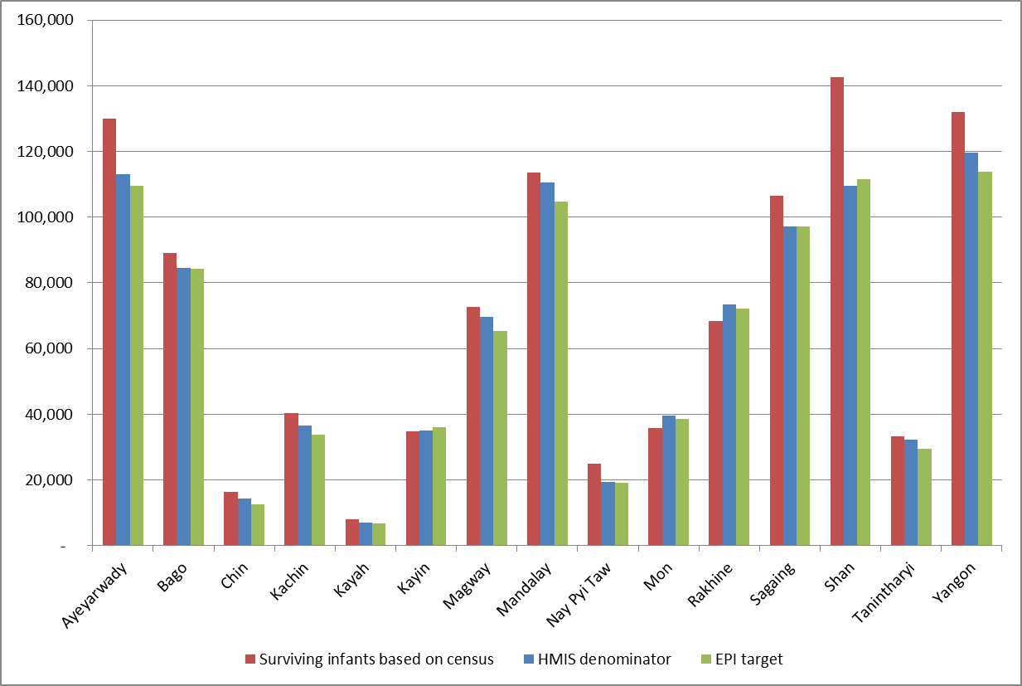

Comparison with DHS
A Demographic and Health Survey took place in 2016, showing Penta3 vaccination coverage of only 62% among children age 12-23 months at the time of the study. However, this result was based on a very low percentage of cards seen by the surveyors (46%), which might have introduced a substantial recall bias in this result. Indeed, coverage for early doses (which are more reliably surveyed based on caretaker’s recall) was much higher, at 87% for Penta1 and 88% for BCG. It is actually quite unlikely that the drop-out rate really was as high as 29%, and the real coverage for Penta3 would probably be higher than the DHS estimate.
For the purpose of the exercise, we will therefore use estimate for Penta1. This analysis still shows a slight difference between penta1 administrative coverage (95%) and survey coverage (87%), with a better match between the two when using the national census derived estimate (85%). This might be further evidence that the denominator issue should be looked into, and that the census estimates might be a better source to evaluate coverage against. This is especially true for certain states such as Shan state, with a large proportion of the population in non-government-controlled areas, and where local enumerations are hard to perform.
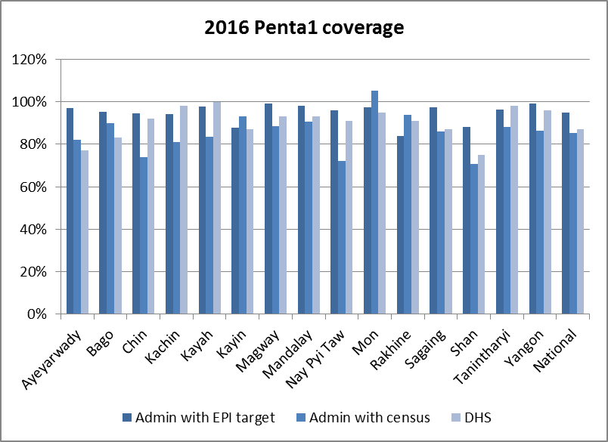

Findings from the field review

Data verification
Overall, there was good consistency between data sources at higher levels, with some minor and one substantial differences. The table below shows differences in data for each of the sampled townships.
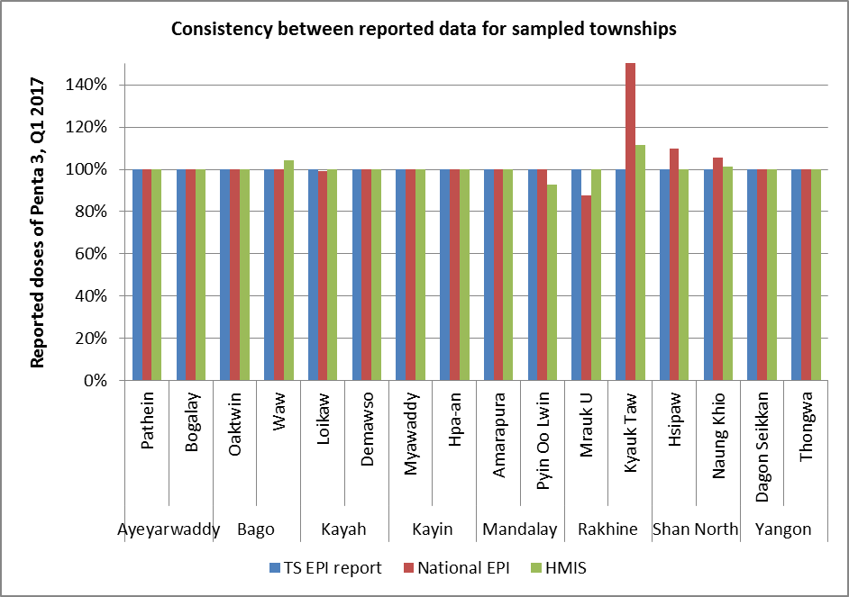
Data verification at the service level showed more issues. In many cases, the registries were poorly kept and contained fewer children than what was reported, and there were also some case of under-reporting (more children in the registers and due lists than what was reported). However, there was no indication of systematic over reporting. The table below compares reported data to what could be verified in due lists and registers.
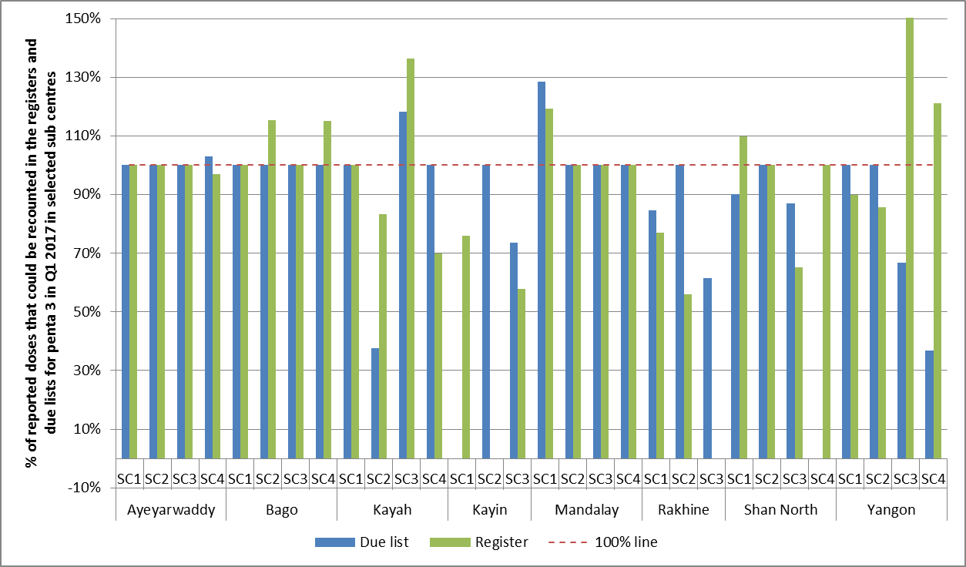

Qualitative assessment
The following show the findings of the qualitative part of the assessment, based on the administration of a standard questionnaire.
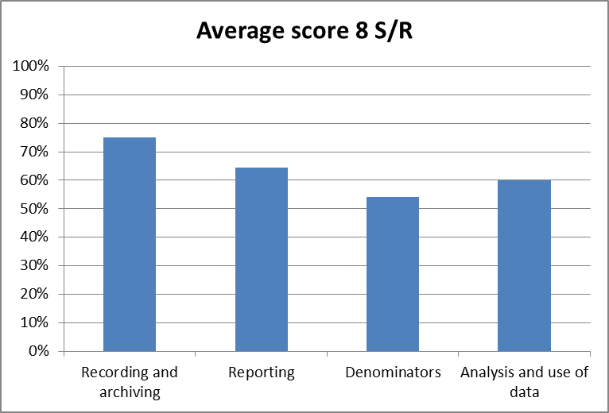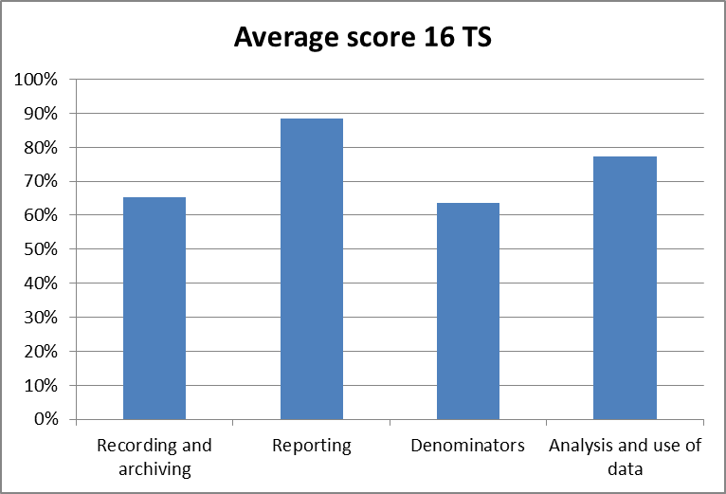
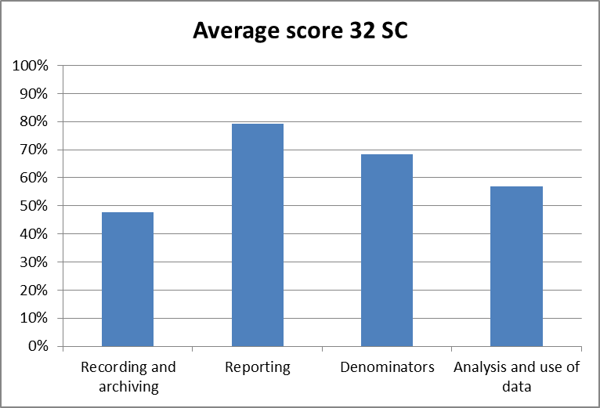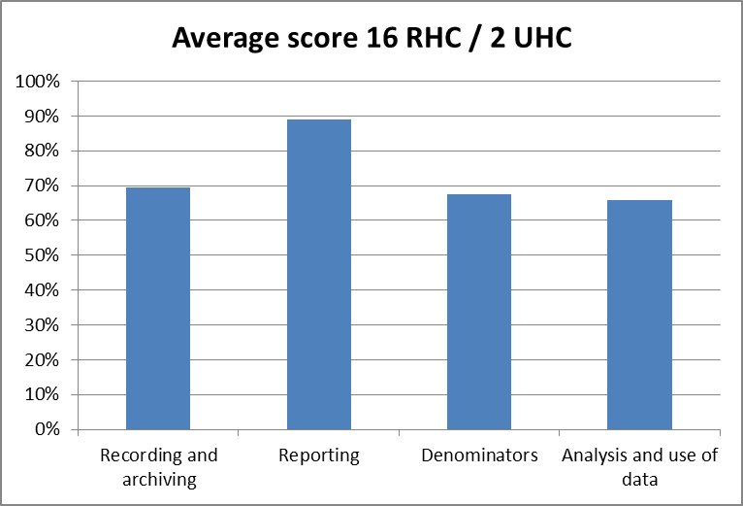
 | Recording | Reporting | Denominators | Analysis and use
Strengths | Largely positive in terms of correct and complete use of forms (due lists, registers, reports, indent forms) | Largely timely reporting between levels  Mostly consistent between different sources | The yearly headcount allows for a good understanding of the target population, and allows for very detailed planning and defaulter tracking | Committed workforce
Challenges | Challenges related to recording migrant/temporary populations– resulting in under-reporting  Inconsistent use of immunisation registries  Insufficient supply of reporting forms, immunisation cards | Sometimes inconsistent / discrepant data reporting through HMIS and EPI, as well as differences in data flows and timelines between the two systems  Potential for some reporting errors / quality concerns in regions using phone based and paper-based reporting modalities | Challenges related to denominators and target setting in all S/R for migrant or guest populations  Health workers not always confident in calculating targets, recording or reporting migrant / guest populations (variations in practices observed)  Microplanning based on registered residents only  Discrepancies between HMIS and EPI targets, and across levels | Require further training on data management, analysis and use across levels  Weak review / feedback mechanisms across levels  Supportive supervision requires strengthening  Not all States / Regions demonstrating use of data to inform prioritisation / sufficient feedback into planning

Community Check
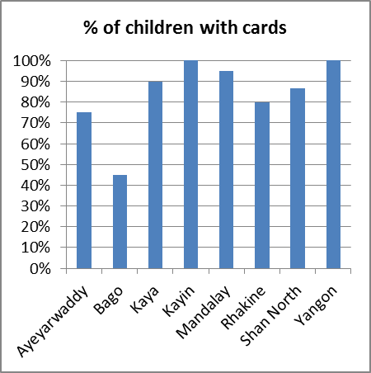
In each sub-centre, 5 one children of about one year of age were selected at random from the registry books, and located in the family. For 84% these children, cards could be seen, and the data recorded in these cards always corresponded to the data in the facility registers.
The main reasons for the non-availability of cards were loss and stock outs in the facility.

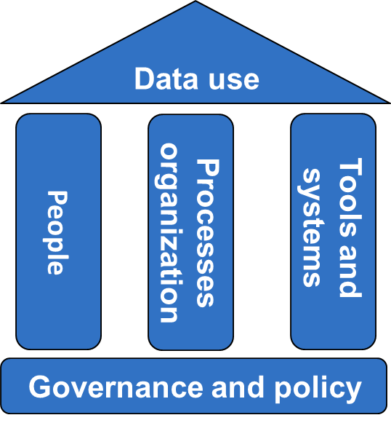
Recommendations
While the assessment showed overall good practices around the recording and reporting of vaccinations (numerator data), the target setting process and the choice of denominators for programme monitoring was less positive.
Ten recommendations were presented and discussed by the main stakeholders at the Ministry of Health and by partners. They aim to cover all the fundamental building blocks of a well-functioning information system, as depicted by the diagram on the side.

1. Revise targets and denominators to ensure that all children are included
The local enumerations may exclude or underestimate migrants, informal settlements, seasonal workers, urban poor, and people living in Non-Government-Controlled Areas (NGCA). That leads not just to an over-estimation of real coverage, but also to the risk that these vulnerable people are being neglected by microplans. The following steps can be taken to make sure that all children are included:
- Develop clear guidelines for the headcount process to include migrants in the targets, and for the monitoring and reporting, including in difficult areas (which might include projections).
- Develop mechanisms to include migrants and other vulnerable populations like the urban poor in micro-planning, including through the formulation of specific strategies, mapping and the use of GIS.
- Triangulate EPI targets with HMIS numbers, census data, previous year’s achievements and campaign achievements.
- Consider using census-derived population estimates for the calculation of coverage, instead of using the reported targets for this purpose.
- Develop an advocacy and implementation plan to sensitize States and Regions of these changes.

2. Further Align EPI and HMIS
While a lot of integration has happened, and there clearly is a good degree of collaboration at all levels, this should be seen as an ongoing process, with further scope to align timelines and data flows, and to clarify roles and responsibilities for data entry, review, and access to information. In the end-state of this process, only one person should enter certain data in a single system.

3: Advance e-HMIS and e-LMIS integration
A plan has been developed to use a single platform (DHIS2) for all EPI data, with single data entry at township level. This 18 month plan was endorsed, and it was noted that it should include:
- The development of EPI specific modules for logistics and dashboard / analytics (18 month plan)
- The exploration of existing modules for EPI reporting, dashboard, and data quality

4. Ensure the availability of reporting forms and vaccination cards
Availability of vaccination cards among the community was low during recent coverage evaluation surveys, and this assessment found insufficient availability of tools at the health facilities that were visited. To remedy this situation, the team recommends to :
- To include these tools in e-LMIS, and indent forms, just like the vaccines and other supplies
- Estimate stock requirements bottom-up
- Keep buffer stocks at S/R and townships

5. Update and consolidate SOP’s for use of all tools
- Develop Handbook for data recording, reporting, review, analysis and use
- Develop a standardized feedback template for use at all levels

6. Integrate data quality in supervision practices
- Include data quality checks in supervisory checklists
- Develop protocol for rapid coverage checks (LQA, RCA or similar)
- States and regions to conduct in-depth data quality self-assessment for their townships periodically (e.g annually or every two years)

7. Develop a comprehensive training strategy
There will be training needs for the new unified system (DHIS2), the handbook, and target setting. To ensure qualitative training:
- Review methodology for training (cascade training)
- Consider building a central training team, as well as cross-cutting teams in the states and regions
- Develop a training curriculum (holistically covering all EPI needs)

8. Consider recruitment of a designated data analyst at State and Region level
These analysts would be in charge of analysis, feedback, capacity building for data.

9. Organise technical working group review meetings
To evaluate coverage, logistics, surveillance, and other programme data, and develop action plans for corrective action. This should be done at national and state and regional level, with the with flexibility to (re-) allocate budgets as required. It should also involve partners beyond EPI.

Next steps
Q3 2017:
- Further refinement of recommendations
- Translate recommendations into milestone-based data quality improvement plan
  - Time-bound deliverables
  - Lead responsible agencies / teams noted against each milestone / deliverable
  - Allocate budget for improvement plan implementation (consider Gavi HSS as a potential source)
  - Endorsement of finalised improvement plan
Q4 2017 onwards:
  - Begin implementation as per plan, with regular monitoring of progress against milestones (including as part of annual Joint Appraisals)

Annex I: evaluation forms

