Hayworth, Philip
EPSY 408 Summer T2

Outline
Introduction: I have two ideas floating around now for work 1.
Idea 1:
The first stems from Skinner’s idea as follows:

“If mediating devices have not been set up, if the student is not automatically reinforced for knowing that he knows, he then stops working, and the aversive by-product of not-knowing pile up.”
Skinner, B.F. 1968. The Technology of Teaching. New York: Meredith Corporation. pp. 61–2, 64–5, 155–8, 167–8. || WorldCat
This speaks to the notion of assessment and feedback, specifically, formative feedback that typically occurs regularly in the classroom. It goes deeper. The idea of knowing that one knows – having absolute, concrete evidence that one is on target – is critical to motivation. But how to do this when one is working with 30 or more students in one classroom? For some, a simple “good work” comment might suffice. For others, more is needed. My central concern is the idea that students give up. I want to know why and avoid the aversive by product of not knowing.
Idea 2:
The second idea stems from Betsey DeVos, US Secretary of Education’s recent Twitter feed regarding “rethinking” schools -- #RethinkSchool

She writes that the “European” model of Education is one she would like to see implemented. The model has two distinct tracks: one for further college entrance and academics. The other is vocational/technical and speaks to the Trumpian notion that people should be able to find work after being educated – that is, either after high school or trade school – and that this type of Education is useful, practical and necessary to achieve the re-industrialization of the US. DeVos asserts that in these countries, “freedom in education isn’t controversial – it’s common sense.”
The use of the term “freedom” is interesting. But how the idea applies to the core themes of this course still escapes me.
You can read the full story here:
https://www.breitbart.com/big-government/2018/06/29/devos-wants-u-s-to-adopt-european-education-policies/
Literature
I’m a very big supporter of technical and vocational education (TVET). I have done a significant amount of reading on the subject in the context of something called the Asian Development State, e.g., Japan, Singapore and, to some degree, China. Southeast Asian nations are pushing TVET education today, specifically, Vietnam, Thailand and Malaysia – in an attempt to escape something called the “middle-income” trap where a nation cannot compete with cheaper labor countries, but cannot compete with advanced economies. While DeVos uses the European model as an exemplar, the Asian model is similar. Indeed, you find German terms used now in Asia, such as “Meister” schools in South Korean that give high school students TVET degrees – similar to what you find in Europe. In Germany, for example, nearly 70 percent of high school graduates take TVET jobs, rather than going to college. This is one reason German engineering firms produce high-quality products in great demand worldwide. In light of the vast numbers of US college graduates unable to find work suitable to the degrees and often forced to take service jobs just to make ends meet, the necessity of TVET-trained workers to meet demand for skilled workers has never been greater. I believe that TVET should be considered a legitimate track and fully funded and encouraged at the high school level and beyond.

My difficulty now is the take this idea and shoehorn it into one of the major themes of this course. Perhaps Behaviorism fits to some degree – if Education is, to some degree, a form of behavior modification. The sheer professionalism of the “meister” programs is such that even at the high school level students are acculturated to the profession of TVET, their behaviors modified to the degree that after graduation the are regarded as fully trained professionals ready for more advanced training. Singapore, too, takes this approach and it’s said that a graduate of a Singapore high school is as educated and professional as someone with four-year Engineering degree.

Perhaps the working title is: What is the Purpose of Education in the Globalized Economy? The idea most certainly fits with the New Learning concept promoted by Kalantzis and Cope. The following is taken from the New Learning module created by Kalantzis and Cope at http://newlearningonline.com/learning-by-design/the-new-school
A revolution is occurring in education. We are on the cusp of the invention of the New School.
This revolution is being fueled in part by the social media, globalisation and local diversity. It is also a result of the presence of a new generation of learners—Generation ‘P’, for participatory. These learners have different kinds of sensibilities to the students of our recent past, increasingly expecting to be agents in their own learning rather than passive recipients, absorbing formal, generic content. These forces suggest a fundamental change in the human relations of learning and the formal institutions of schooling in which they have been traditionally located.
The Learning by Design Project uses the new, social media and a more varied and engaging pedagogy to develop dynamic learning environments that are more relevant to our changing times. It builds on the work of the Multiliteracies Project and the analysis of the today’s educational transitions described in New Learning

My take on the above is that, one, that picture doesn’t look too revolutionary to me. It looks incredibly boring – and not exactly the kind of Education that builds a nation or economy. My idea of Education is more like the following below:
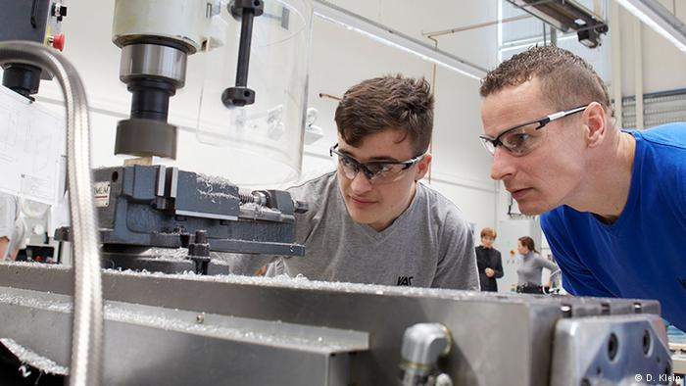
The above is taken from this article: https://www.dw.com/en/germany-exports-a-secret-of-its-success-vocational-education/a-38114840

Here’s another look at German TVET:
https://www.bmbf.de/en/the-german-vocational-training-system-2129.html
Here’s a comparative look at the best TVET programs in the world – this one with a focus on Singapore:
http://www.ncee.org/wp-content/uploads/2014/01/The-Phoenix1-7.pdf
So that’s my preferred focus for Work 1. But what “theories” apply? I’m still unsure.

