Week 1 Community assignment

- Task 1. Flag all the suspicious values. (Outliers, repetitions, etc.) (spend max 15 minutes)

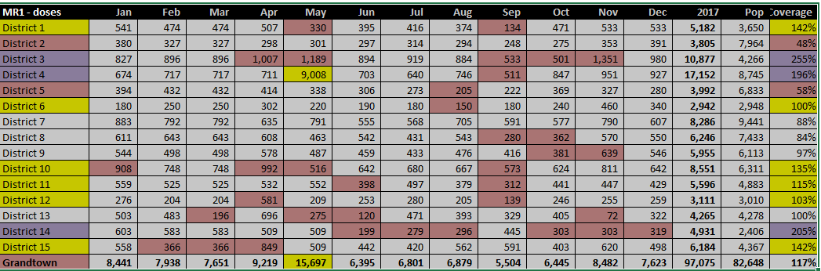
There are numerator (high numbers of doses administered) and denominator (lower than the doses administered, so they are not representative of the population being served. Data presents serious issues to be able to use it for action as is. The health facility and district cannot determine the number of children being missed, actual coverage.

- Task 2. Review the national and subnational coverage for MR1. Your data manager produces the following tables. What can you conclude from the administrative data?

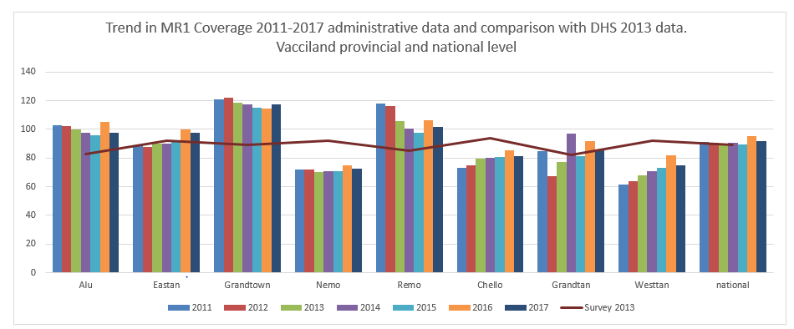

The administrative data on coverage is not reliable, as we saw in the aggregated data form above there are mistakes in the numerator (doses administered) and denominators are under estimated for the population being served. This is a serious concern because the data cannot be used to estimate the number of children not reached by services, especially populations that are not served appropriately due to social determinants (lack of transportation, education, culture and language, other), who also tend to cluster in certain localities, areas, like in the margins of big cities.

- Task 3. Review coverage evaluation survey data. You remember that in 2013, there was a coverage evaluation survey. You pull up the data for that. Does this change your view about coverage at national level? For any of the regions?
- There are three region of main concern due to the high discrepancy between administrative and survey data.
- Grandtown, Alu, Remo, Grandtan. This is not a surprise, because of the issues with administrative coverage being reported over 100 and 200%.

- Task 4. Review the chart with the age distribution of measles cases. Does that tell you anything additional about coverage?

- If you consider the measles outbreak in 2011 the SIA that year with high coverage, those born 2010 and before are protected either due to disease or vaccination, although there are still cases in all age groups, close to 50% of cases is among the under, 9 years of age, the age group most affected is the under 5 yo (37%).

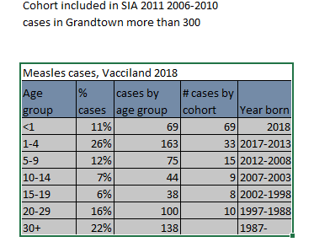

Part 2. Brief the Minister
- Task 5. Brief the Minister (spend max 1/2 hour on this section). Summarize the situation in three bullet points.
- Susceptibles/Cases
  - Most cases in Grandtown (> 50%)
  - Last outbreak + SIA in 2011
  - AGE
            - - 11 % <1 cohort,
            - - 37 % cases < 5,
-50% <9
  - 80% cases NOT vaccinated or no data
  - Hesitancy is growing
  - 10% access services through private provider

- Task 6. Brief the Minister. Propose three actions to respond to the outbreak.
  - MR vaccination at 6 months during the outbreak
  - Increase access, extend hours, outreach sessions
  - Consider MR SIA
  - Focus groups on acceptability of vaccine
  - Social mobilization to increase demand for vaccination

- Task 7. Formulate recommendations. List your top 3-5 recommendations specific to data strengthening you would prioritize as the EPI and surveillance teams in Vacciland
- Activate the EOC
- Increase granularity of data analysis
  - Improve numerator/denominator
  - Provide age specific data > 10 years old cases
  - Case Mapping, cluster and cohort analysis of cases
  - Field visits, session observations
  - Qualitative data
  - Private providers

